How to set up Printing for External Users inc Tenants

Access the User Portal https://papercut.wlv.ac.uk
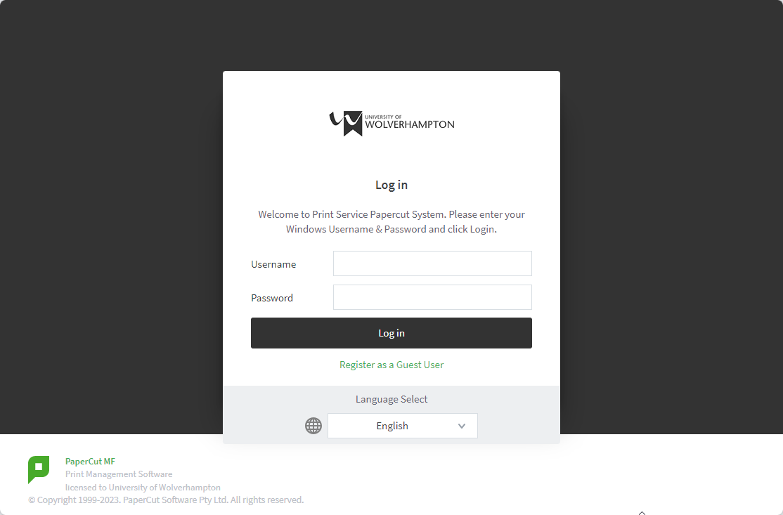
Click Register as Guest User
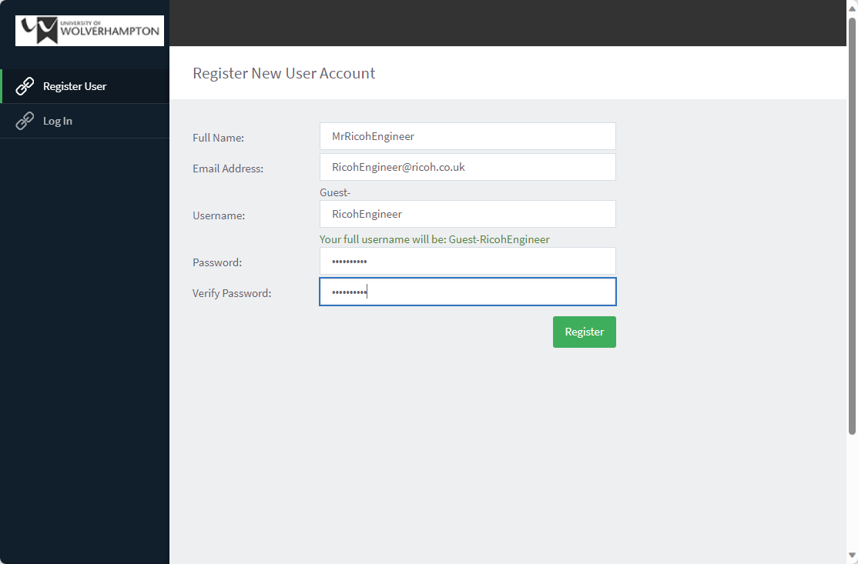
Enter the following information:
Full Name, Email Address, Preferred Username & Password
Click Register
User will get confirmation that their account has been created.
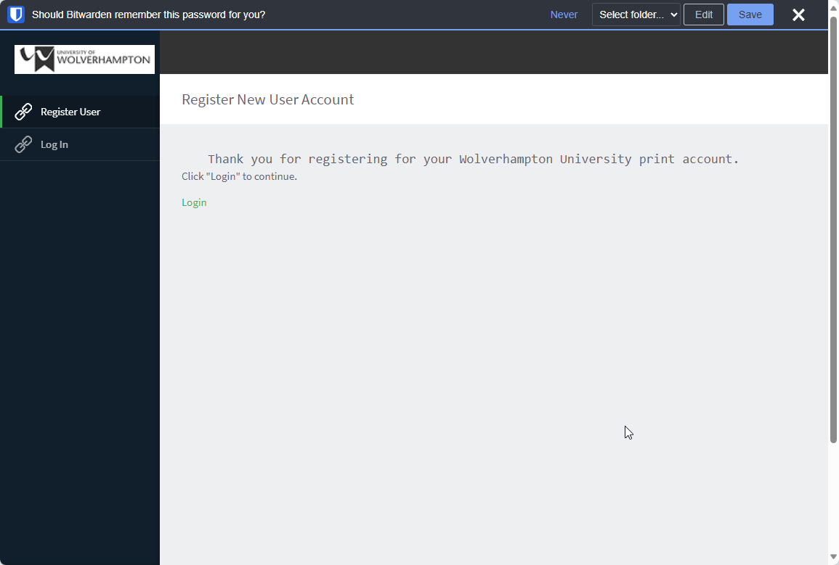

Activate the Account
The newly created user will receive an email advising to activate their account following a email link:
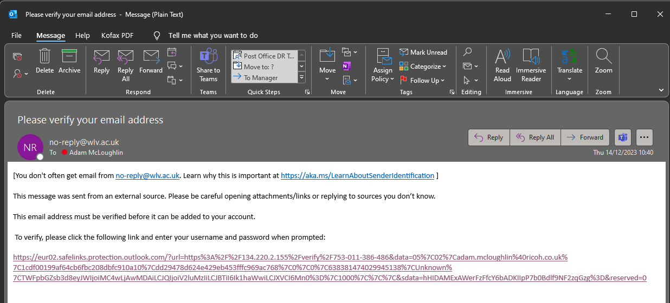
Click the link
Enter your Username & Password that was created to validate your account.
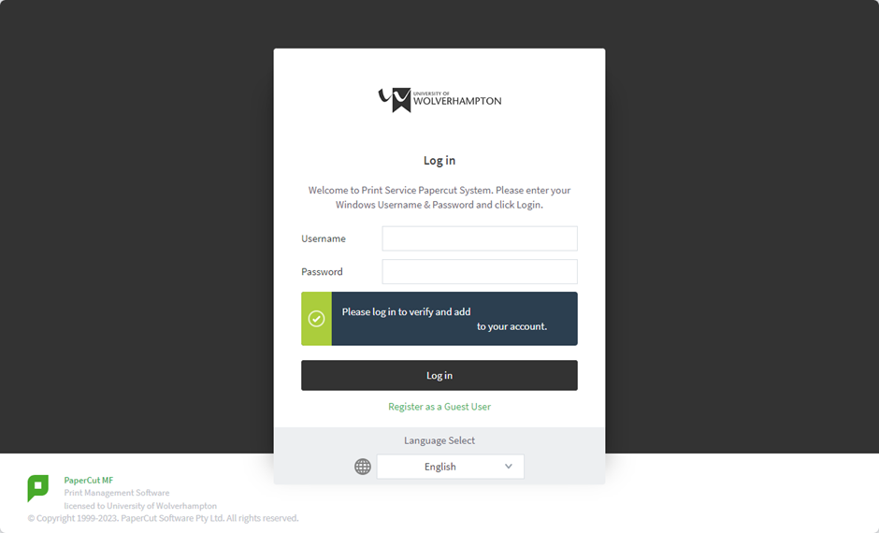
Once activated the user will see a successful account creation message.


Authentication
The newly created guest account will need to use the username which will be External- followed by the username they setup e.g., External-RicohEngineer and the password to use all Papercut functions.
This includes:
Logging into Papercut to add credit via WPM
Logging into Ricoh MFD to access Print, Copy and Scan and Register Card
Please note, the password created can only be reset/modified by a Papercut Admin.

How to Print

Ensure the account has been created and verified using the steps on Page 1.
Click Here to get started

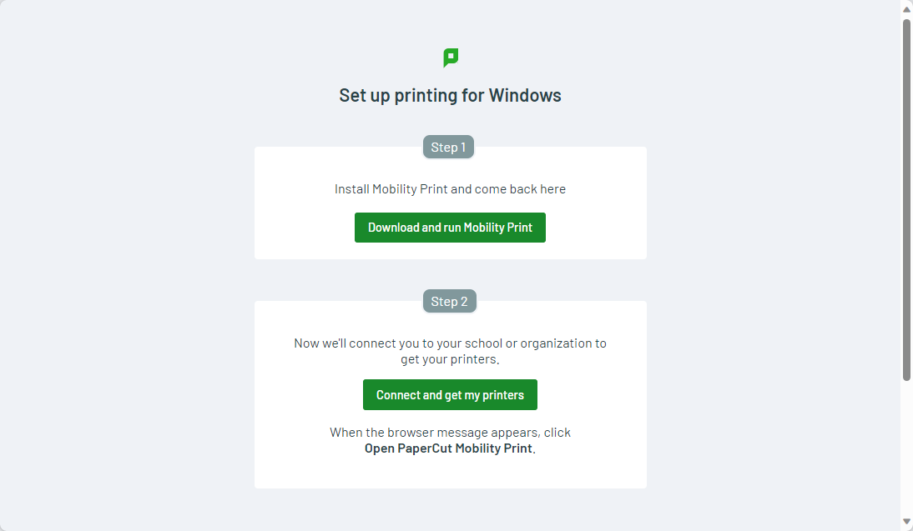

Click Download & Run Mobility Print (You must be a machine administrator to complete this)

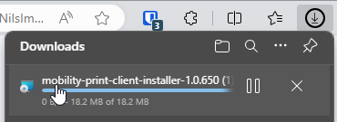

Click Next

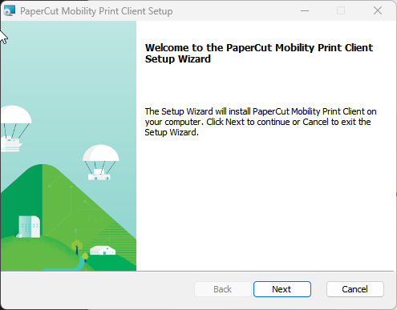

You will be prompted for User Account Control Process and Click Finish.

Once installed, click on Step 2 – Connect and Get My Printers
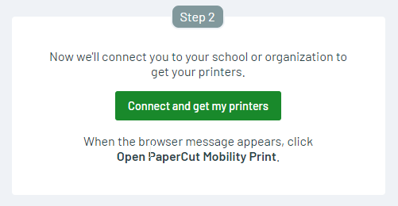

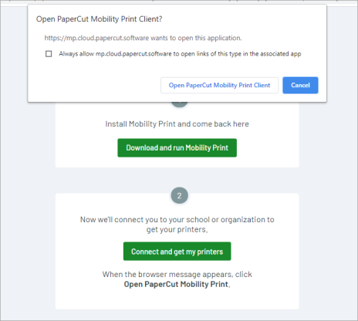
Click Open Papercut Mobility Print Client, once the setup complete, you will see the following message saying Fetching your printers.
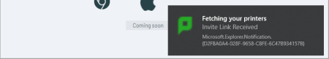
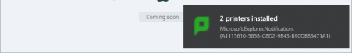
Now you are ready to print. Find your document you wish to print and print to:
Follow-You-Student [PaperCut Virtual Print Queue](Mobility)
You will be prompted to enter your Papercut Username & Password.
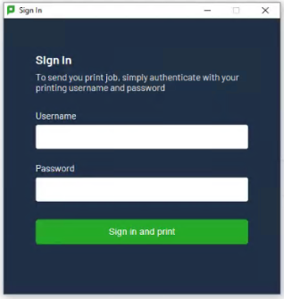
Once you have entered the credentials that you created in Page 1 click Sign in and Print. Your print job will be processed and will be available for release on the Ricoh MFD.

