

Managing Workload User Guide (Department Head)
Workload Planning
Table of contents

Managing Workload User Guide (Department Head) 1
Introduction 3
Logging in 4
Managing my workload 5
Freezing/Editing others workload 6
Searching for user 6
Viewing/Managing a users workload 7
Viewing reports 8
My individual report 8
Find users individual report 8
All individual reports for school 8
Summary of department workload 8
Summary of workloads frozen by user 8
Summary of workloads not frozen by user 8
Teaching report by staff member 8
Reports by activity 8
Teaching gap report 9
Exporting reports 9
Snapshots 9
Reviewing a snapshot 9
Frequently asked questions 10
Why can’t I find my a staff member in the list? 10
Why can’t I freeze a staff member’s workload? 10

Introduction
This document is targeted at department heads and designed to be used in addition to the “Managing Workload User Guide”. It covers the additional functionality available to department heads related to viewing/managing and freezing their staff member’s workload allocation ready for school executive to review. The additional reports available are also detailed.

Logging in
The workload planning system will automatically log you in if you are on campus and using Internet Explorer. If either of these is not the case then you will presented with dialog box (fig 1.0).

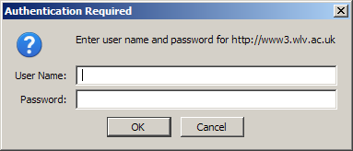
Fig 1.0 – Login dialog box

Within this dialog box enter you University userid and password (e.g. the same as the one used for accessing email.).

NOTE: You may be required to prefix your userid with unv\ or select “UNV” from the domain drop down.

Managing my workload
Please see the “Managing Workload User Guide” for details on managing your own workload.

Freezing/Editing others workload
As a department head it is possible to view, edit and freeze any staff member workload allocation within your department.

When logged into the workload planning system you will be presented with your workload and have a menu on the left hand side of the screen (fig 1.1).

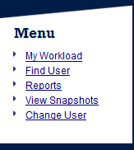
Fig 1.1 – Dept head menu

From this menu select the “Find User” option. You will then be presented with a full list of staff members within your department. From this screen you will be able to search for users, access their workload allocation and view their individual and teaching reports.

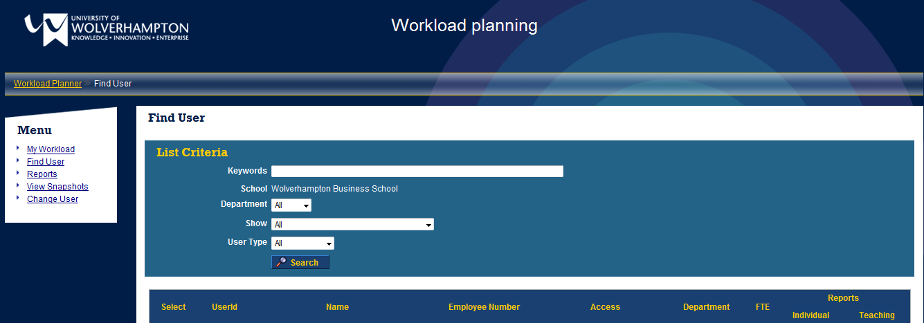
Fig 1.2 – Find User screen

Searching for user
To search for a specific user or group of users you can enter keywords in the “Keywords” text box and/or use the “Show” drop down to filter users on the current status of their workload. When searching using the keyword functionality the system will search forenames, surnames and userid's. It will also match partial words such as entering “smi” will match will match “smith” and “smithers”.

The “Show” drop can used to filter the staff members on the status of their current workload, for example you could find all staff members whose workload has been frozen by them but not by yourself or those that have not been frozen by the staff member yet.

Once you have entered your required criteria click the “Search” button and the staff members matching the criteria will be listed below the “List Criteria” box.

Viewing/Managing a users workload
To view and manage a staff member’s workload see the “Searching for user” section to find the user and then click on the user’s name. This will then take you to that users workload management screen (fig 1.3).

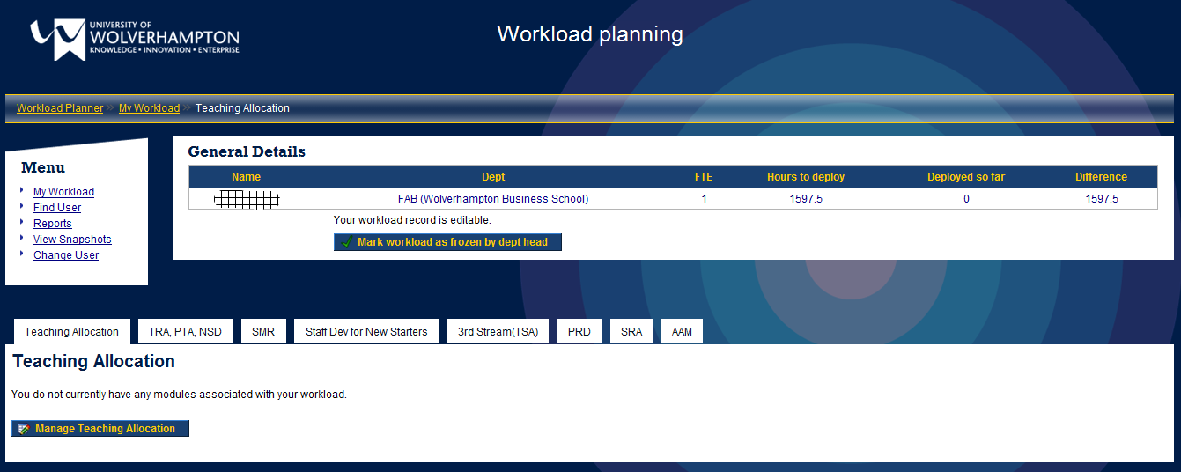
Fig 1.3 – Workload management screen

For further details on how to edit the user’s workload please refer to the “Managing Workload User Guide”.

Freezing the workload
Once you are happy with a user’s workload you can freeze that workload by clicking on the “Mark workload as frozen by dept head”. This will make that user’s workload read only and flag it to the school executive that it is available for final approval.

Unfreezing by school executive
Once school executive have reviewed the workload for the users who have been approved, they may unfreeze a user’s workload and pass it back to the department head for revision. If this happens you will receive an email informing you of this containing the comments/suggestions from school executive. These comments/suggestions are also available for viewing in the general information area of the workload management screen. These workloads can be reviewed as before (as detailed in the above “Viewing/Managing a users workload” section) and then re-frozen using the same mechanism detailed in the “Freezing the workload” section above.

NOTE: If school executive unfreeze a workload it will still remain in a read only state to the staff member and can only be edited by you.

Once in the editing screen select “Find User” from the menu or breadcrumb trail (located under the main banner) to return to find another user.

NOTE: You can freeze a staff member’s workload whether they have frozen it or not.

Viewing reports
There are several reports that are available to the department head. Access to these are available by clicking the “Reports” link in the menu, shown in fig 1.1.

NOTE: To print any report that is displayed on screen use your browsers standard print functionality.

My individual report
This report is your own personal workload allocation record as described in the “Managing Workload User Guide” report section.

Find users individual report
The find users individual report option allows you to locate a user and view and print their personal workload allocation record and teaching module report. When clicking this link you will be presented with the “Find User” screen described in “Freezing/Editing others workload” section.

To view individual’s reports, find the user and then click on the appropriate button.

will display the user’s individual workload allocation report.
will display the user’s individual teaching allocation report

It is also possible to view a selection of user’s workload allocation reports. To do this find the appropriate users and checked the checkbox next to their names. Once you have checked all the users you wish to view, click the “View selected user’s individual reports” button.

All individual reports for school
This option will display the workload allocation reports for all members of your department. The report screen also has the option to filter the staff members by the state of their workload allocation. For example you can view only those that have not yet frozen their workload.

Summary of department workload
This option generates a summary report giving overview figures for all members of staff in your department. The report screen also has the option to filter the staff members by the state of their workload allocation. For example you can view only those that have not yet frozen their workload.

Summary of workloads frozen by user
This option generates a summary report giving overview figures for all members of staff in your department that have frozen their workload. The report screen also has the option to filter the staff members by the state of their workload allocation.

Summary of workloads not frozen by user
This option generates a summary report giving overview figures for all members of staff in your department that have not frozen their workload. The report screen also has the option to filter the staff members by the state of their workload allocation.

Teaching report by staff member
This option generates a report detailing each member of staffs teaching allocation within your department.

Reports by activity
Allows the viewing of details for specific activities (tabs) by user.

Teaching gap report
This report makes it possible to view the gap in teaching allocation and require allocation. It uses the expected students and hours per student to calculate a required number of hours to run the module. It then takes the total hours allocated and determines the difference.

Exporting reports
It is possible to export any report to excel by clicking the “Export to Excel” button within each report.

Snapshots
The workload planning system has the functionality to take snapshots of the data entered. There are two types of snapshots available, mid-term and year-end. You have the ability to review snap shots taken by school administrators.
snapshot” button and the snap shot will be taken.

Reviewing a snapshot
To review a snapshot previously taken select the “View Snapshots” item from the left menu. From here select the snapshot you wish to review. From this screen you will be able to select a user to review their individual and teaching reports. The menu on the right of the screen also generates all the other reports available on the system but only on the snapshot data. For example you are able to generate the individual reports for each user within a given department and export it to excel.

Frequently asked questions

Why can’t I find my a staff member in the list?
If having used the “List Criteria” options detailed in the “Searching for user” section above you are unable to find a user that is in your department please contact your school administration office.

Why can’t I freeze a staff member’s workload?
A workload will appear read only if it has been marked as frozen. This can be done either by yourself clicking the “Mark workload as frozen by dept head” button or by a school administrator. The current status of each workload is shown in the general information area of the screen (see “General Information” section in the “Managing Workload User Guide”).

