

Managing Workload User Guide
Workload Planning

Table of contents
Managing Workload User Guide 1
Table of contents 2
Logging in 3
Managing my workload 4
General information 5
Managing teaching allocation 6
Managing diss/proj, TRA, PTA, NSD 7
Managing SMR 8
Managing Staff dev for new starters 9
Managing 3rd Stream (TSA) 10
Managing PRD 11
Managing SRA 12
Managing AAM 13
Freezing workload 14
Viewing & printing your report 15
School Reports 15
Individual reports. 15
All individual reports within school. 15
Summary of school workload. 15
Teaching report by staff member 16
Teaching report by module 16
Activity Report 16
Exporting reports 16
Snapshots 16
Reviewing a snapshot 16
Frequently asked questions 17
Why is my workload read only? 17
Why do I receive a "403 Unauthorized" unauthorised? 17
Why do I receive a “User not present” message? 17
I work in multiple departments but only one is shown. 17

Logging in
The workload planning system will automatically log you in if you are on campus and using Internet Explorer. If either of these is not the case then you will presented with dialog box (fig 1.0).

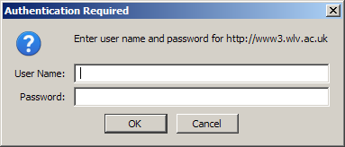
Fig 1.0 – Login dialog box

Within this dialog box enter you University userid and password (e.g. the same as the one used for accessing email.).

NOTE: You may be required to prefix your userid with unv\ or select “UNV” from the domain drop down.

Once successfully logged in you will be presented with one of two screens. If you work solely for one department e.g. Music, then you will taken directly to the managing workload screens (see the “Managing my workload” section). If you work for multiple departments you will be presented with a screen to select which department you would like to manage your workload for (fig 1.1).

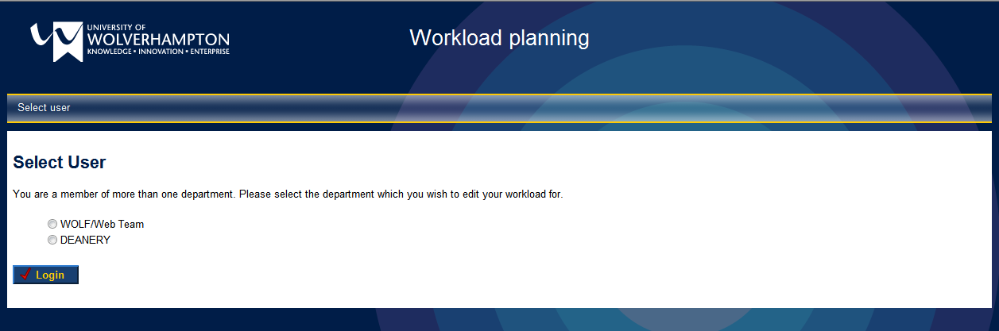
Fig 1.1 – Department selection screen

Once you have selected the appropriate department you will be taken to the managing workload screen (see the “Managing my workload” section)

NOTE: If you work in more than one department and this screen is not shown or a department you are shown is not listed please see the FAQ section.

Managing my workload
Once you have been successfully authenticated you will be presented with the workload management screens in fig 1.2.

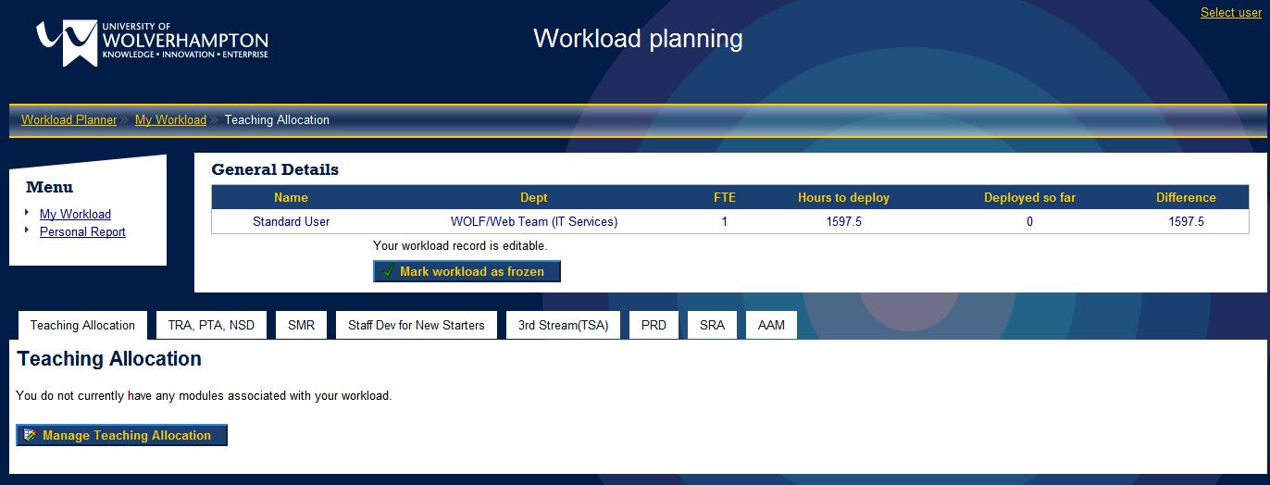
Fig 1.2 – Workload management screen.

From here you can manage all aspects of your workload as well as view and print a personal workload allocation report. You will also be able to view all reports within your school.

To manage the individual aspects of your workload select the appropriate tab, as shown in fig 1.2. The below sections contain details on managing your workload using this system.

The menu on the left of the screen shown in fig 1.2 allows you to navigate between managing your workload and viewing your individual report (see “Viewing report” for more detail).

NOTE: Navigating away from a tab before saving any changes made will mean that those changes will be lost.

General information
When managing your workload the general information at the top of the screen (fig 1.3) gives both personal data and an overview of the total hours you can deploy, the hours already deployed and the remaining hours left to deploy.

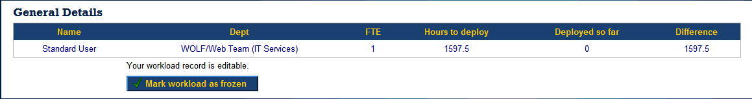
Fig 1.3 – General Information

The text at the bottom of the general information section details the current state of you workload. The various states are detailed below:

- Your workload record is editable: Your workload is currently available for editing by yourself
- Your workload record is in the process of being approved by your department head: Your workload has been frozen and is being approved by your department head.
- Your workload record has been approved by you department head and is in the process of being approved by your school executive: You workload has been approved by your department head and is being approved by school executive.
- Your workload record has been approved by your school executive: Your workload has now been approved by school executive.

NOTE: For information on the “Mark workload as frozen” button see the “Freezing workload” section.

Managing teaching allocation
The first screen displayed when selecting the “Teaching Allocation” tab shows the current teaching workload in a read only view with totals. To update your teaching allocation, click the “Manage Teaching Allocation” button. This will then display edit screen shown in fig 1.4.

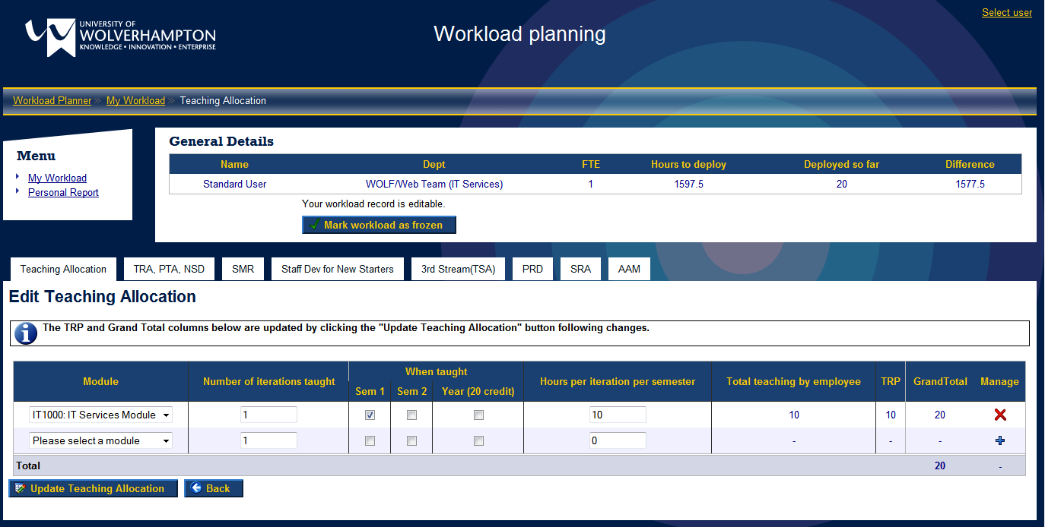
Fig 1.4 – Edit teaching allocation screen.

The “Back” button shown on this screen will take you back to the read only view of your teaching allocation.

Adding a module
To add a module to your teaching allocation select the module from the list box which displays the text “Please select a module” (the last row in the table). Once this is selected enter the remaining data in the appropriate columns. When you have entered the information for this module, click in the button in the “Manage” column. This will save the information and update the totals in the general information section.

NOTE: You must select at least one semester that the module runs in.

Editing a module
To edit a module that is already present in your allocation, find the module in the list and edit the information required. Once you have made all of the changes you require click the “Update Teaching Allocation” button. This will save the information and update the totals in the general information section.

HINT: You can edit as many modules as you like before clicking the update button.

NOTE: You must select at least one semester that the module runs in.

Removing a module
To remove a module from your teaching allocation find the module you wish to remove and click the appropriate button. This will remove the module from your allocation and update the totals shown in the general information area.

NOTE: Once you have removed the module it can not be recovered and must be added again if required (see the “Adding a module” section).

Managing diss/proj, TRA, PTA, NSD

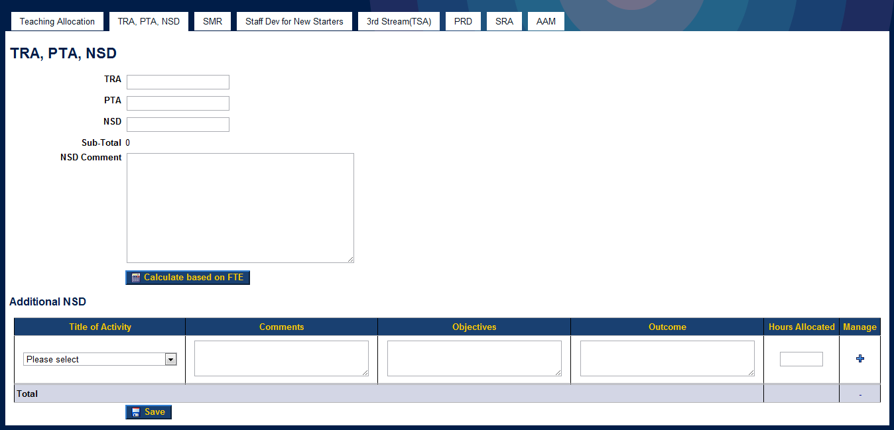
Fig 1.5 – Diss/Proj, TRA, PTA NSD screen

To enter custom values enter the number of hours in the appropriate fields and click the “Save” button. The system can automatically calculate values based on your FTE, to do this click on the “Calculate based on FTE” button. As with the “teaching allocation” screen altering these figure will update the general information section.

It is also possible to enter “additional NSD” activities using the activity drop downs.

NOTE: When entering values into the fields they must be entered in hours, with decimal places being accepted for parts of hours (e.g. 1.5 = 1hr 30mins).

NOTE: Clicking the “Calculate based on FTE” button will also save these values as well as calculate them.

Managing SMR
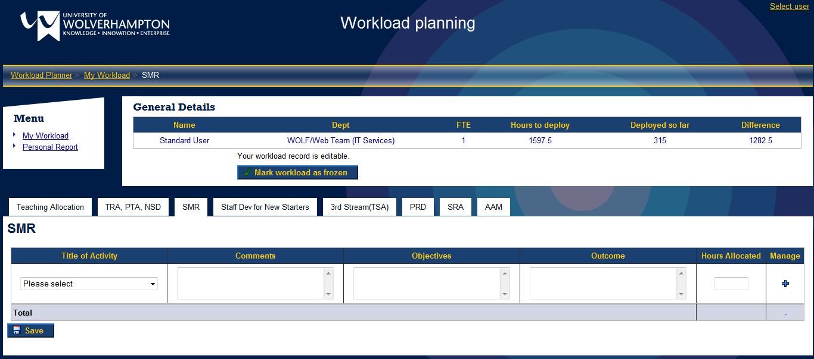
Fig 1.6 – SMR screen

Please see the below sections for adding, editing and removing activities from your SMR workload.

NOTE: All of the fields on the SMR screen are mandatory.

Adding Activity
To add an SMR activity to you workload allocation, select the title of activity from the list box which displays the text “Please select” (the last row in the table). Then enter your comments, objectives, outcome and the hours allocated to the activity in the appropriate fields. Once these values have entered click on the button to add the activity.

NOTE: When entering a value into the “Hours Allocated” column it must be entered in hours, with decimal places being accepted for parts of hours (e.g. 1.5 = 1hr 30mins).

Editing Activity
To edit an SMR activity already present in your workload allocation, find the activity in the table you wish to edit and change its values. Once you are happy with the changes click the “Save” button under the table. This will save the changes and update the general information at the top of the screen.

HINT: You can edit as many activities as you like before clicking the update button.

Removing Activity
To remove an activity from your SMR record find the activity you wish to remove and click the appropriate button. This will remove the activity from your allocation and update the totals shown in the general information area.

NOTE: Once you have removed the activity it can not be recovered and must be added again if required (see the “Adding activity” section).

Managing Staff dev for new starters
This tab allows the managing of staff development for new starters (fig 1.7).

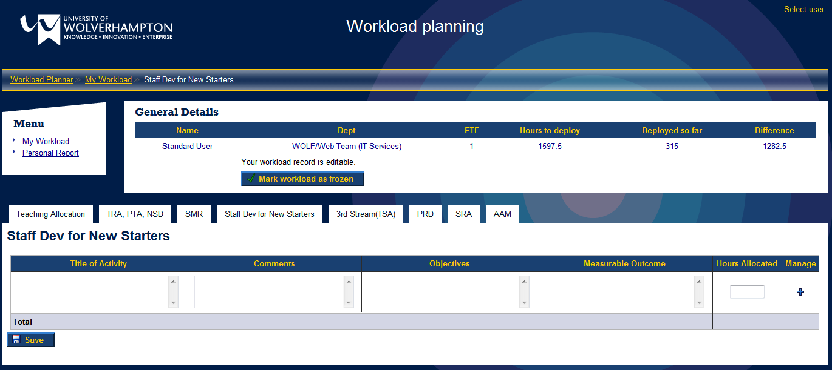
Fig 1.7 – Managing staff development for new starters

Please see the below sections for adding, editing and removing activities from your workload allocation.

NOTE: All of the fields on the Staff dev for new starters screen are mandatory.

Adding Activity
To add a Staff dev for new starter’s activity to you workload allocation, select the title of the activity. Then enter your comments, objectives, outcomes and the hours allocated to the activity in the appropriate fields. Once these values have entered click on the button to add the activity.

NOTE: When entering a value into the “Hours Allocated” column it must be entered in hours, with decimal places being accepted for parts of hours (e.g. 1.5 = 1hr 30mins).

Editing Activity
To edit a Staff dev for new starter’s activity already present in your workload allocation, find the activity in the table you wish to edit and change its values. Once you are happy with the changes click the “Save” button under the table. This will save the changes and update the general information at the top of the screen.

HINT: You can edit as many activities as you like before clicking the update button.

Removing Activity
To remove an activity from your Staff dev for new starter’s record find the activity you wish to remove and click the appropriate button. This will remove the activity from your allocation and update the totals shown in the general information area.

NOTE: Once you have removed the activity it can not be recovered and must be added again if required (see the “Adding activity” section).

Managing 3rd Stream (TSA)
This tab allows the managing of the 3rd stream (TSA) activities (fig 1.8).

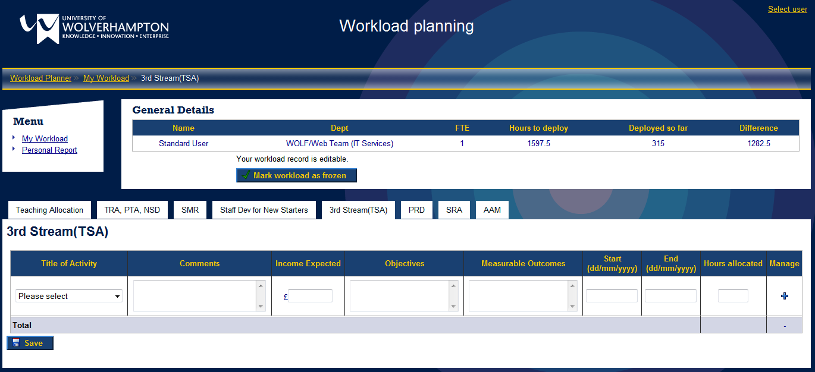
Fig 1.8 – 3rd Stream (TSA) activity manager

Please see the below sections for adding, editing and removing activities from your workload allocation.

NOTE: All of the fields except for “Start” on the 3rd stream (TSA) screen are mandatory.

Adding Activity
To add a 3rd stream (TSA) activity to you workload allocation, select the title of activity from the list box which displays the text “Please select” (the last row in the table). Then enter your comments, income, objectives, outcomes, start, end and the hours allocated to the activity in the appropriate fields. Once these values have entered click on the button to add the activity.

NOTE: When entering a value into the “Hours Allocated” column it must be entered in hours, with decimal places being accepted for parts of hours (e.g. 1.5 = 1hr 30mins).

NOTE: When entering a value for the “Income expected” column the system expects a numerical value with up to two decimal places if required. The system will accept “,” in this value, but will remove them when saving the data.

Editing Activity
To edit a 3rd stream (TSA) activity already present in your workload allocation, find the activity in the table you wish to edit and change its values. Once you are happy with the changes click the “Save” button under the table. This will save the changes and update the general information at the top of the screen.

HINT: You can edit as many activities as you like before clicking the update button.

Removing Activity
To remove an activity from your 3rd stream (TSA) record find the activity you wish to remove and click the appropriate button. This will remove the activity from your allocation and update the totals shown in the general information area.

NOTE: Once you have removed the activity it can not be recovered and must be added again if required (see the “Adding activity” section).

Managing PRD

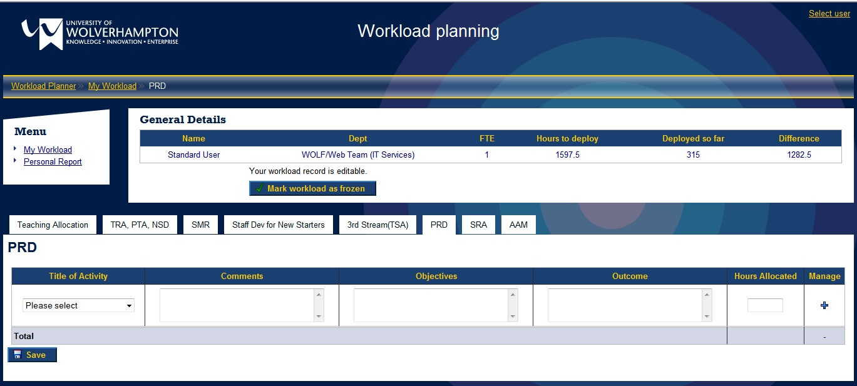
Fig 1.9 – Managing PRD workload screen

Please see the below sections for adding, editing and removing activities from your PRD workload.

NOTE: All of the fields on the PRD screen are mandatory.

Adding Activity
To add a PRD activity to you workload allocation, select the title of activity from the list box which displays the text “Please select” (the last row in the table). Then enter your comments, objectives, outcomes and the hours allocated to the activity in the appropriate fields. Once these values have entered click on the button to add the activity.

NOTE: When entering a value into the “Hours Allocated” column it must be entered in hours, with decimal places being accepted for parts of hours (e.g. 1.5 = 1hr 30mins).

Editing Activity
To edit a PRD activity already present in your workload allocation, find the activity in the table you wish to edit and change its values. Once you are happy with the changes click the “Save” button under the table. This will save the changes and update the general information at the top of the screen.

HINT: You can edit as many activities as you like before clicking the update button.

Removing Activity
To remove an activity from your PRD record find the activity you wish to remove and click the appropriate button. This will remove the activity from your allocation and update the totals shown in the general information area.

NOTE: Once you have removed the activity it can not be recovered and must be added again if required (see the “Adding activity” section).

Managing SRA

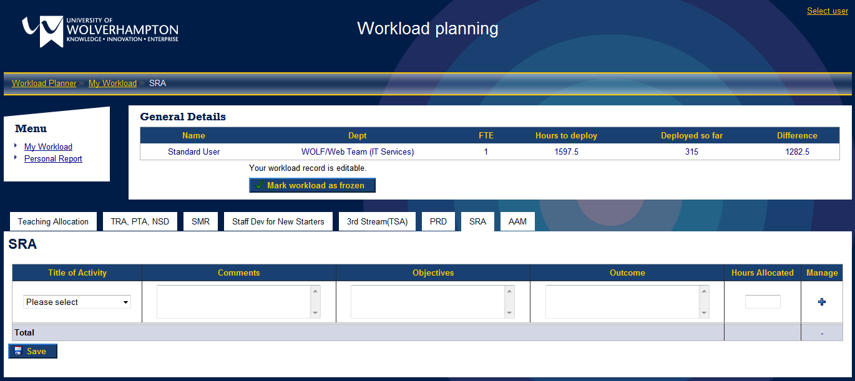
Fig 2.0 – Managing SRA workload screen

Please see the below sections for adding, editing and removing activities from your SRA workload.

NOTE: All of the fields on the SRA screen are mandatory.

Adding Activity
To add an SRA activity to you workload allocation, select the title of activity from the list box which displays the text “Please select” (the last row in the table). Then enter your comments, objectives, outcomes and the hours allocated to the activity in the appropriate fields. Once these values have entered click on the button to add the activity.

NOTE: When entering a value into the “Hours Allocated” column it must be entered in hours, with decimal places being accepted for parts of hours (e.g. 1.5 = 1hr 30mins).

Editing Activity
To edit an SRA activity already present in your workload allocation, find the activity in the table you wish to edit and change its values. Once you are happy with the changes click the “Save” button under the table. This will save the changes and update the general information at the top of the screen.

HINT: You can edit as many activities as you like before clicking the update button.

Removing Activity
To remove an activity from your SRA record find the activity you wish to remove and click the appropriate button. This will remove the activity from your allocation and update the totals shown in the general information area.

NOTE: Once you have removed the activity it can not be recovered and must be added again if required (see the “Adding activity” section).

Managing AAM

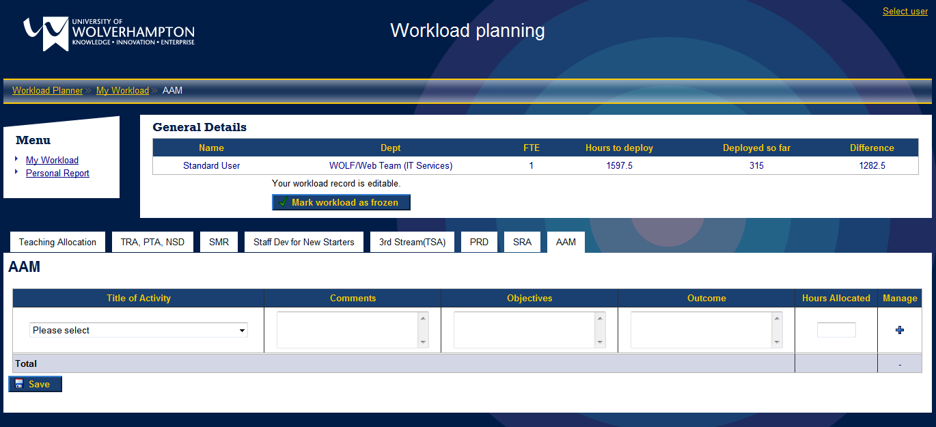
Fig 2.1 – Managing AAM workload screen

Please see the below sections for adding, editing and removing activities from your SRA workload.

NOTE: All of the fields on the AAM screen are mandatory.

Adding Activity
To add an AAM activity to you workload allocation, select the title of activity from the list box which displays the text “Please select” (the last row in the table). Then enter your comments, objectives, outcomes and the hours allocated to the activity in the appropriate fields. Once these values have entered click on the button to add the activity.

NOTE: When entering a value into the “Hours Allocated” column it must be entered in hours, with decimal places being accepted for parts of hours (e.g. 1.5 = 1hr 30mins).

Editing Activity
To edit an AAM activity already present in your workload allocation, find the activity in the table you wish to edit and change its values. Once you are happy with the changes click the “Save” button under the table. This will save the changes and update the general information at the top of the screen.

HINT: You can edit as many activities as you like before clicking the update button.

Removing Activity
To remove an activity from your AAM record find the activity you wish to remove and click the appropriate button. This will remove the activity from your allocation and update the totals shown in the general information area.

NOTE: Once you have removed the activity it can not be recovered and must be added again if required (see the “Adding activity” section).

Freezing workload
Once you have completed entering details of your workload, you must mark it as frozen by clicking the “Mark workload as frozen” button under the general information area.

Marking your workload as frozen will flag it as now ready for your head of department to approve and update the status displayed in the general information area (see “General Information” section for more detail). It will also make your workload allocation read only meaning that no more changes can be made by you.

NOTE: Department heads and administrative staff can also mark your workload as frozen if required.

Viewing & printing your report
To view you a printable report of your personal workload allocation record click the “Personal Report” item located in the menu on the left of the screen. This will generate a report detailing your workload that the system currently holds (fig 2.2).

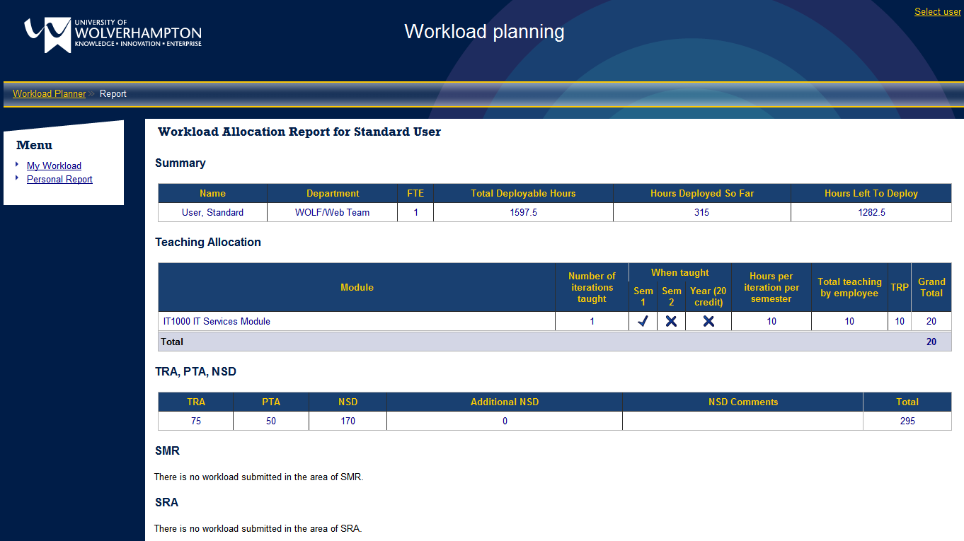
Fig 2.2 – Workload allocation report

To print this report use you browser standard print functionality.

NOTE: The print out will not contain the menu or any other navigation and will only contain the report.

School Reports
Reporting is now available to all users within your school. This gives everyone the ability to view all others workload allocations. To access the reports select the “Reports” item located in the menu on the left of the screen. You will then be presented with a list reports available:

Individual reports.
This report gives you the ability to view all individual and teaching reports for specific users are groups of users. The results can be filtered by department, current workload status and user type (establishment or VL).

All individual reports within school.
This report displays the individual reports for all the users within the school. The users reports are ordered by department and then user surname. This can be filtered by choosing a department and a user type (see managing users for more information on user types).

Summary of school workload.
This report gives an overview of the schools workload by user. By default the report will show all users within the school. This can be filtered by choosing a department and/or the current status of the workload. For example you could find all workloads that have not yet been frozen by the department head across the whole school.

Teaching report by staff member
This reports details the teaching commitment for each member of staff within a given department or across the whole school. By default the report will show all users within the school. This can be filtered by choosing a department and a user type.

Teaching report by module
This reports details the teaching commitment by module within a given department or across the whole school. By default the report will show all modules within the school. This can be filtered by choosing a department and a user type.

Activity Report
This report details the workload allocated by activity type. For example, it will generate a report of all the activities and allocated workload for AAM. This can be filtered by choosing a department and a user type.

Exporting reports
It is possible to export any report to excel by clicking the “Export to Excel” button within each report.

Snapshots
The workload planning system has the functionality to take snapshots of the data entered. There are two types of snapshots available, mid-term and year-end. You have the ability to review snap shots taken by school administrators.
snapshot” button and the snap shot will be taken.

Reviewing a snapshot
To review a snapshot previously taken select the “View Snapshots” item from the left menu. From here select the snapshot you wish to review. From this screen you will be able to select a user to review their individual and teaching reports. The menu on the right of the screen also generates all the other reports available on the system but only on the snapshot data. For example you are able to generate the individual reports for each user within a given department and export it to excel.

Frequently asked questions

Why is my workload read only?
Your workload will appear read only if it has been marked as frozen. This can be done either by yourself clicking the “Mark workload as frozen” button or by your department head or a school administrator. The current status of you workload is shown in the general information area of the screen (see “General Information” section).

Please contact your department head if you require more detail.

Why do I receive a "403 Unauthorized" unauthorised?
This means that the credentials you have entered to access the system are incorrect or your IT account has been locked.

Please close all browser windows and try again. If the problem persists please contact the ITS Service Desk on ext: 2000.

Why do I receive a “User not present” message?
If you receive this message you have not been correctly added to the system.

Please contact your school administrative department.

I work in multiple departments but only one is shown.
If all of the departments you work in are not shown, please content your school administrative department.

