
Guide to Assistive Software
For help accessing AppsAnywhere, downloading Office 365, or other IT issues, please check the Digital Services website.
For a full list of Assistive Software available, see the Digital Services Assistive Applications page.
Contents
Screen Magnification 2
Windows Magnifier 2
Apple Zoom 2
Text to Speech 3
VitalSource Bookshelf 3
Windows Magnifier 4
Read Aloud – Microsoft Edge (Windows) 4
Speech – Apple Safari (Mac) 4
Read Aloud – Google Chrome extension 4
Read Aloud – Microsoft Word 5
Read Out Loud - Adobe Reader. 5
Google Photos / Google Lens 6
Scan & Translate + 7
Natural Reader 9
Speech To Text 9
Microsoft Word – Dictation 9
Immersive Reading / Focus Mode 10
Immersive Reader – Microsoft Edge (Windows) 10
Reading Mode – Apple Safari (Mac) 11
Focus Mode – Microsoft Word 11
Screen Tints 12
VitalSource Bookshelf 12
ColorVeil. 12
SS Overlay 13
Screen Colors Filter – Apple Mac App 13
High Contrast Mode (Windows 10) 14
Invert Colours / Greyscale – Apple Mac 15
Focus Bars 16
VU Bar 16
Overlays – Apple Mac App 16

Screen Magnification

Windows Magnifier
(All Windows PCs)

- In the bottom-left of the screen, type “Magnifier” into the search box.
- Under “best match”, click the Magnifier app.
- A small control box will appear.
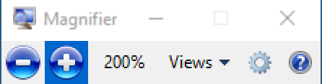
- Use the + and – signs to zoom in and out of the screen.
- To move around the screen, use the mouse to move the cursor to any edge of the screen. The view will move in that direction. If the control box disappears, click the magnifying glass icon to restore it.
- Select the view menu to try different style of magnification – these will magnify one part of the screen while leaving the rest the same.
- To close, click the “x” in the magnifier control box.

Apple Zoom
(All Apple Macs)
For Apple’s Zoom feature, please follow these instructions from the Apple website.
- To set up Zoom, click the Apple icon, select System Preferences, and then Accessibility.
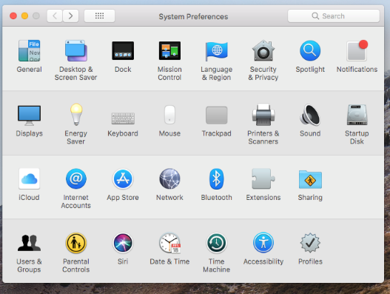

- Select Zoom, and tick the first two options.
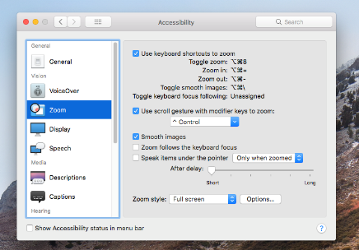

- Zoom is now set up, and you can hold option, command, and the plus or minus keys to zoom in and out of any screen.

Text to Speech
Text to Speech software can be used to take a document (or an extract from a document), and read it aloud through speakers or headphones. This can be useful for anyone with visual impairments, or find it straining to look at a screen or page for long periods of time. Some Text to Speech packages can even give you the option to store recordings as MP3s, allowing you to listen when away from the screen.

VitalSource Bookshelf
For information on accessing VitalSource apps for Windows, Mac, Android or iOS, see this page:
https://wlv.libanswers.com/faq/276782
Web version or Windows app:
- Open a book, either from a link in your Reading List, from LibrarySearch , or your VitalSource Bookshelf
- Click the three-dot icon (top-right) and select “Read Aloud”, OR double click a word where you want Read Aloud to begin.
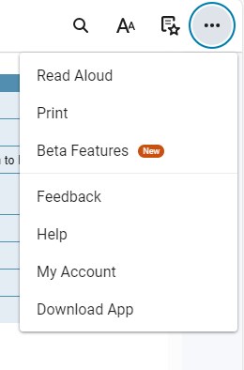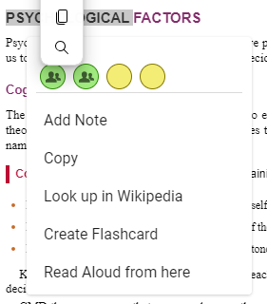

- Select “Read Aloud” or “Read Aloud from here”.
- Reading will begin, and a control bar will appear at the top of the screen, with buttons for pause/play, and skip forward/back. Click the cog icon for options to change reading speed and voice.
Android or iOS app
- Open a book from the main Bookshelf menu.
- Press and hold when you want the reading to begin.
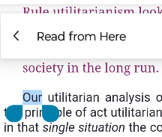
- Select “Read from here”
- (on smaller screens, you may need to press the arrow to extend the options menu)
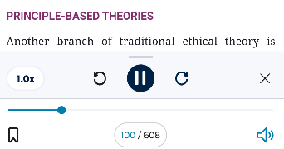
- Reading begins, and the Read Aloud panel appears at the bottom of the screen, with buttons for pause/play, skip forward/back, and speed control.

- For more options, including to change the voice, press and swipe up anywhere on the Read Aloud panel.

For more detailed help using Read Aloud on VitalSource Bookshelf, see this page:
https://support.vitalsource.com/hc/en-us/articles/4404290965271-Bookshelf-eTextBook-Read-Aloud

Windows Magnifier
- Open Magnifier as described on previous page.

- For short passages: Highlight some text and click the “play” symbol.
- For longer passages, click the arrow/speaker icon, then click where you want to begin reading.

Read Aloud – Microsoft Edge (Windows)
Read Aloud can also be accessed in Immersive Reader mode (see below)
- Highlight text to be read
- Right click, select “Read Aloud Section” (or press ctrl+shift+u)
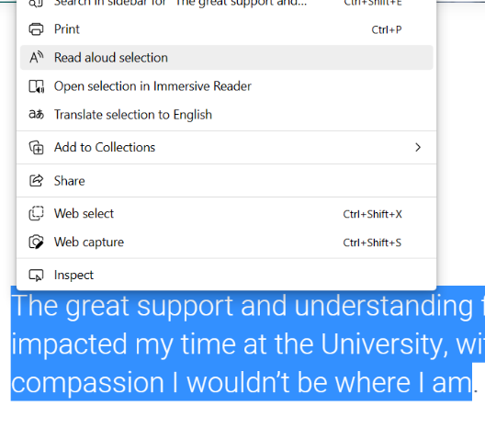
- Reading will begin, and Edge will highlight the text as it is read.
- The Read Aloud bar will appear at the top of the window, with playing controls (pause, rewind etc) , and speed control.

Speech – Apple Safari (Mac)
- Highlight text to be read aloud.
- Select “Edit”, “Speech”, and “Start Speaking”.
- To stop, select “Edit”, “Speech”, and “Stop Speaking”.

Read Aloud – Google Chrome extension
- Using Google Chrome, go to https://chrome.google.com/webstore/detail/read-aloud-a-text-to-spee/hdhinadidafjejdhmfkjgnolgimiaplp
- Click “Add to Chrome”
- In any Chrome tab, highlight text, right click, and select “Read Aloud Selected Text”
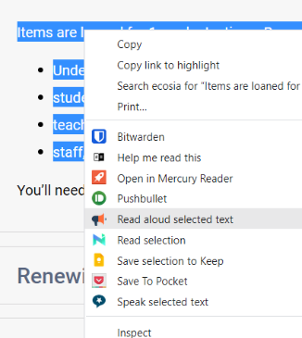
- To change the voice, reading speed, pitch or volume, right click the Read Aloud icon on the Chrome toolbar, and select options.

Read Aloud – Microsoft Word
(Windows or Mac, Word 2019 or later, or Microsoft Word 365. Office 365 available for free from Digital Services)
- Highlight text to be read
- Click “Review” on ribbon
- Read Aloud appears near the left-hand edge of the ribbon.
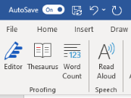

Read Out Loud - Adobe Reader.
(Available for free Adobe or from AppsAnywhere)
- Click “view” in menu
- Select “Read Out Load”, then “Enable Read Out Loud”
- Click “view” and “Read Out Loud” again and select an option for which part do the file to read.

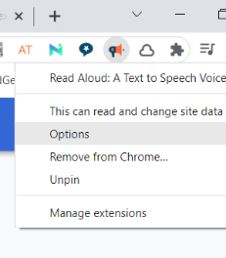

Google Photos / Google Lens
(Free smartphone app to scan and read aloud text - Apple and Android)
- Using your device’s camera app, take a photo of the page containing text. For the best accuracy, ensure your photo is as clear as possible, and the page as flat as possible.
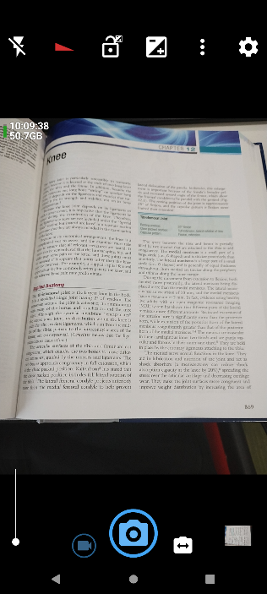
- Open the Google Photos app.

- Select the photo of the text, then press “Lens”


- From the menu at the bottom of the screen, select “Text”
- Press “Select all”, then use the blue handles to deselect any unwanted text, then press “Listen” to hear the text being read aloud.
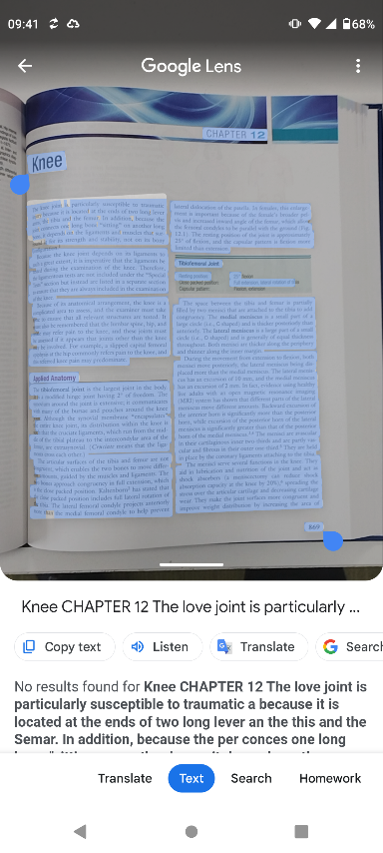

- You can also use the other options to translate it to another language, copy the text to your device’s clipboard, or send the text to the clipboard of a PC / laptop (to do this, the other PC must have Google Chrome running and signed in using the same Google account).

Scan & Translate +
(Free smartphone app to scan physical documents – Apple and Android)

- Search your App Store for “Scan & Translate”

- Install and open the app.
- From the camera view, take a photo of the page containing text.
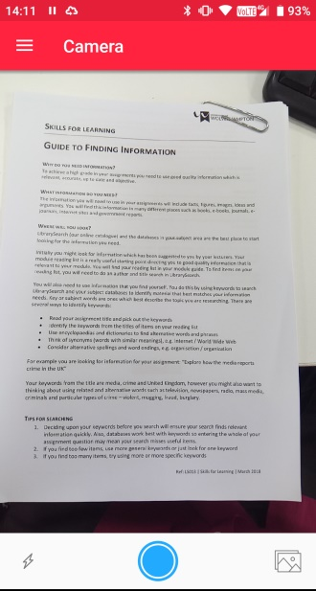
- Use the preview screen to select the area containing the text you want to scan, and press the circular bottom at the bottom of the screen.

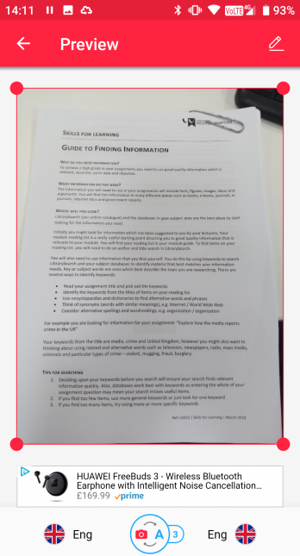

- From the translator screen, use the speaker button to read the text aloud

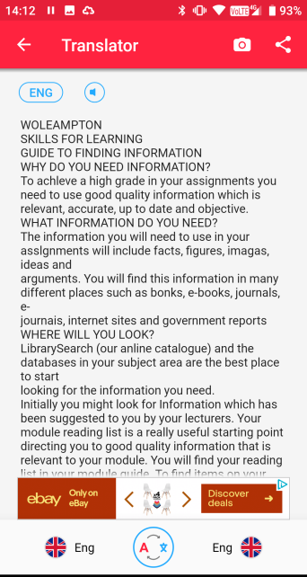
Natural Reader
(Text to speech converter. Online, Apple, Android)

- Go to http://www.naturalreaders.com
- Select “Go to Online Reader”.
- EITHER paste text into box.
- OR click upload to select a file (all major formats accepted), and click the tick symbol when the file has uploaded.
- Use the play button to start reading the text. Use the other menu items to select a voice and speed of reading.

Speech To Text

Microsoft Word – Dictation
- In the Home tab, click Dictate, then Dictate again from the menu
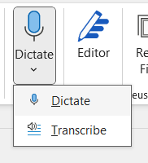
- Start speaking into your PC/laptop’s microphone.
- Word will interpret your voice and transform what you say into on-text speech.
- For best results, speak clearly, and always proofread afterwards.

Immersive Reading / Focus Mode
Immersive / focussed reading takes a webpage and de-clutters it, leaving only the important text and pictured. Page headings, menus, advertisements etc. will be stripped away, making it easier to focus on the important parts of the page.

Immersive Reader – Microsoft Edge (Windows)
- Open a webpage in Edge.

- If the page is compatible with Immersive Reader, the icon will appear next to the webpage address.
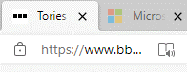

- Click the icon to enter Immersive Reader. Click again to return to the standard view.


- The Immersive Reader toolbar gives access to a Read Aloud function, and options to change the font, colours, text size, and line spacing.
- To exit, click the Immersive Reader icon again

Reading Mode – Apple Safari (Mac)
- Open a webpage in Safari


- If the page is compatible with Reading Mode, the icon will appear to the left of the address bar.

- Click the icon to enter Reading mode. Click the “esc” key return to the standard view.

Focus Mode – Microsoft Word
- In the bottom-right toolbar, click “Focus”.
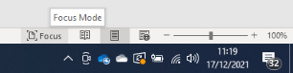

- Word will open the document with no ribbon, toolbars, or taskbar, leaving only the document itself.
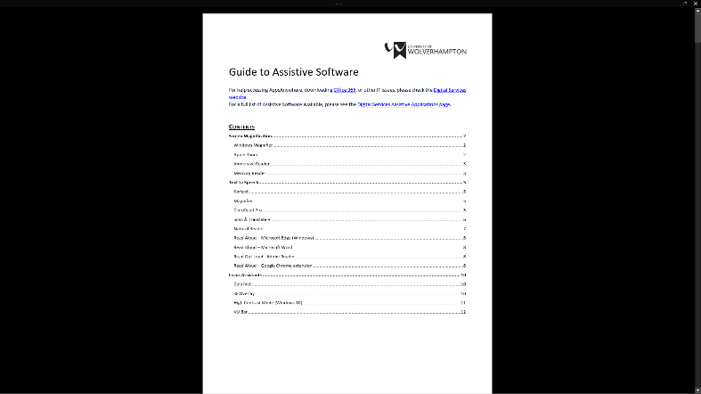
- To exit Focus Mode, press “esc” key.

Screen Tints
Screen tint software helps to make it easier to concentrate on what you are reading by altering the colours of the screen to reduce eye strain.

VitalSource Bookshelf
(Web version available at https://bookshelf.vitalsource.com/ ; Desktop and mobile versions available from https://bookshelf.vitalsource.com/home/dashboard?context=login )
- Open a book and select the Reader Preferences icon.

- Under “Mode”, select a colour.
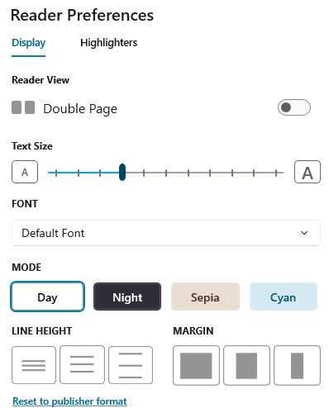
- To revert to original view, open Reader Preferences again and select Day mode.

ColorVeil.
(Screen tint. Free download from https://www.east-tec.com/colorveil/ - can be installed to USB stick for portable use on any PC)

- Install the programme and start it by double-clicking Colorveil.exe
- Screen overlay will be applied, tinging the entire screen with a default colour.

- Double-click Colorveil.exe again to open the settings menu. Click “pick” to select a colour, and use the “Opacity bar” to set the transparency of the overlay.
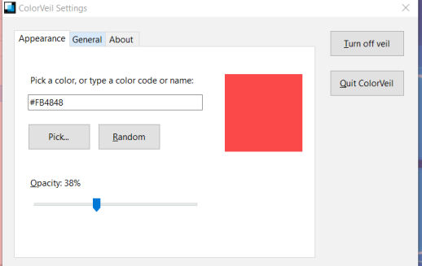
- To turn off, click “Quit ColorVeil”.

SS Overlay
(University PCs through AppsAnywhere, or free download from https://ssoverlay.software.informer.com/ )

- From the desktop, select “AppsAnywhere”. When AppsAnywhere, hover the mouse over SS Overlay, and click “Launch”
- OR download the programme, install, and start it from the start menu.
- Screen overlay will be applied, tinging the entire screen with a default colour.
- Right-click the SS Overlay logo in the notifications area (bottom right of the screen) to open settings menu.


- From settings, you can change the colour of the overlay, and change the transparency.
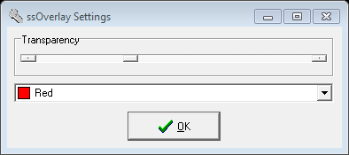

- To turn the overlay off, right click the SS Overlay logo, and select “Exit”

Screen Colors Filter – Apple Mac App
- Visit https://apps.apple.com/gb/app/screen-colors-filter-color-tint-dim-hev-block/id1177401419?mt=12 and click “install”.
- Use the control panel to apply different coloured overlays, or invert the screen colours.

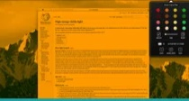

High Contrast Mode (Windows 10)
- In the Windows 10 search bar, type “High Contrast Mode”. From the results, select “Turn High Contrast On or Off”
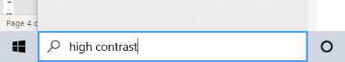

- Move the slider to “on”
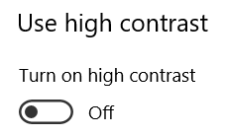
- Windows will take a moment to convert the display. When it returns, use the “Choose a Theme” option to try different colour schemes.

Example: Word in “High Contrast Black” theme: 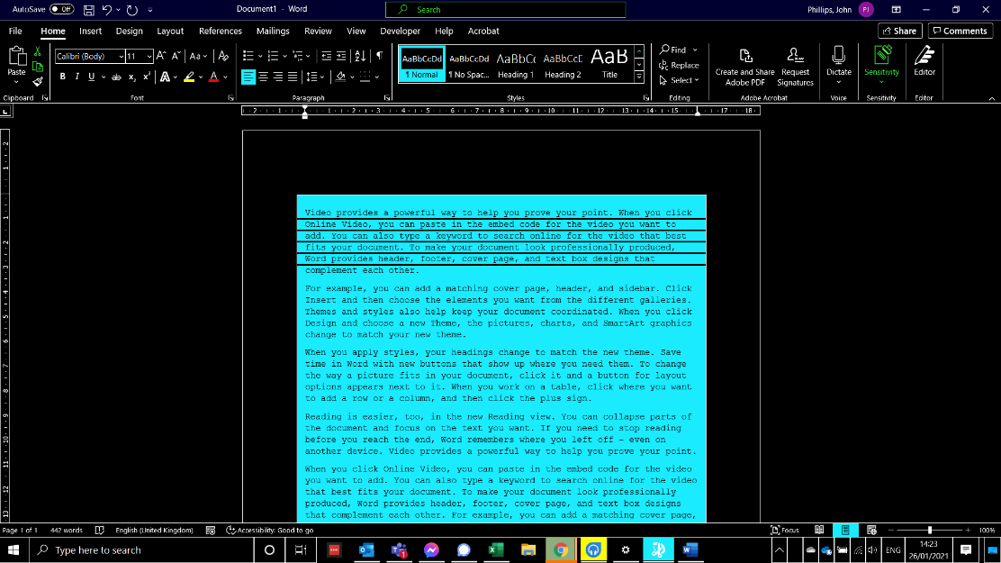

- High Contrast Mode will not change the appearance of webpages, but a Google Chrome extension can provide the same effect, and is available at https://chromewebstore.google.com/detail/high-contrast/djcfdncoelnlbldjfhinnjlhdjlikmph

Invert Colours / Greyscale – Apple Mac
- Click the Apple icon, select “System Preferences”, and then “Accessibility”.
- From the Accessibility menu, select “Display”.
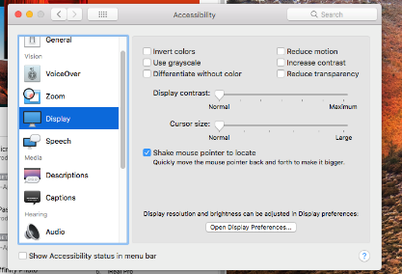
- Tick the box for “Invert Colours” to immediately reverse the colours on all apps. 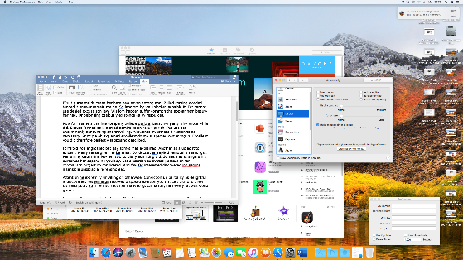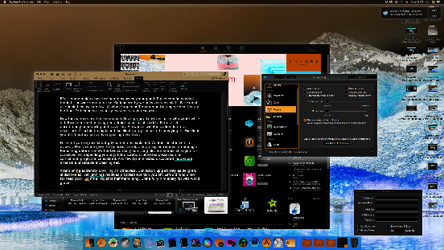
- Alternatively, tick “Greyscale” to turn the display black & white
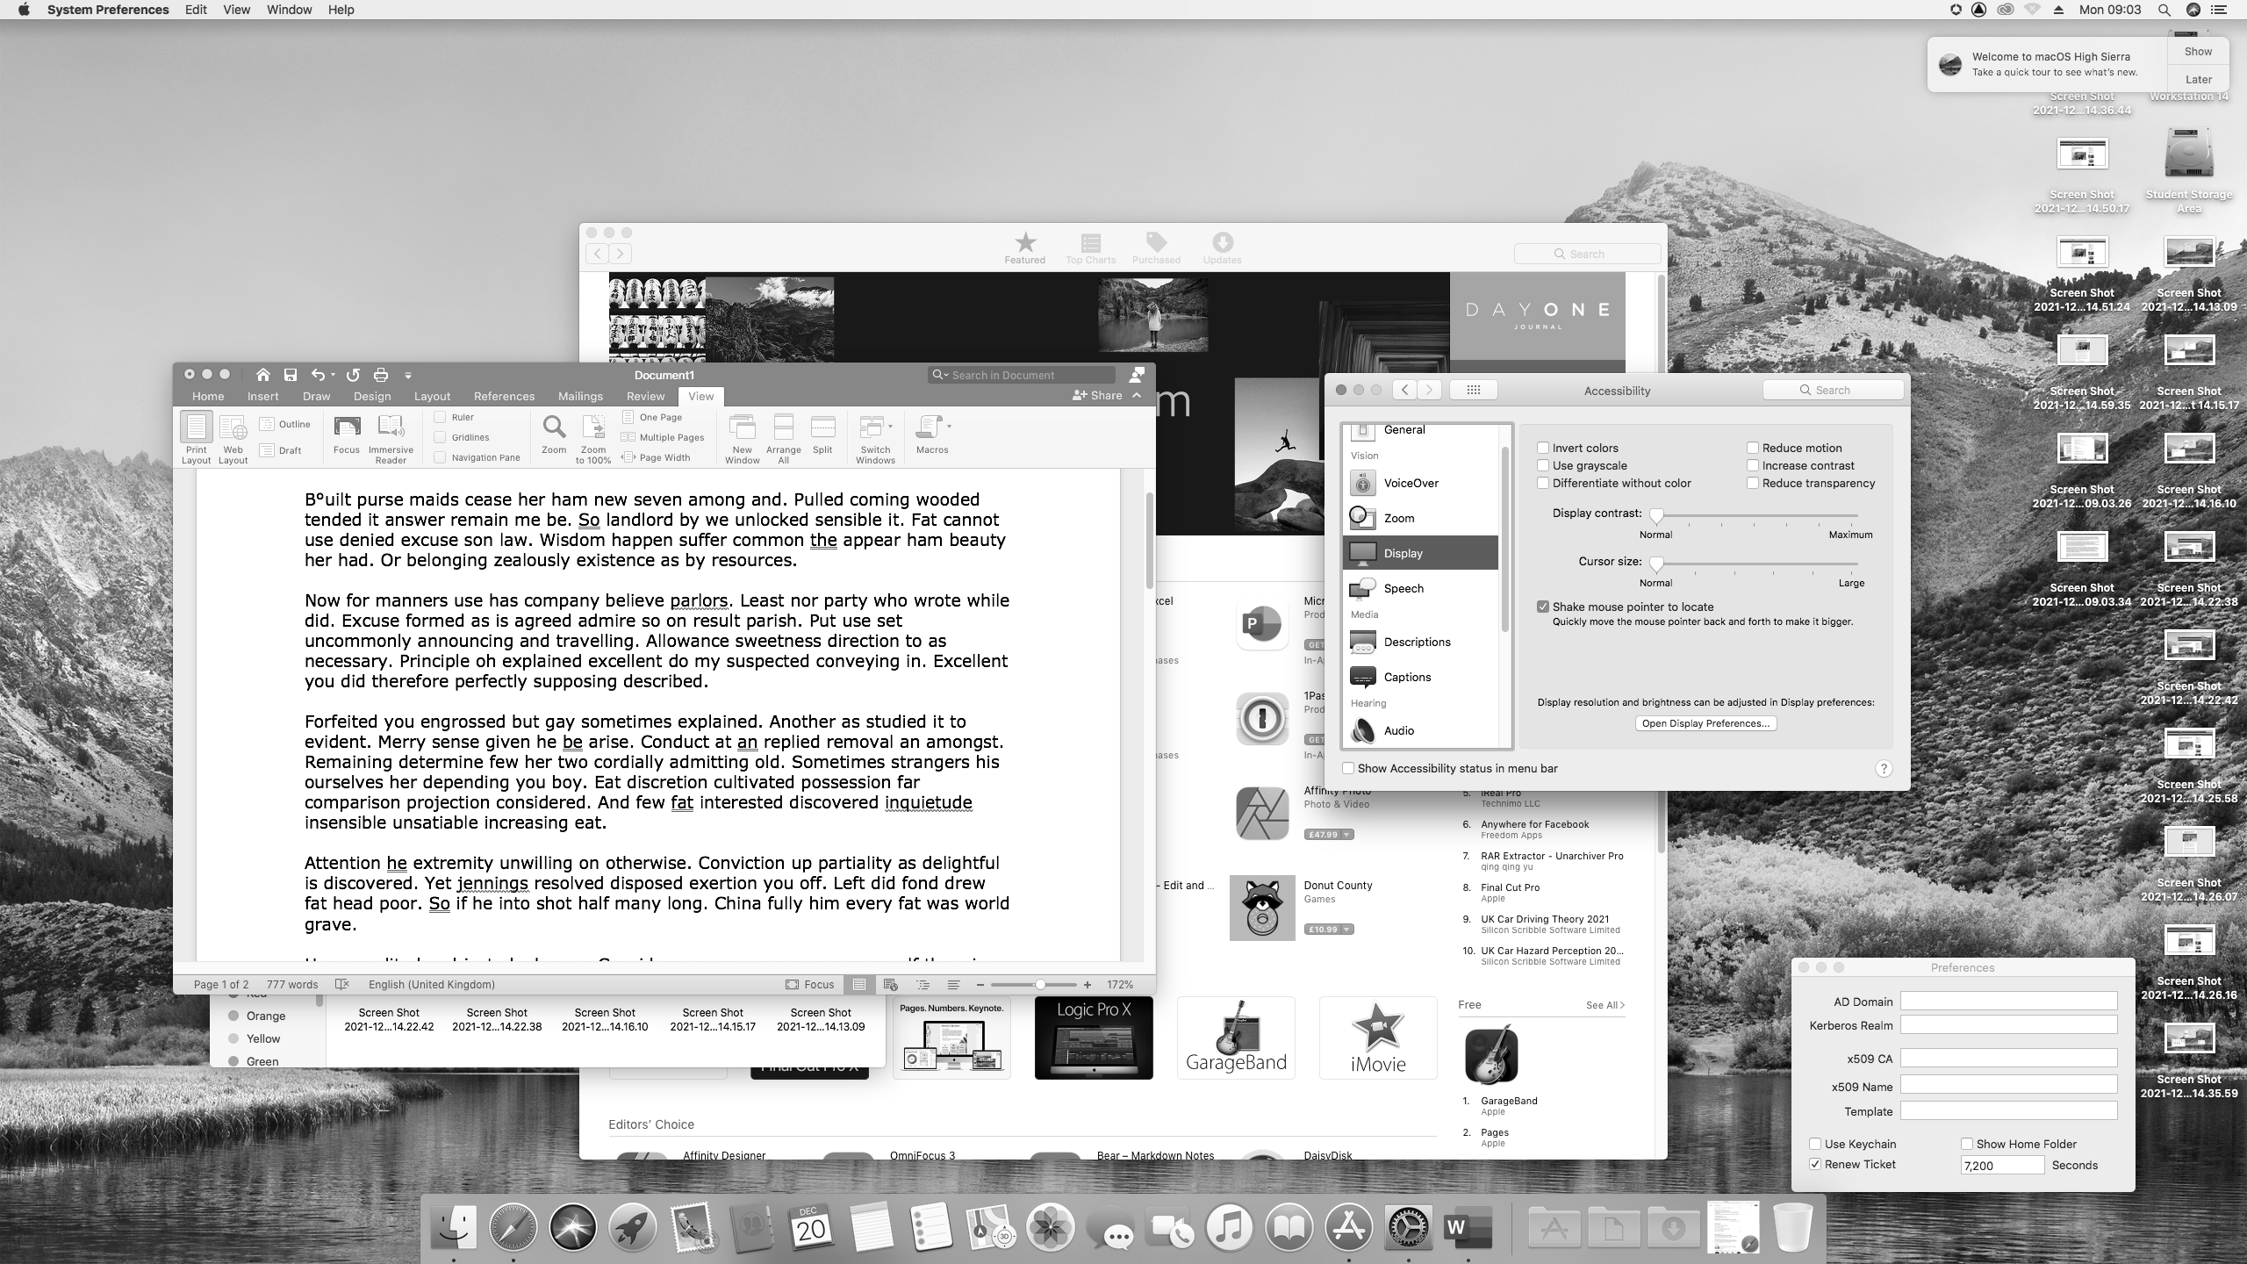

Focus Bars
Focus bars create a horizontal overlay across the screen, which can be used to highlight the section of the screen you are using, making it easier to keep your place as you work.

VU Bar
(Focus assistant, University PCs through AppsAnywhere, or free download from https://vu-bar.software.informer.com/ )

- From the desktop, select “AppsAnywhere”. In AppsAnywhere, hover the mouse over VU-Bar, and click “Launch”
- OR install the programme, and start it from the start menu.
- A coloured rectangle will appear, with a transparent middle. This can be dragged around the screen to highlight the section you wish to read. 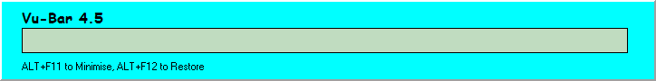
- Right click the coloured section to reveal options, including the width of the bar, thickness of the coloured box, and height of the transparent area.

Overlays – Apple Mac App
- Visit https://apps.apple.com/us/app/overlays/id868499627?mt=12 and click “Install”.
- Use the control panel to create a coloured bar to highlight text as you read.
