

Skills for Learning
Guide to Accessing and
Searching Google Scholar

Google Scholar (http://scholar.google.co.uk) is intended as a complementary, rather than as an alternative resource to the subscription databases and e-journals available via the University Library.

For a complete list of the subscription resources available please visit: http://www.wlv.ac.uk/lib/resources.aspx

Consider the Advantages and Disadvantages of Using Google Scholar

Advantages | Disadvantages
Useful to carry out an initial search or scoping exercise for immediately accessible resources. | Unable to provide full access to all the resources returned in the search. You will only have access to compatible resources that the University of Wolverhampton subscribes to. This does not include all of our resources.
One-shop searching tool for articles, books and academic websites. | Not all items retrieved will be academically reliable and/or peer reviewed. It is not possible to know fully what, or how, Google Scholar is searching.
Able to identify databases and journal titles relevant to subject areas. | Limited or no access to commercially valuable online resources. Examples include: Westlaw and Lexis Library databases.
Useful for searching for items which are difficult to find on subscription databases. | Unable to conduct a systematic review of literature on a subject area. It is very likely that Google Scholar will miss items that an academic database would pick up on.
Able to link to information on authors’ citations to check on their research history and academic credibility. | Unable to limit searches to subject/disciplinary fields.
Able to identify similar resources by using the Related Article searching feature | Difficult to assess the currency of results returned, and to identify how frequently items in Google Scholar are updated.

Google Scholar searches for a wide range of academic materials including: journal articles, research reports, dissertations, court documents and technical reports. When you search in Google Scholar, you receive a list of results. Full text access to documents may be available in the following cases:

- The University of Wolverhampton holds a subscription to the journal title, inclusive of the date of publication required
- It is an Open Access resource and is freely available on a researcher’s website

How Do I Get Started?

If you are on-campus, some of the journals and databases available at University of Wolverhampton are linked to the results list. If the University of Wolverhampton link appears at the end of a resource click on it and it will direct you to the full-text item. Even if the link does not appear, it is always useful to check the subscription resources for availability, as Google Scholar may have missed this information.

Searching Google Scholar

Google Scholar searches widely, so it is useful to use the advanced search option to tailor your searches, and to reduce the number of unnecessary results returned. To access this option, click on the ☰ menu in the top left corner and select Advanced search. The advanced search screen will appear.

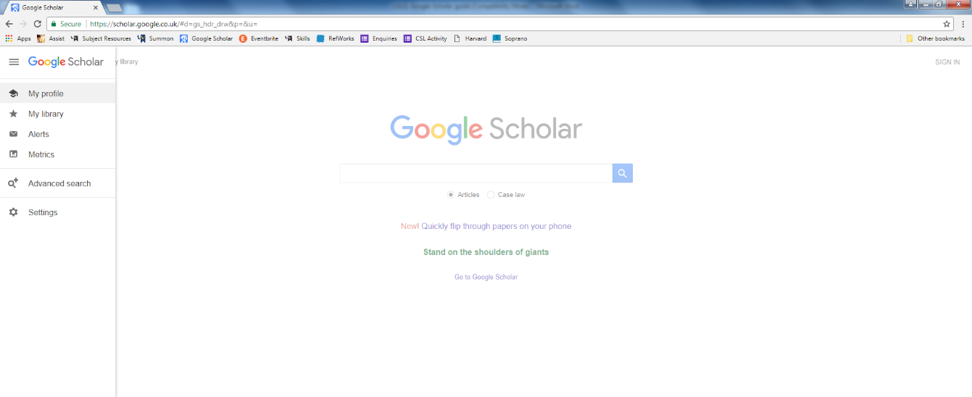
Click on the menu to access the advanced search option

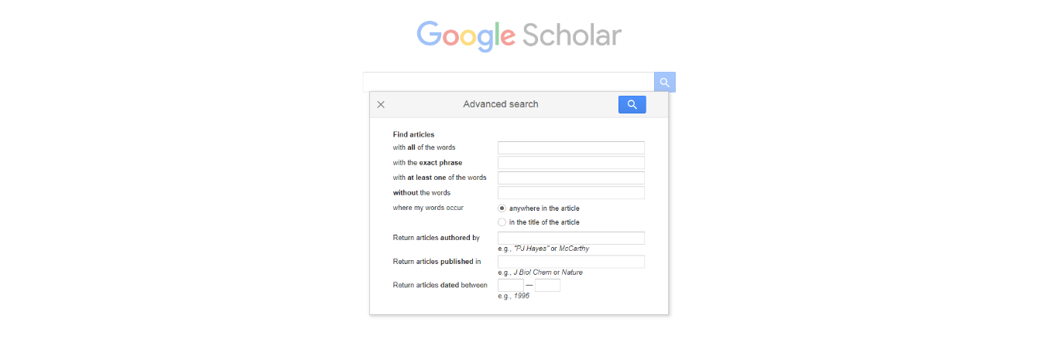
The advanced search gives extra fields to refine your searches

How Do I Access Full-Text Resources Off-Campus?

To access full-text resources off-campus, you will need to set your search preference to University of Wolverhampton using the following steps:

- Click the ☰ menu in the top left corner then choose Settings
- Select the Library Links on the left hand side of the screen
- Type in University of Wolverhampton and click the box on the left hand side
- Click on Save

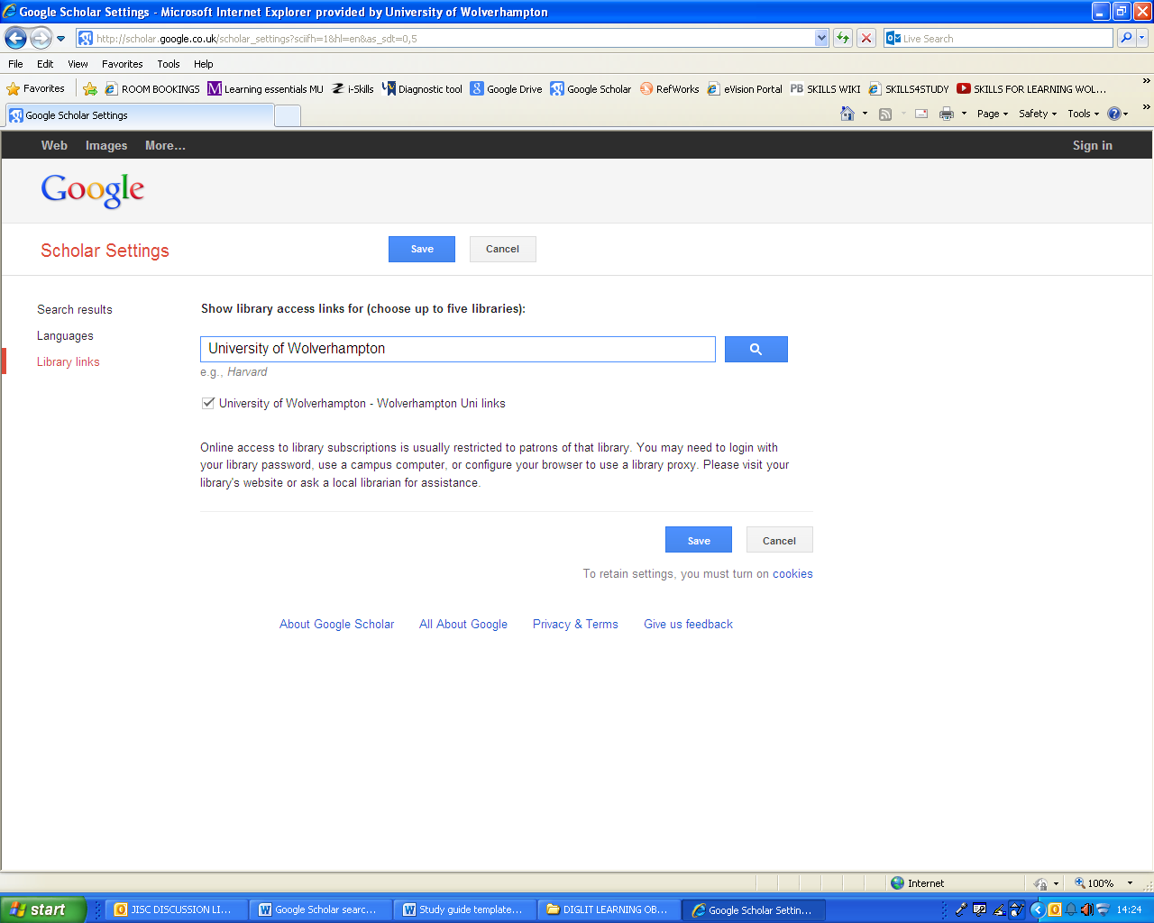
Select the University of Wolverhampton from the list and select Save
To access full-text resources off-campus, click on Library Links and type in University of Wolverhampton

You will be required to use your University username and password. Once you have found an article, find a link for Institutional Login which will direct you to the University of Wolverhampton login box. Depending on the resource you are accessing, you may need to select UK Access Management Federation and University of Wolverhampton from the drop-down boxes.

Remember that searching for information in Google Scholar is a far less precise and reliable option than using subject specific databases and e-journals provided by the University Library. Resources located in Google Scholar need to be evaluated fully before using them in your university assignments. For further guidance, see the separate Skills for Learning guides on Finding Information and Evaluating Information.

If you would like to find out how to export references from Google Scholar to Refworks, please refer to the Refworks guide, or attend the Referencing with Refworks workshop.

Help and Advice

If you require any further information on any aspect of finding information, including details of the Finding Information workshop, please visit the Skills for Learning website.



Cite this work:

Skills for Learning (2024) Guide to Accessing and Searching Google Scholar. Available at: http://www.wlv.ac.uk/skills (Accessed: give date accessed)

To request this document in an alternative format please contact skills@wlv.libanswers.com

