

University Library: Skills for Researchers

Guide to RefWorks

This workbook will guide you through the following tasks for creating a RefWorks account and entering and editing references:

- Creating a RefWorks account
- Adding a reference manually
- Organising your references into folders
- Importing references from the library catalogue
- Importing references from academic databases
- Importing references from Google Scholar
- Creating a reference list
- Inserting references into a Word document
- Importing References from the Internet

Creating a RefWorks Account

1. Access RefWorks at: https://refworks.proquest.com/

2. Click on Create Account.

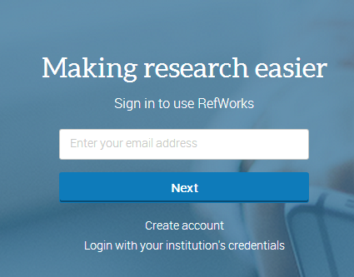

3. Follow the on-screen instructions to create your account. Please note: The email address must be your University of Wolverhampton account.

You can access your RefWorks account from any computer with an Internet connection using the login details you have created.

Adding a reference manually

1. Click on the  button at the top of the screen and select Create new reference.
2. Select your reference type (e.g. Journal Article, Book).

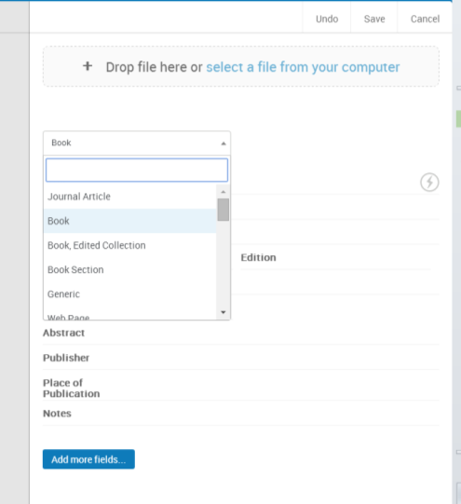

3. Start to type in the reference title. At the bottom of the page, RefWorks will start to suggest possible matches.
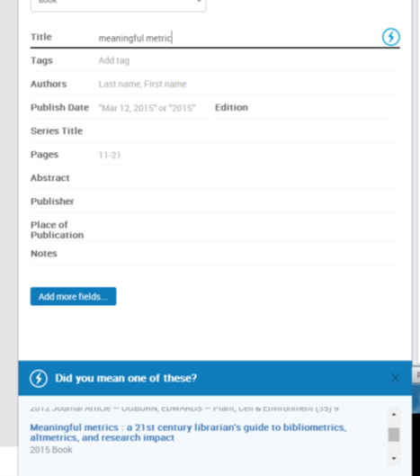
4. Select the correct reference if it appears or continue to enter the details (e.g. Author, Title etc.).

5. Click on 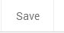 at the top of the screen.

Organising your references into folders

All new items are put into the “last imported folder”. Additional folders can be created, which can be used to organise references into different assignments or projects.
1. First, click on the 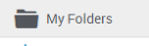 button and select .

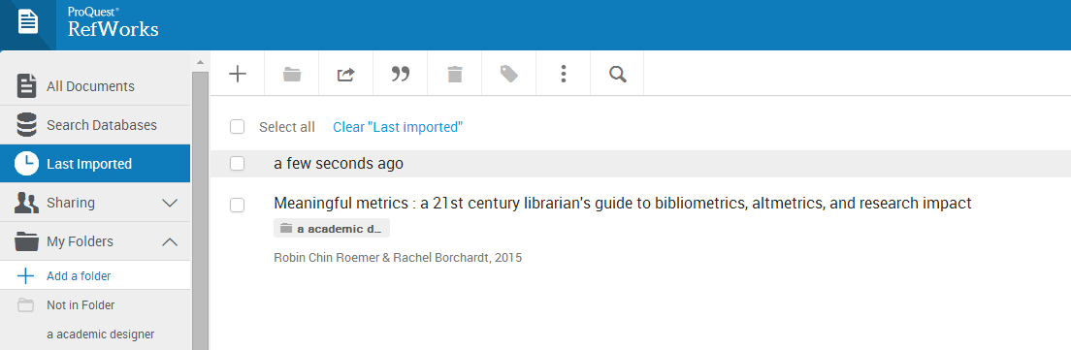
2. Give your folder a name, then click Save.

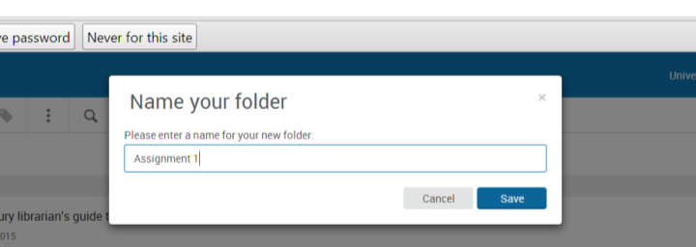
3. Select the references you want to move to the new folder. Click the  button and then choose the folder you want to move the references to.

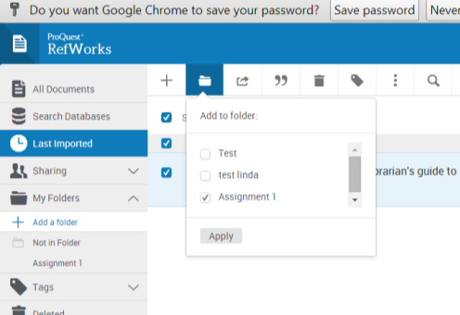

Importing references from the library catalogue (LibrarySearch)
- To access LibrarySearch go to the LIS website at http://www.wlv.ac.uk/lib
- Perform a search
- When your search results appear, use the pin button to send items you are interested in to My favourites.
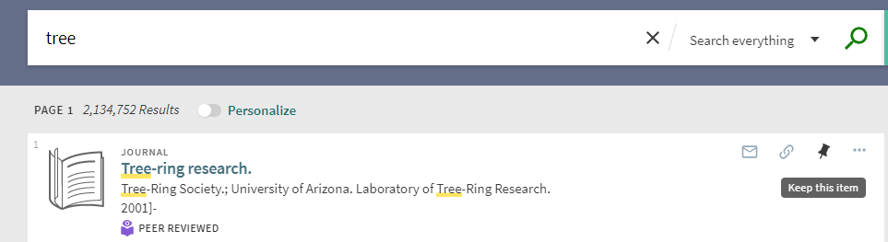
- Open My favourites and select the items to be sent to RefWorks.
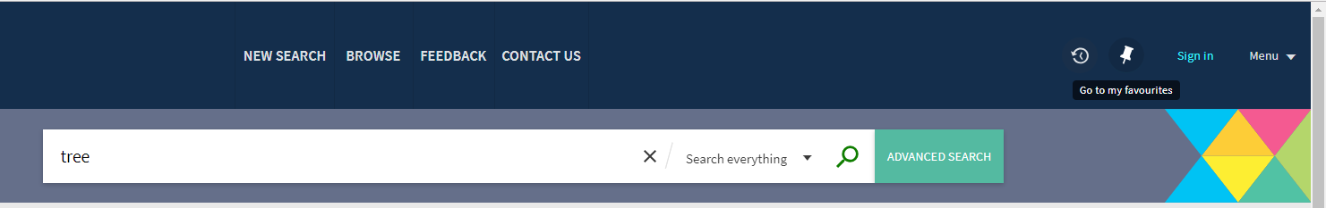
- Click the ‘Push to actions’ button and select RefWorks.
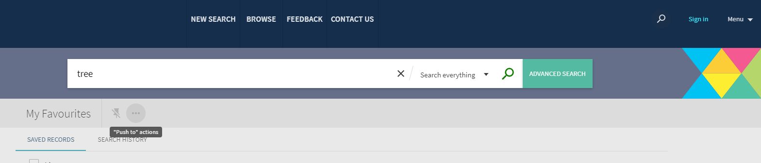
Please note, all items you want to send to RefWorks must be highlighted by checking the tick box to the left before the ‘push to actions’ button becomes available.
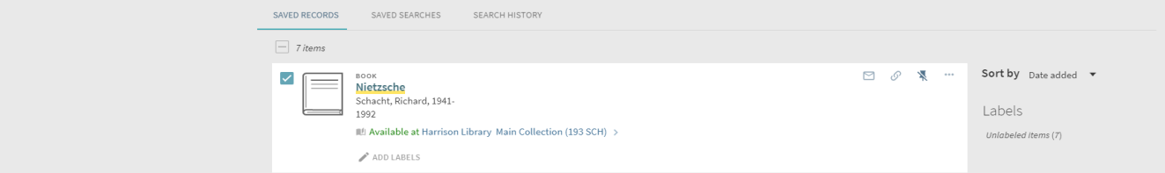

RefWorks will now open and tell you that the references were imported.
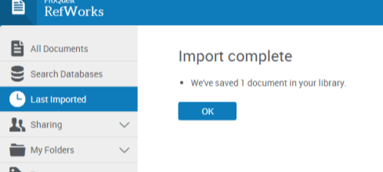
6. To view the references you have imported, click on OK.
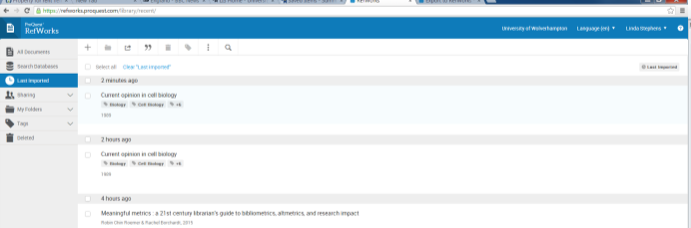

This will always display the most recently imported set of references. At this stage you should check your references and edit them if necessary.
7. To edit your references, change to Citation View using the 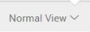 button on the bottom right of the screen.
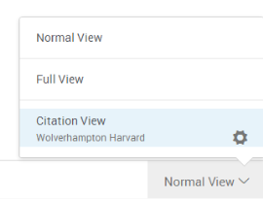
RefWorks will highlight any missing elements in the references. To edit the references, click on the individual highlight and add the missing information.
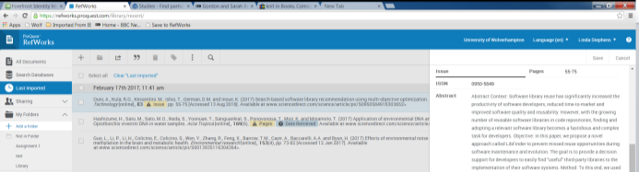

Importing references from a database

Many online databases will import references directly into RefWorks.

The following instructions explain how to export references from the ScienceDirect database:

1. To find ScienceDirect go to the LIS website at http://www.wlv.ac.uk/lib

2. Select Quick links, then Subject resources and then Databases A-Z.

3. Click on S in the alphabetical list at the top of the page, then scroll to find ScienceDirect.

4. Using the quick search box, carry out a search for a topic of your choice.

5. When your search results appear, select the articles you are interested in by checking the tick box to the left. Click Export and then select “Save to RefWorks.”

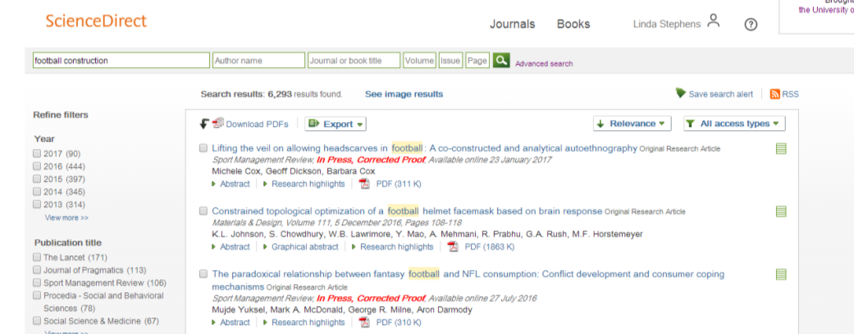

RefWorks will now open and tell you the references were imported.

Importing references from Google scholar

You can also import references from Google Scholar, although you can only import one reference at a time. You just need to change your settings to enable Scholar to import.
1. First, open Google Scholar at: https://scholar.google.com/
2. Then open your Scholar settings and set Bibliography Manager to RefWorks and click save.

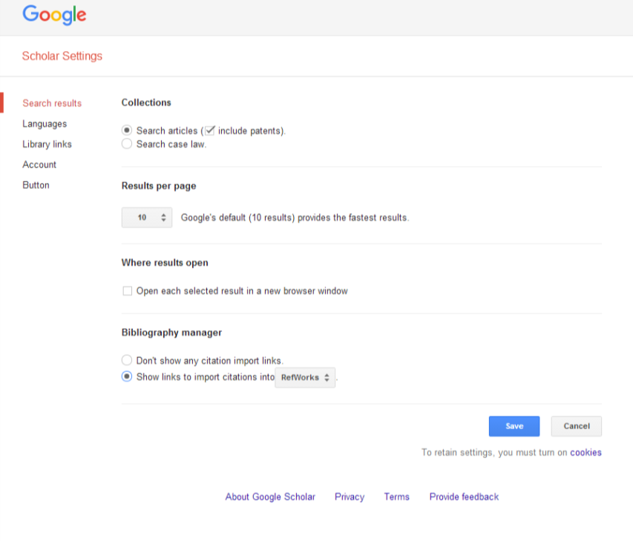
3. Next time you search Google Scholar, an import into RefWorks button will be visible under each result. Clicking on this button will add your references to RefWorks.


Whenever you import references, it is worth checking to make sure all the necessary information is present. You may need to edit your references and add data. To edit a reference in your reference list, select the item and click on the icon to start editing.

Creating a Reference List

- Open the folder that contains the references you want to go into your reference list. Then select the individual references.

- Click on the  button and then select create bibliography.

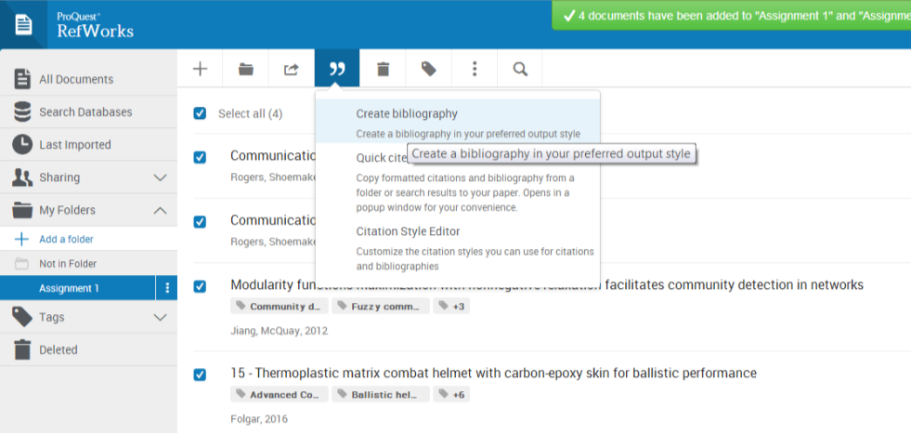

- Check that the appropriate referencing style has been selected.

- The reference list can now be copied and pasted into your assignment.

Importing References to RefWorks from the Internet

RefWorks can import references directly from websites using the Save to RefWorks tool. This feature can be downloaded from the RefWorks tools area.

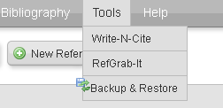
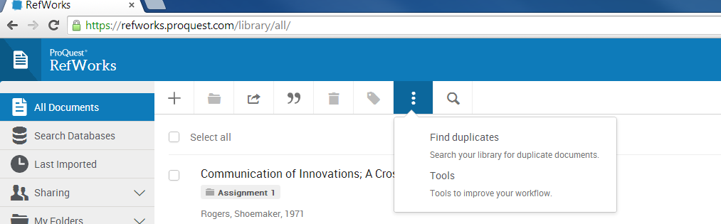
Save to RefWorks

If you find a website that you think may be useful and would like to import reference data for it into your RefWorks account, click on the Save to RefWorks bookmark located on the toolbar at the top of the screen.

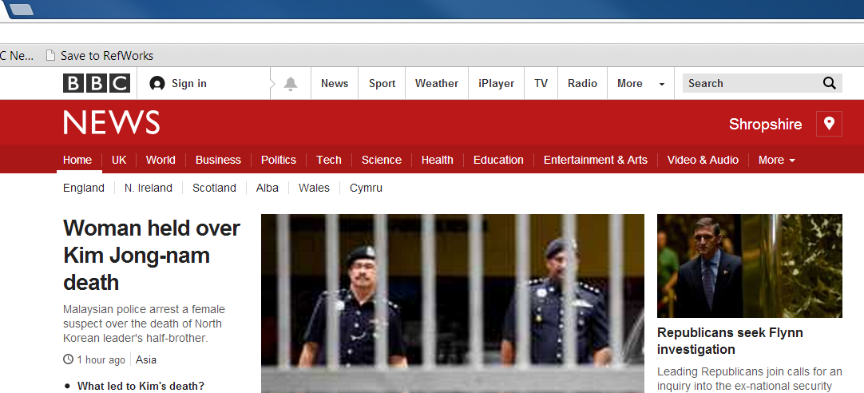

You will then see a Save to RefWorks screen, if you are happy with the details click the save to RefWorks button.

You can now click on the ‘View Last Imported Folder’ to see the reference(s) you have imported.

From this folder you can then move the reference(s) to the folder of your choice.

Inserting references into Word Document

RefWorks can import citations and format your reference list as you write it in Word using “RefWorks Citation Manager”. This requires Word 2016 or later, or Office 365. University of Wolverhampton students and staff can download Office 365 for free by following the instructions at https://www.wlv.ac.uk/its/microsoft-365/

Setting up RefWorks Citation Manager

- Visit https://store.office.com/
- Log in, if asked, with your university email address and password. Use the search box at the top of the screen to search for “RefWorks Citation Manager”.
- Select RefWorks Citation Manager from the results and click “Get it now”.
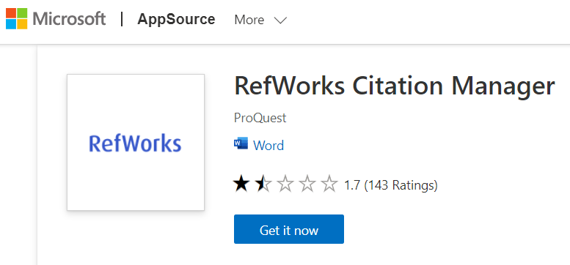
- If Word is already open on your PC, you may be required to close it and restart. When you open Word, you should now see “RCM” on the Word toolbar. 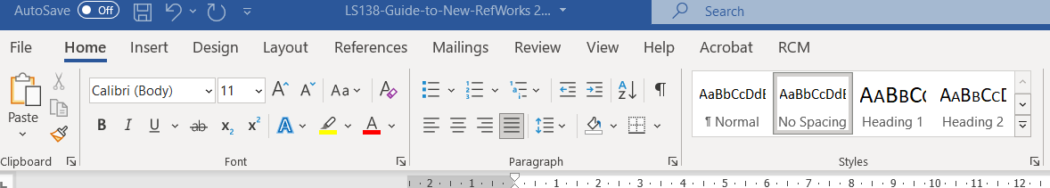
- Click “RCM” on the toolbar, followed by “RefWorks Citation Manager”. This will open a panel on the right-hand side of the screen. Log in using your University email address and your RefWorks password.
- You will see a list of your recently-added citations. To set up the app for future use, click the 3-line options menu.
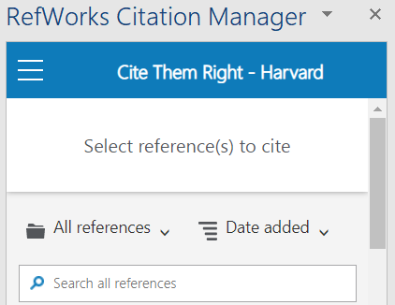
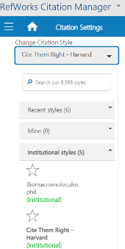
- Ensure “Bibliography” is switch on.
- Click “Citation style”. Under “Change Citation Style”, click the down arrow, then “Institutional styles”. Select your style from the list. Note: You may see more than one option for Harvard. Any of these options can be chosen, as they are identical.
- Click the three lines to return to the setting menu, then “References homepage”.

Cite in Microsoft Word

- Begin to write your document in Microsoft Word. When you want to add a citation, place the cursor at the point in the document you want it to appear.
- Open RCM tab on the toolbar and click “RefWorks Citation Manager”.
- Choose a folder, or use the search box to find the relevant citation.
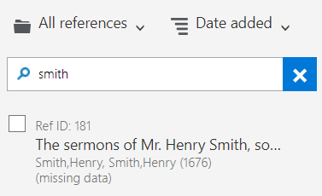
- Tick the box next to the citation(s) you want to add. You can select multiple citations if required. A preview of the citation will appear at the top of the panel.
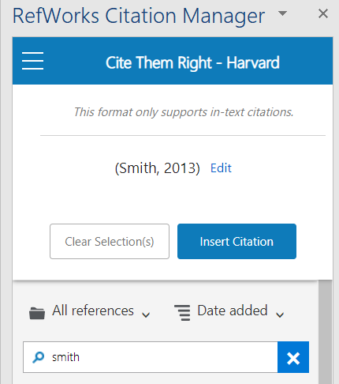
- If you need to amend the citation, click “Edit”. To remove the author’s name, untick “Include author”. To add page numbers, use the “suffix” box. Remember to include the “p”, e.g. “p34”.
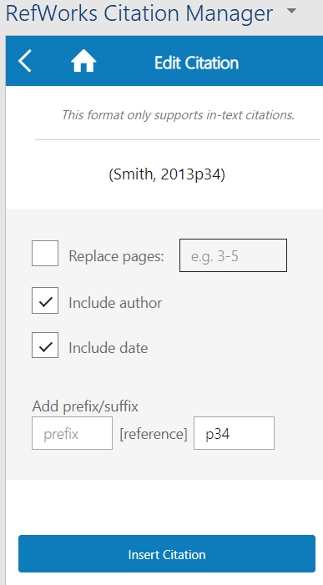
- Click “Insert Citation”. This will add the in text citation where you placed the cursor. It will also add an entry to the reference list at the bottom of your document, and maintain the reference list in alphabetical order.

Example in-text citation:

Example reference:

Changing / removing citations:
- Open RCM tab on the toolbar and click “RefWorks Citation Manager”.
- Click the in-text citation you want to remove (not the entry in the reference list).
- The RCM panel will show the “Edit citation” panel.
- To change the citation, make the required edits, and click “Update citation”.
- To remove the citation, click “Delete citation”. If this is the only citation for the source, the corresponding entry will also be removed from the reference list.



To request this document in an alternative format please contact LISliaison@wlv.ac.uk

