Freezer
User manual



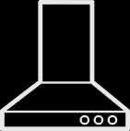
EWWEERQNWEW
FCFM154 FFG1545W FFG1545S FSG1545W
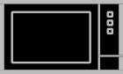

FXFP1545S FXFP1545W FXFG1545S FXFP1545B
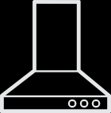



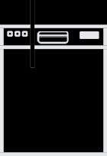


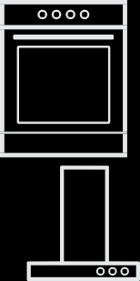








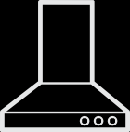










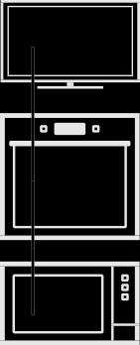

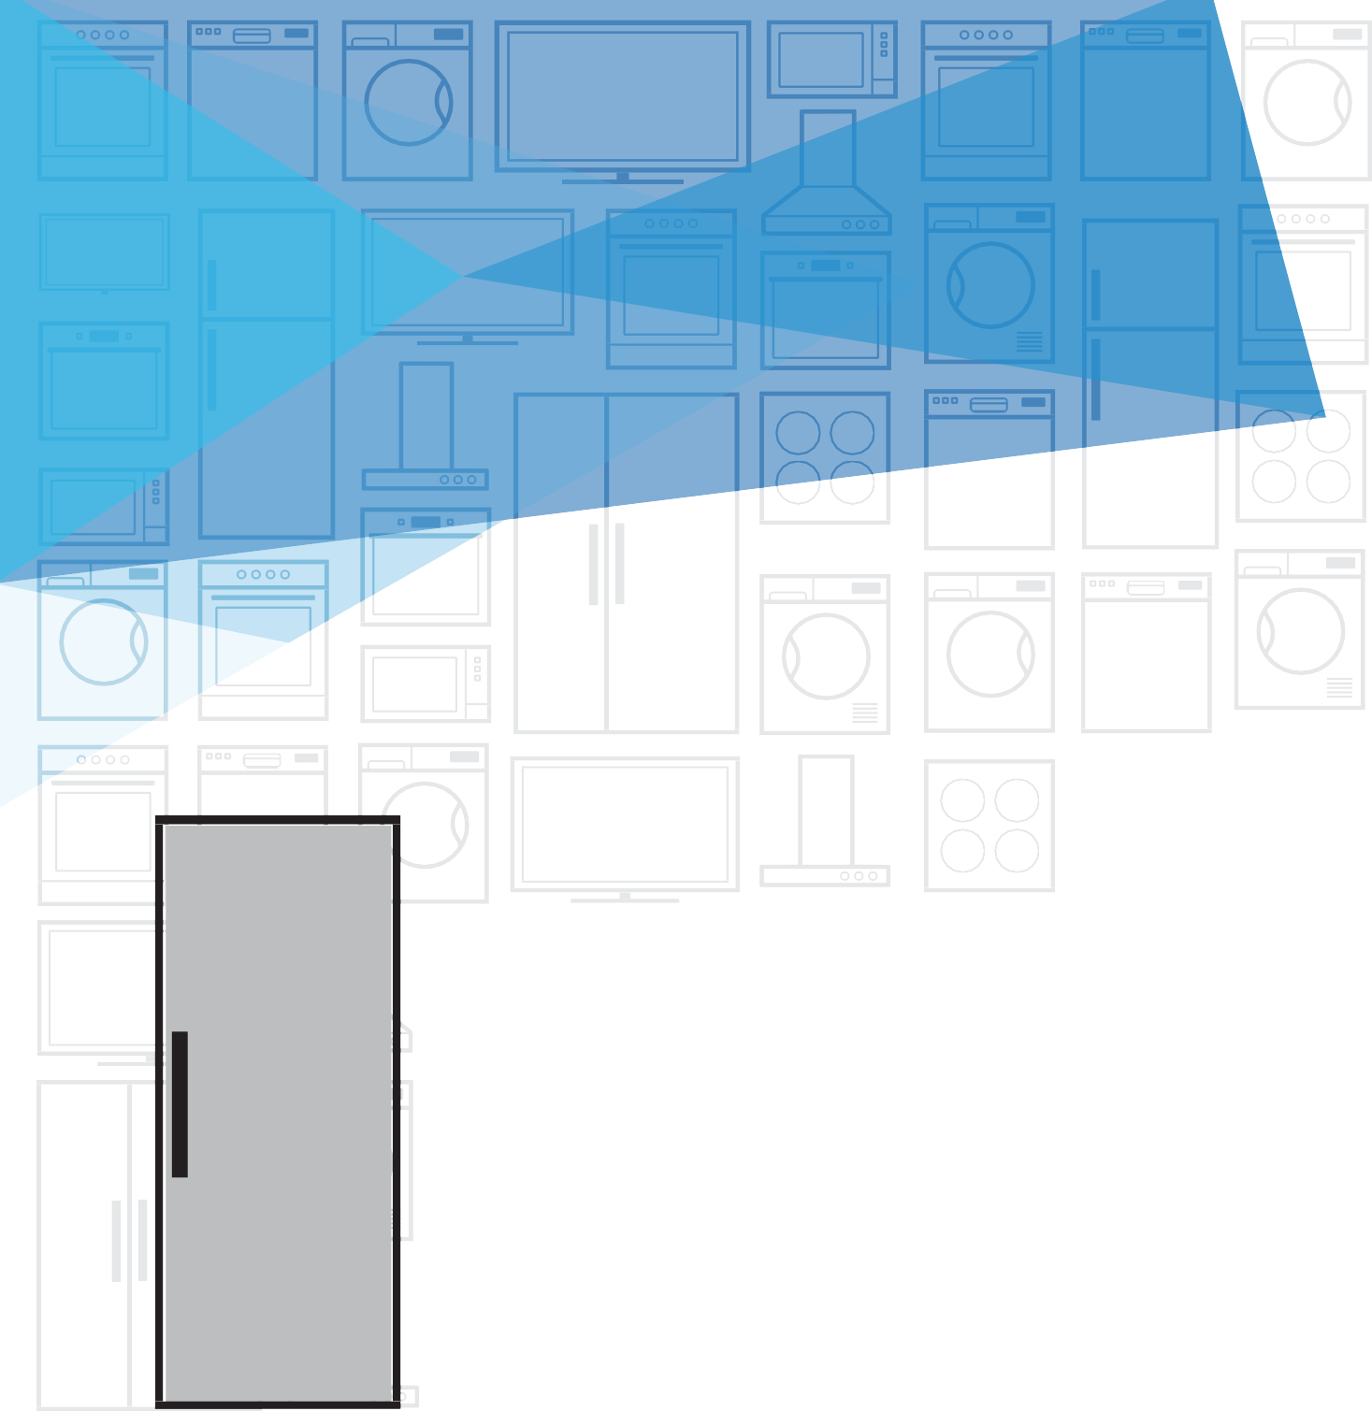



5W




Downloaded from www.Manualslib.com manuals search engine

Please read this manual first!
Dear Customer,
We hope that your product, which has been produced in a 1st-class manufacturing facility and checked under the most meticulous quality control procedures, will provide you with years of good service.
For this, we recommend you to carefully read the entire manual of your product before using it and keep it at hand for future reference.
This manual
- Will help you use your appliance quickly and safely.
- Read the manual before installing and operating your product.
- Follow the instructions, especially those for safety.
- Keep the manual in an easily accessible place as you may need it later.
- Besides, read also the other documents provided with your product. Please note that this manual may be valid for other models as well.
Symbols and their descriptions
This instruction manual contains the following symbols:
C Important information or useful usage tips.
A Warning against dangerous conditions for life and property.
B Warning against electric voltage.

- Your Freezer 3
- Warnings 4
Electrical requirements 6
Warning! This appliance must be earthed 6
Energy saving tips 7
Compliance with WEEE Directive and Disposing of the Waste Product: 8
Compliance with rohs directive: 8
Package information 9
- Installation 10
Points to be paid attention to when the relocation of the freezer 10
Electrical connection 10
Disposing of the packaging 11
Disposing of your old freezer 11
Placing and Installation 11
- Before operating 13
Starting 13
- Using your freezer 14
- Maintenance and
cleaning 15
- Do's and Don'ts 16
Problem Solving 17
- Guarantee Details 18
- How To Obtain Service 19

Your Freezer
1
Congratulations on your choice of a Beko quality Appliance which has been designed to give you service for many years.

1

2

3

4

- Thermostat
- Flap (Fast-Freeze compartment)
- Drawers
- Adjustable front feet
C Figures that take place in this instruction manual are schematic and may not correspond exactly with your product. If the subject parts are not included in the product you have purchased, then it is valid for other models.

Warnings
2

- Do not connect your appliance to the
electricity supply until all packing and transit protectors have been removed.
- If transported horizontally leave to stand upright for at
least 4 hours before switching on to allow compressor oil to settle
- If you are discarding an old refrigerator with a
lock or latch fitted to the door, disable the lock/ latch, ensure that it is left in a safe condition to prevent the entrapment of young children.
- This freezer must only be used for its intended
purpose i.e the storing and freezing of edible foodstuff.
- Do not dispose of the appliance on a fire.
At Beko, the care and protection of our environment is an
ongoing commitment.

4
This appliance which is among the latest range introduced is particularly environment friendly.
Your appliance contains non CFC / HFC natural substances
in the cooling system (Called R600a) and in the insulation
(Called cyclopentane) which are potentially flammable if exposed to fire. Therefore, take care not to damage, the cooling circuit / pipes of the appliance in transportation
and in use. In case of
damage do not expose the appliance to fire
or potential ignition source and immediately ventilate the room where the appliance is situated.
- We suggest you contact your local authority for disposal information
and facilities available.
- See Installation Instructions on page 11 for information on
EN suitable location.

  - To obtain the best possible performance and trouble free
operation from your appliance it is very important to carefully read these instructions.
  - On delivery, check to make sure that the
product is not damaged and that all the parts and accessories are in perfect condition.
  - Ensure that the plug remains readily
accessible. Do not use multiple adapter or extension cable.
  - Failure to observe these instructions may invalidate your right to
free service during the guarantee period.
  - Keep ventilation openings, in the
appliance enclosure or in the built-in structure, clear of obstruction.
  - Do not damage the refrigerant circuit.
  - Do not use electrical appliances inside the food storage
compartments of
5
the appliance, unless they are of the type recommended by the manufacturer.
- We suggest you keep these instructions in a safe place for easy
reference.
- This appliance can be used by children
aged from 8 years and above and persons with reduced physical, sensory or mental capabilities or lack
of experience and knowledge if they have been given supervision or instruction concerning use of the appliance in a safe
way and understand the hazards involved. Children shall not play with the appliance.
Cleaning and user maintenance shall not be made by children without supervision.
- Children should be supervised to ensure
that they do not play with the appliance.

EN

Electrical requirements
Before you insert the plug into the wall socket make sure that the voltage and the frequency shown on the rating plate inside the appliance corresponds to your electricity supply.
Rating label is on the left
hand side of freezer inner liner.
We recommend that this appliance be connected to the mains supply via a suitable switched and fused socket. The appliance must be positioned so that the plug is accessible.
WARNING:
When positioning the appliance ensure the supply cord is not trapped or damaged.
Should the mains lead of the appliance become damaged or should it need replacing at any time, it must be replaced by a special purpose made mains lead which can only be obtained
from a Beko authorised

Warning! This appliance must be earthed
If the fitted moulded plug is not suitable for your socket, then the plug should be cut off and an appropriate plug fitted. Destroy the old plug which is cut off as a plug with bared cord could cause a shock hazard if inserted into a socket elsewhere in the house.
The moulded plug on this
appliance incorporates a 13 A fuse. Should the fuse need to be replaced an ASTABEAB approved BS 1362 fuse of the same rating must be used. Do not forget to refit the fuse cover. In the event of losing the fuse cover the plug must not be used until a replacement fuse cover has been fitted.
Colour of the
replacement fuse cover must be the same colour as that visible on the pin face of the plug. Fuse covers are available from any good electrical store.

service agent.
6 EN

Important! Fitting A Different Plug
- As the colours of the wires in the mains
lead of this appliance may not correspond with the coloured markings identifying the terminals in your plug proceed as follows: (See diagram).
32mm.
- Connect the green- yellow or green (Earth) wire to the terminal

in the plug marked ‘E’ or with the symbol
or coloured green and yellow or green.
- Connect the blue (Neutral) wire to the terminal in the plug
marked ‘N’ or coloured black.
- Connect the brown (Live) wire to the terminal in the plug marked ‘L’ or coloured
red.
- With alternative plugs a 13 A fuse must be fitted either in the plug or adaptor or in the main
fuse box. If in doubt contact a qualified



Energy saving tips
GREEN & YELLOW OR GREEN
6mm.
N
BLUE OR BLACK
L
BROWN
OR RED
22mm.
CORD GRIP
6mm.
12mm.
FUSE
FITTED WITH
BS 1362 13A FUSE ALWAYS FIT BS 1362 REPLACEMENT CARTRIDGE FUSE
- Ensure your appliance is installed in a well ventilated area.
- Ensure the time between buying chilled/ frozen food and placing them in your appliance
is kept at minimum, particularly in summer. We recommend you use a cool bag or a special carrier bag to carry perishable food.
- Do not leave the door (s) of your appliance open longer than necessary and ensure they are
closed properly after each opening.

electrician.
6mm.
7 EN

- Defrost frozen food in your fridge
compartment, so that frozen food acts as an ice pack to assist cooling in your fridge.
- Energy consumption of this appliance is
measured while freezer compartment is loaded without use of top shelf lid and the drawers except the bottom drawer. It is advised that freezer compartment
is loaded without use of drawers except the bottom drawer in order to achieve maximum loading capacity.

Compliance with WEEE Directive and Disposing of the Waste Product:
This product complies with EU WEEE Directive (2012/19/EU). This
product bears a classification symbol for waste electrical and
electronic equipment (WEEE).This product has been manufactured with high quality parts and materials which can be reused and are suitable for recycling. Do not dispose of the waste product with normal domestic and other wastes at the end of its service life. Take it to the collection center for the recycling of electrical and electronic equipment. Please consult your local authorities to learn about
these collection centers.

Compliance with rohs directive:
The product you have purchased complies with EU RoHS Directive (2011/65/EU). It does not contain harmful and prohibited materials specified in the Directive.

Package information
Packaging materials of the product are manufactured from recyclable materials in accordance with our National Environment Regulations. Do not dispose of the packaging materials together with the domestic or other wastes. Take them to the packaging material collection points designated by the local authorities.

Installation
3
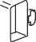
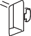


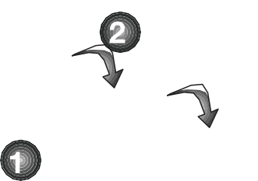
BThe manufacturer will not be liable for any event caused by disregarding the information supplied in this user manual.

Points to be paid attention to when the relocation of the freezer
  - Your freezer should be unplugged.Before transportation of your freezer, it should be emptied and cleaned.

  - Before it is re-packaged, shelves, accessories, crisper, etc. inside your freezer should be fixed with adhesive tape and secured against impacts. Packaging should be adequate and the transportation rules on the package should be strictly observed.
  - Original packaging and foam materials should be kept for future transportations or moving.
Before you start the freezer, Check the following before you start to use your freezer:
- Attach 2 plastic wedges as illustrated below. Plastic wedges are intended to keep the distance which will ensure the air circulation between your freezer and the
wall. (The picture is drawn up as a representation and may not be identical with your product.)
- Clean the interior of the freezer as recommended in the “Maintenance and cleaning” section.
- Connect the plug of the freezer to the wall socket. When the freezer door is opened,freezer internal lamp will turn on.
- When the compressor starts to operate, a sound will be heard. The liquid and gases sealed within the refrigeration system may also give rise to noise, even if the compressor is not running and this is quite normal.
- Front edges of the freezer may feel warm. This is normal. These areas are designed to be warm to avoid condensation.

Electrical connection
Connect your product to a grounded socket which is being protected by a fuse with the appropriate capacity.
Important:
The connection must be in compliance with national regulations.
- The power plug must be easily accessible after installation.
- Electrical safety of your freezer shall be guaranteed only if the earth system in your house complies with
standards.
- The voltage stated on the label located at left inner side of your product should be equal to your
network voltage.

  - Extension cables and multi plugs must not be used for connection.
B A damaged power cable must be replaced by a qualified electrician.
B Faulty product must not be operated before it is repaired! There is the risk of electric shock!

Disposing of the packaging
The packing materials may be dangerous for children. Keep the packing materials out of the reach of children or dispose of them by classifying them in accordance with the waste instructions stated by your local authorities. Do not throw away with regular house waste, throw away on packaging pick up spots designated by the local authorities.
The packing of your freezer is produced from recyclable materials.

Disposing of your old freezer
Dispose of your old freezer without giving any harm to the environment.
  - You may consult your authorized dealer or waste collection center of
your municipality about the disposal of your freezer.
Before disposing of your freezer, cut off the electric plug and, if there are any locks on the door, make them inoperable in order to protect children against any danger.

Placing and Installation
A If the entrance door of the room where the freezer will be installed is not wide enough for the freezer to pass through, then carefully remove the doors of your freezer and pass it sideways through the door.
- Install your freezer to a place that allows ease of use.
- Keep your freezer away from heat sources, humid places and direct sunlight.
- There must be appropriate air ventilation around your freezer in order to achieve an efficient operation. If the freezer is to be placed in a recess in the wall, there must be at least 5 cm distance with
the ceiling and at least 5 cm with the wall. Do not place your product on the materials such as rug or carpet.
- Place your freezer on an even floor surface to prevent jolts.
WARNING:
Do not locate extension sockets or charging transformers/power supplies or Lithium-Iron battery operated
products adjacent to the compressor as they could overheat.

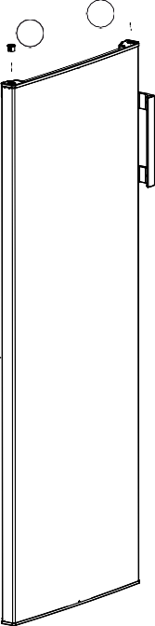
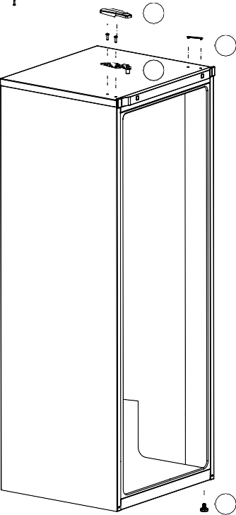
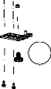
Reversing the doors
16
15
11
12
10
14
13
17
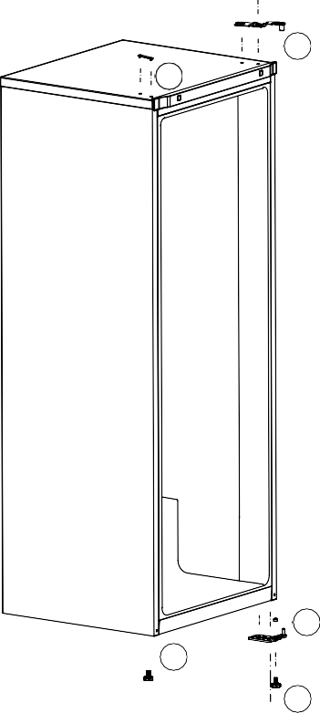
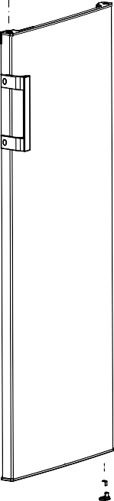
Proceed in numerical order .
2
3
6
4
5
8
7
9
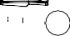

1

Before operating
4

Starting
Final Check
Before you start using the freezer check that:
  - The front feet have been adjusted so the appliance is level.
  - The interior is dry and air can circulate freely at the rear.
  - Clean the interior as recommended under “CLEANING AND CARE.”
  - Insert the plug into the wall socket and switch on the
electricity supply. Avoid accidental disconnection by taping over the switch, the compressor will start running in about five minutes.
  - You will hear a noise as the compressor starts up. The liquid and gases sealed within the refrigeration system may also give rise to noise, whether the compressor is running or not which is quite normal.
  - Do not load the appliance immediately it is switched on. Wait until the correct storage temperature has been reached. We recommend that you check the temperature
with an accurate thermometer (see;Temperature Control and Adjustment)..
  - Front edges of the cabinet may feel warm. This is normal. These areas are designed to be warm to avoid condensation.
  - We recommend that you set the thermostat at MIN setting and monitor the temperature to ensure the appliance maintains desired storage temperatures
  - (See Temperature Control and Adjustment section).
Important Notes :
  - If there is a power failure do not open the door. Frozen food
should not be affected if the failure lasts for less than 17 hours. If the failure is longer, then the food should be checked and either eaten immediately or cooked and then re- frozen.
  - If you find the freezer door difficult to open just after you have closed it, don’t worry. This is due to the pressure difference which will equalise and allow the door to open normally after a few moments.
  - You will hear a vacuum sound just after closing the door. This is quite normal.
  - When you switch on, the appliance will not start immediately, because the appliance incorporates a protection device in the electronics - wait for about 5 minutes.

Using your freezer
5


1 2 3 4

    - Freezer Set Function
This function allows you to make the freezer compartment temperature setting.
Press this button to set the temperature of the freezer compartment to - (warmest), --, ---,
----, (coldest) respectively.
    - High Temperature Error / Warning Indicator
This light comes on during high
temperature failures and error warnings.
- Quick Freeze Indicator
This icon lits when the Quick Freeze function is active.
- Quick Freeze Function
When you press Quick Freeze button, the temperature of the compartment will be colder than the adjusted values. This function can be used for food placed in the freezer compartment and required to be cooled down rapidly. If you want to cool large amounts of fresh food, it is recommended to active this feature before putting the food into the freezer.
Quick Freezer indicator will remain lit when the Quick Freezer function is enabled. To cancel this
function press Quick Freezer button again. Quick Freezer indicator will turn off and return to its normal settings.
If you do not cancel it, Quick Freezer will cancel itself automatically after 24 hours or when the freezer compartment reaches to the required temperature. This function is not recalled when power restores after a power failure.

C Figures that take place in this instruction manual are schematic and may not correspond exactly with your product. If the subject parts are not included in the product you have purchased, then it is valid for other models.

6 Maintenance and cleaning

      - We recommend that you switch off the appliance at the socket outlet and pull out the mains plug before
cleaning.
      - Never use any sharp abrasive instrument, soap, household cleaner, detergent and wax polish
for cleaning.
      - Use luke warm water to clean the cabinet of the appliance and wipe it dry.
      - Use a damp cloth wrung out in a solution of one teaspoon of
bicarbonate of soda to one pint of water to clean the interior and wipe it dry.
      - If the freezer is not going to be used for a long period of time switch it off, remove all food, clean it as above
and leave the door ajar.
      - To remove a drawer, pull it as far as possible, and then tilt it upwards, and then pull it out completely.
      - Any dust that gathers on the condenser, which is located at the back of the freezer, should be
removed once a year with a vacuum cleaner.
- Check door seals regularly to ensure they are clean and free from food particles.
ANever use cleaning agents or water that contain chlorine (bleach) to clean the outer surfaces and chromium coated parts of the product. Chlorine causes corrosion on such metal surfaces.

7 Do's and Don'ts

Do-Check contents of the freezer at regular intervals.
Do- Clean your freezer regularly.
Do- Keep food for as short a time as possible and adhere to “Best Before”,
“Use By” dates.
Do-Store commercially frozen food in accordance with the instructions given
on the packets that you buy.
Do-Always choose high quality fresh food and be sure it is thoroughly clean before you freeze it.
Do-Prepare fresh food for freezing in small portions to ensure rapid freezing.
Do-Wrap all foods in aluminium foil or freezer quality polythene bags and
make sure any air is excluded.
Do-Wrap frozen food when you buy it and put it in to the freezer as soon as possible.
Do-Separate food in the compartments. This will enable you to find food quickly and avoid excessive door opening therefore save electricity.
Do-Remove ice cream from the freezer 10-20 minutes before serving. Don’t- Leave the door open for long periods as this will make the freezer more costly to run.
Don’t- Put hot food into the freezer. Let it cool down first.
Don’t- Put liquid-filled bottles or sealed cans containing carbonated liquids into the freezer as they may burst.
Don’t- Store poisonous or dangerous substances in the Freezer. Your freezer has been designed for the storage of edible foodstuffs only.
Don’t- Exceed the maximum freezing capacity (10 kg in any 24 hours) when freezing fresh food.
Don’t- Consume ice-cream and water ices direct from the freezer. The low temperature may cause ‘freezer burns’ on lips.
Don’t- Freeze fizzy drinks.
Don’t- Try to keep frozen food which has thawed, it should be eaten within 24 hours or cooked and refrozen.
Don’t- Remove items from the freezer with wet hands.
Don’t- Close the door before placing the fast-freeze compartment cover in its place.
Don’t- Leave frozen food at room temperature to thaw; the best way to defrost food is to put it in the freezer to thaw slowly. Make sure you avoid defrosting food or food juices drip onto other food.
Don’t-Remove the plastic cover on the rear wall.
Don’t Damage the pipes on the appliance.

Problem Solving
If the appliance does not operate when switched on, check:
  - The plug is inserted properly in the socket and that the power supply
is on. (To check the power supply to the socket, plug in another appliance)
  - The fuse has blown/circuit breaker has tripped/main distribution switch has been turned off.
  - The temperature control has been set correctly.
  - New plug is wired correctly if you have changed the fitted moulded plug.
If the appliance is still not operating after the above checks, please refer to the section on “How To Obtain Service”.
Please ensure that above checks have been made as a charge will be made if no fault is found.

8 Guarantee Details
GUARANTEE DETAILS

Your new Beko product is guaranteed against the cost of breakdown repair for twelve months from the date of the original purchase.
What is covered?
- Repairs necessary as a result of faulty materials, defective components or manufacturing defec.t
- The cost of functional replacement parts, but excluding consumable items.
- The labour costs of a Beko approved repairer to carry out the repair.
What is not covered?
- Transit, delivery or accidental damage or misuse and abuse.
- C abinet or appearance parts, including control knobs, flaps, handles or container lids.
- Accessories or consumable items including but not limited to, ice trays, scrapers, cutlery baskets, filters and light bulbs.
- Repairs required as a result of unauthorised repair or inexpert installation that
fails to meet the requirements contained in the user instruction book.
- Repairs to products used on commercial or non-residential household premises.
- Loss of frozen food in freezers or fridge/freezers. (Food loss insurance is often included within your household contents insurance policy, or may be available separately from your retailer).
Important notes.
- Your Beko product is designed and built for domestic household use only.
- The guarantee will be void if the product is installed or used in commercial or non-residential domestic household premises.
- The product must be correctly installed, located and operated in accordance with the instructions contained in the User Instructions Booklet provided.
- Professional installation by a qualified Electrical Domestic Appliance Installer isrecommended forall Washing Machines, Dishwashers and Electric Cookers
- Gas Cookers must onlybe installed by a Gas Safe (or BORD GAIS) registered Gas Installer.
- The guarantee is given only within the boundaries of the United Kingdom and the Republic of Ireland.
- The guarantee is applicable only to new products and is not transferable if
the product is resold.
- Beko disclaims any liability for incidental or consequential damages.
The guarantee does not in anyway diminish your statutory or legal rights.

How To Obtain Service
9

HOW TO OBTAIN SERVICE

Please keep your purchase receipt or other proof of purchase in a safe place; you will need to have it should the product require attention under guarantee.
You should also complete the details below; it will help us assist you when requesting service. (The model number is printed on the Instruction Booklet and the serial number is printed on the Rating Label affixed to the appliance)
Model No: Obtaining service please contact Beko Costumer Help-Line.
Serial No:

Retailer:
Date of purchase:
Tel: 0845 6004911 or 0345 6004911

For service under guarantee simply telephone the appropriate number below
UK Mainland & Northern Ireland
Fridges & Freezers 0845 6004903 or 0345 6004903
Electric Cookers 0845 6004902 or 0345 6004902
Gas & Dual Fuel Cookers 0845 6004905 or 0345 6004905
Washing Machines 0845 6004906 or 0345 6004906
& Dishwashers
Republic of Ireland

All Refrigeration All Cookers
Washing Machines & Dishwashers
01 862 3411

Beforere questing service please check the trouble-shooting guide in the Operating Instructions as a charge may belevied where no fault is found even though your product may still be under guarantee.
Service once the manufacturers guarantee has expired.
If you have purchased an extended guarantee please refer to the instructions contained with in the extended guarantee agreement document.Otherwise please call the appropriatenumber above whereservice can be obtainedat a charge.
Should you experience any difficulty in obtaining service please contact the Beko Customer Help-Line. Tel: 0845 6004911 e-mail: service@beko.co.uk






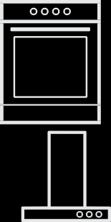




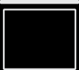




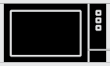

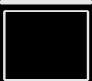

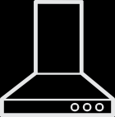




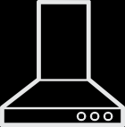
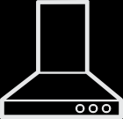













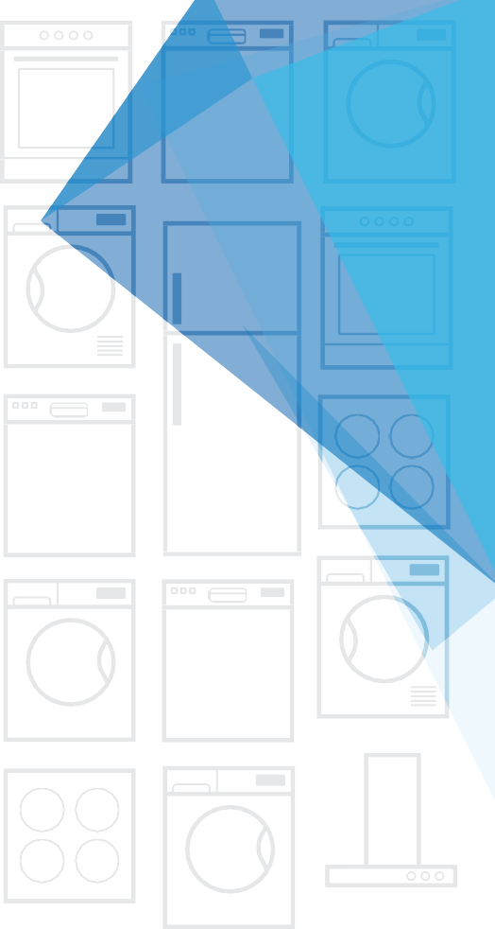




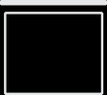
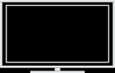


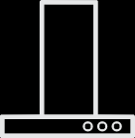


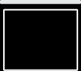

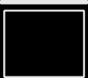

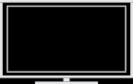


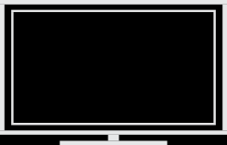
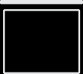




BEKO plc Beko House

57 7725 000
0/AK



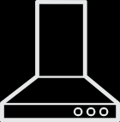

1 Greenhill Crescent Watford Hertfordshire WD18 8QU
Tel: 0845 6004911
Fax:0 845 6004922


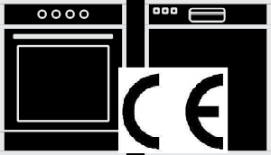
e-mail:service@beko.co.uk website: www.beko.co.uk

Downloaded from www.Manualslib.com manuals search engine


