

3.6 cu.ft. Upright Freezer

ZA 630

BEKO plc Beko House Caxton Way Watford Hertfordshire WD18 8UF
Tel: 01923 654650
Printed in Turkey

Part no: 48 3013 00 00
Revision no: 0
Fax: 01923 819653
e-mail: service@beko.co.uk website: www.beko.co.uk

Congratulations on your choice of a quality Appliance which has been designed to give you service for many years.
WARNING ! IMPORTANT !
DO NOT connect your appliance to the electricity supply until all packing and transit protectors have been removed.
- Leave to stand for at least 4 hours before switching on to allow compressor oil to settle if transported horizontally.
- If you are discarding an old refrigerator with a lock or latch fitted to the door, disable the lock/latch, ensure that it is left in a safe condition to prevent the entrapment of young children.
- This freezer must only be used for its intended purpose i.e the storing and freezing of edible foodstuff.
- Do not dispose of the appliance on a fire. At BEKO, the care and protection of our environment is an ongoing commitment. This appliance which is among the latest range introduced is particularly environment friendly. Your appliance contains non CFC / HFC natural substances in the cooling system (Called R600a) and in the insulation (Called cyclopentane) which are potentially flammable if exposed to fire. Therefore, take care not to damage, the cooling circuit / pipes of the appliance in transportation and in use. In case of a damage do not expose the appliance to fire, potential ignition source and immediately ventilate the room where the appliance is situated.
- We suggest you contact your local authority for disposal information and facilities available.
- To obtain the best possible performance and trouble free operation from your appliance it is very important to carefully read these instructions.
- On delivery, check to make sure that the product is not damaged and that all the parts and accessories are in perfect condition.
- Ensure that the plug remains readily accessible. Do not use a multiple adapter bar or extension cable.
- Failure to observe these instructions may invalidate your right to free service during the guarantee period.
WARNING- Keep ventilation openings, in the appliance enclosure or in the built-in structure, clear of obstruction.
WARNING- Do not use mechanical devices or other means to accelerate the defrosting process, other than those recommended by the manufacturer.
WARNING- Do not damage the refrigerant circuit.
WARNING- Do not use electrical appliances inside the food storage compartments of the appliance, unless they are of the type recommended by the manufacturer.
- We suggest you keep these instructions in a safe place for easy reference.
 | Upright Freezer ZA 630
PERFORMANCE
Energy efficiency class | A
Energy consumption - Kwh/year | 204
Net storage - vol fresh food ltrs (cu.ft.) | -----
Net storage - vol frozen food ltrs (cu.ft) | 85 (3.0)
Total net vol - ltrs (cu.ft.) | 85 (3.0)
Frozen food compartment rating | 4 STAR
Conservation time from failure | 16 hrs.
Freezing capacity fresh food - kg /24 hrs. | 10.5
Climate class | SN
Operating noise level dB(A) | 39

CONTENTS PAGE
ELECTRICAL REQUIREMENTS
Before you insert the plug into the wall socket make sure that the voltage and the frequency shown in the rating plate inside the appliance corresponds to your electricity supply.Rating label is on the left hand side of freezer inner liner. We recommend that this appliance is connected to the mains supply via a suitable switched and fused socket in a readily accessible position. Should the mains lead of the appliance become damaged or should it need replacing at any time, it must be replaced by a special purpose made mains lead

SAFETY FIRST / ELECTRICAL REQUIREMENTS TRANSPORTATION INSTRUCTIONS INSTALLATION INSTRUCTIONS REPOSITIONING THE DOOR
INDICATOR LIGHTS STARTING
TEMPERATURE CONTROL AND ADJUSTMENT STORING FROZEN FOOD
FREEZING FRESH FOOD MAKING ICE CUBES DEFROSTING CLEANING AND CARE DO'S AND DON'TS PROBLEM SOLVING GUARANTEE DETAILS
HOW TO OBTAIN SERVICE
3
4
5
6-7
8
9
10
10
11
12
12
13
14
14
15
16
which can only be obtained from a BEKO Authorised Service Agent.

WARNING! THIS APPLIANCE MUST BE EARTHED
If the fitted moulded plug is not suitable for your socket, then the plug should be cut off and an appropriate plug fitted. Destroy the old plug which is cut off as a plug with bared cord could cause a shock hazard if inserted into a socket elsewhere in the house.
The moulded plug on this appliance incorporates a 13 A fuse. Should the fuse
need to be replaced an ASTABEAB approved BS 1362 fuse of the same rating must be used. Do not forget to refit the fuse cover. In the event of losing the fuse cover the plug must not be used until a replacement fuse cover has been fitted. Colour of the replacement fuse cover must be the same colour as that visible on the pin face of the plug. Fuse covers are available from any good electrical store.

IMPORTANT! FITTING A DIFFERENT PLUG



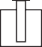

As the colours of the wires in the mains lead of this appliance may not correspond with the coloured markings identifying the terminals in your plug proceed as follows:
GREEN & YELLOW OR GREEN
6mm.
N
BLUE OR BLACK
L
BROWN
OR
22mm.
RED
CORD GRIP
(See diagram).
- Connect the green-yellow or green (Earth) wire to the terminal in the plug marked 'E' or with the symbol  or coloured
FUSE
32mm.
6mm.
FITTED WITH
BS 1362 13A FUSE ALWAYS FIT BS 1362 REPLACEMENT CARTRIDGE FUSE
green and yellow or green.
6mm.
12mm.

- Connect the blue (Neutral) wire to the terminal in the plug marked 'N' or coloured black.
- Connect the brown (Live) wire to the terminal in the plug marked 'L' or coloured red.
With alternative plugs a 13 A fuse must be fitted either in the plug or adaptor or in the main fuse box.
If in doubt contact a qualified electrician.

TRANSPORTATION INSTRUCTIONS
- The appliance should be transported only in a vertical upright position. The packing as supplied must be intact during transportation.
- If during the course of transport the appliance has to be transported horizontally, it must only be laid on its right hand side when standing in the front of the appliance. After bringing it to upright position,it must not be operated for at least 4 hours to allow the system to settle.
- Failure to comply with the above instructions could result in damage occuring to the appliance. The manufacturer will not be held responsible if these instructions are disregarded.
- The appliance must be protected against rain, moisture and other atmospheric influences.
- When positioning your appliance take care not to damage your flooring, pipes, wall coverings etc. Do not move the appliance by pulling by the door

IMPORTANT
INSTALLATION INSTRUCTIONS
- The space in the room where the appliance is installed must not be smaller than 10 cubic metres.
- If possible avoid placing the appliance near cookers, radiators or in direct sunlight as this will cause the compressor to run for long periods. If installed next to a source of heat or refrigerator, maintain the following minimum side clearances:
From Cookers 2" (50 mm)
From Radiators 12" (300 mm) From Refrigerators or Larder Fridge 1" (25 mm)

- Make sure that sufficient room is provided around the appliance to ensure free

or handle.

IMPORTANT : Care must be taken while cleaning / carrying the appliance to avoid touching the bottom of the condenser metal support or pipework at the back of the appliance as you might injure your fingers and hands or damage your product.

IMPORTANT : This appliance is not designed for stacking with any other appliance.
Do not attempt to sit or stand on top of your appliance as it is not designed for such use. You could injure yourself or damage the appliance.
air circulation.
- Fit the two plastic wall spacer supplied with the appliance rotating 1/4 turn to the condenser at the back of the refrigerator (see diagram).
- The appliance should be located on a smooth surface. The two front feet can be adjusted as required. To ensure that, your appliance is standing upright adjust the two front feet by turning clockwise or
anti-clockwise, until the product is in
Thermostat

IMPORTANT : Make sure that mains cable is not caught under the appliance during and after carrying / moving the appliance, to avoid the mains cable becoming cut or damaged.

Do not allow children to play with the appliance or tamper with the controls. BEKO plc declines to accept any liability should the instructions not be followed.
firm contact with the floor. Correct adjustment of feet avoids excessive vibration and noise.
- Refer to "Cleaning and Care" section to prepare your appliance for use.
- Thermostat is located on the rear wall of the cabinet (See above diagram) and controlled by the thermostat knob located on the indicator light set.
(See diagram on page 8)

- A special receptacle is supplied to store the mains plug during transit.
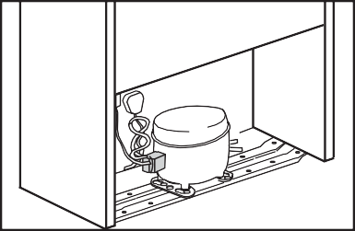
The receptacle is fixed at the back of the cabinet, on the left hand side of the compressor. (See diagram) Gently remove the plug from the receptacle. Never pull the mains cord, you may damage the appliance. In the case of transportation,
ensure you locate the plug in the receptacle provided to avoid transit damage.

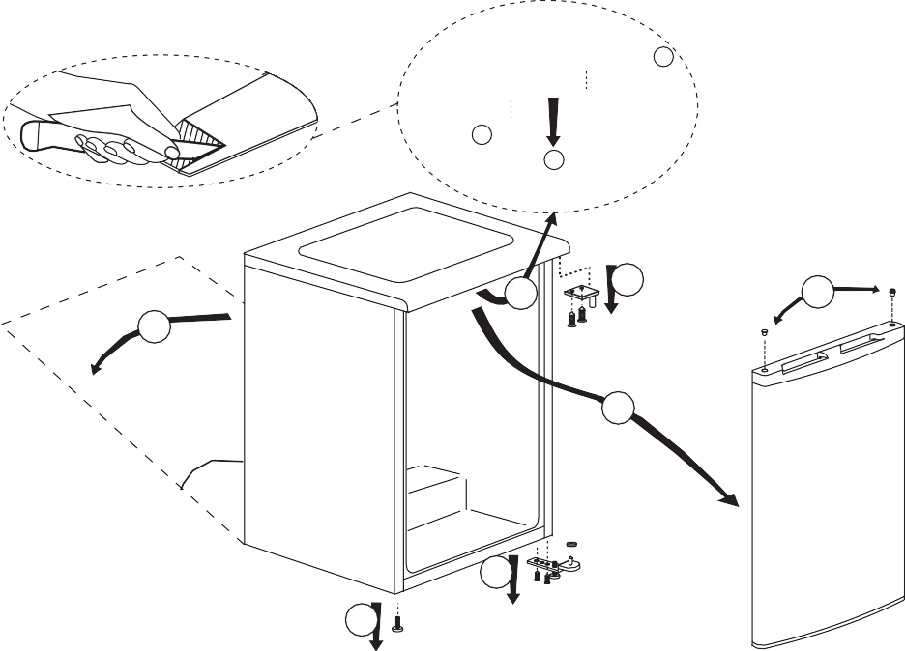
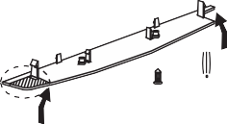
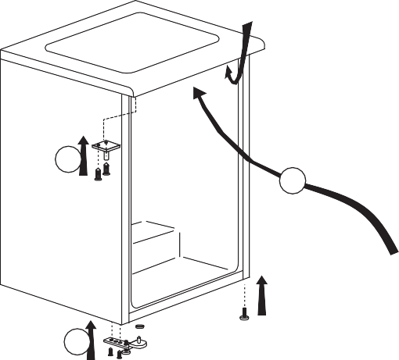
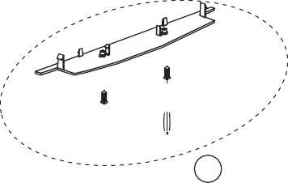

REPOSITIONING THE DOOR
Follow the step by step instructions and the diagram below. Numbers in brackets refer to diagrams.
b
b
a
7
6
5
1
4
60°
3
2
8
9
10
12
11
  - Switch off at the socket outlet and pull out the mains plug.
  - Remove all food, loose items and fittings from inside the appliance and door shelves.
  - Carefully tilt the appliance on its back side. (1) (You may need somebody to help you.) Take care not to damage the appliance by laying on
some protective material (e.g. its original packaging). Make sure that you tilt the appliance on its back side, otherwise compressor oil may block the pipes and you may damage the appliance.
  - Unscrew and remove the LHS front feet (2).
  - Unscrew the bolts and remove the bottom hinge while holding the door (3).
  - Remove the door carefully from the top hinge by sliding towards the right hand side (4).
  - Reposition top hinge bushing and blanking plug on the opposite side and stand the door safely (5). You may find it easier to remove the bushing and the plug with the tip of a small screwdriver. Take care not to mark the door.
  - Reposition the top hinge on the opposite side (6 and 13).
  - Remove the top trim bottom cover as shown in the figure. (7) Cut the shaded part from left hand side of top trim bottom cover.
  - Fit the top trim bottom cover as shown in the figure. (8)

  - To refit the door, locate the top hinge in the door, attach to the cabinet and hold the door (10).
  - Fit the bottom hinge (11). If necessary adjust and then tighten the bolts. Ensure, that the door opens and closes easily and that there are no gaps allowing air into the cabinet. If there are gaps between the door seal and the cabinet, adjust the door seal by gently pulling away from the door using fingers.
  - Fit the other front feet (12).
  - Carefully stand your appliance. (You may need somebody to help you.) Adjust the front feet (See Installation Instructions)
  - Put back all, loose items and fittings.
  - Wait for at least 4 hours to allow the system to settle before switching on.
Spare plastic parts supplied with the appliance are for your future use during door repositioning.

INDICATOR LIGHTS
There are three coloured indicator lights located on the front of the appliance which shows the operating mode of the freezer.

Green Indicator (1)
Illuminates when the appliance is connected to the mains and will glow as long as electricity is available. The green light will not glow if the thermostat is set in the '0' position. The green indicator does not give any indication of the temperature inside the freezer.

Amber Indicator (2)
This indicator will glow when the fast freeze switch (4) is on and will continue to glow until the fast freeze switch is turned off. The compressor will run continuously while fast freeze switch is on. Fast freeze operation is for freezing fresh food (see Freezing Fresh Food, page 11).

Red Indicator (3) Illuminates:

- If the pre-set temperature can not be maintained.
- If excessive amounts of fresh food are placed inside.
- If the appliance door is left open accidentally.

Thermostat knob (5)
Thermostat knob is located on the indicator light set.

IMPORTANT :
When you press the fast freeze switch, there may be a short delay before the compressor starts to operate. This is normal and not a compressor fault.

4 2 3 1 5
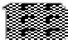
1-
-2
4-
-3

STARTING
Final Check
Before you start using the freezer check that:
- The feet have been adjusted and the product is level.
- The interior is dry and air can circulate freely at the rear.
- Clean the interior as recommended under "CLEANING AND CARE."
- Insert the plug into the wall socket and switch on the electricity supply. Avoid accidental disconnection by taping over the switch. Green and red lights will glow and the compressor will start running.
- You will hear a noise as the compressor starts up. The liquid and gases sealed within the refrigeration system may also give rise to noise, whether the compressor is running or not which is quite normal.
- If you are going to store already frozen food open the freezer door and check that the fast-freeze switch is at off (the amber light will not come on). The red light will go out when the freezer has reached the correct temperature. Then you can put in your already frozen food. (See Storing Frozen Food page 9).
- If you are going to freeze fresh food, you must press the fast-freeze switch. The amber light will come on and you must wait at least three hours before putting in your fresh food to be frozen. (See Freezing Fresh Food, Page: 10).
- Slight undulation of the top of the cabinet is quite normal due to the manufacturing process used, so do not worry, it is not a defect.
- Front edges of the cabinet may feel warm. This is normal. These areas are designed to be warm to avoid condensation.
- We recommend that you set the thermostat knob at 3 and monitor the temperature to ensure the appliance maintains desired storage temperatures (see section Temperature Control and Adjustment).
- Do not load the appliance immediately it is switched on. Wait until the correct storage temperature has been reached. We recommend that you check the temperature with an accurate thermometer (see; Temperature Control and Adjustment).

Important Notes :
- If there is a power failure do not open the door. Frozen food should not be affected if the failure lasts for less than 16 hours. If the failure is longer, then the food should be checked and either eaten immediately or cooked and then
re-frozen.
- If you find the freezer door difficult to open just after you have closed it, don't worry. This is due to the pressure difference which will equalise and allow the door to open normally after a few minutes.

TEMPERATURE CONTROL AND ADJUSTMENT
Temperature is controlled by the thermostat which is located on the rear wall of the cabinet (see the diagram on page 5). Thermostat knob is located on the indicator light set. "Number 4" is the coldest setting (see the diagram on page 8).
The normal storage temperature of your appliance should be -18 °C (0 °F). Lower temperatures may be obtained by adjusting the thermostat knob towards 'number 4 ' position.
We recommend that you check the temperature with a thermometer to ensure that the storage compartments are kept to the desired temperature. Remember you must take your reading very quickly since the thermometer temperature will rise very rapidly after you remove it from the freezer.
Please remember each time the door is opened cold air escapes and the internal temperature rises. Therefore never leave the door open and ensure it is closed immediately after food is put in or removed.

FREEZING FRESH FOOD

Freezing capacity of your appliance in a 24 hours period is 10.5 kg (23 lb). Never exceed this maximum capacity.
If you are going to freeze fresh food in excess of 2 kg. (4.5 lb) turn on the fast freeze switch and wait for about three hours before placing the fresh food in the freezer. Remember to turn off the fast freeze switch.
Fast freeze compartment (7) is shown in diagram. Leave the fast freeze switch on for about 24 hours if the maximum quantity (10.5 kg / 23 lb) is being frozen. Do not freeze too large a quantity at any one time. The quality of the food is best preserved when it is frozen right through to the centre as quickly as possible. You may place fresh food to be frozen in any part of the freezer.
Take special care not to mix already frozen food and fresh food. If the fast freeze compartment (7) is filled with fresh food, other compartments can also be used to freeze fresh food. Ice-bank (6) has been specially designed to obtain ice cubes (see making Ice Cubes).

STORING FROZEN FOOD

Prepacked commercially frozen food should be stored in accordance with the frozen food manufacturer's instructions for a frozen food storage compartment.

The freezing area is marked with symbol on the door liner.

To ensure that the high quality achieved by the frozen food manufacturer and the food retailer is maintained the following should be remembered:

- Put packets in the freezer as quickly as possible after purchase.
- Do not exceed "Use By", "Best Before" dates on the packaging.
- If there are no instructions on the packet, refer to the storage life guide on the door liner.
- Please note that drawers, baskets, flaps, trays are all removable.
3 4 5 2 1

6

7

8

8

9
  - Reflectors
  - Top trim

  - Fast-Freeze switch
  - Indicator lights
  - Thermostat knob
  - Ice bank
  - Fast-freeze compartment
  - Frozen-food compartments
  - Adjustable front feet

MAKING ICE CUBES

Fill the ice-cube tray 3/4 full with water and place it on the special Ice Bank. Loosen frozen trays with the handle of a spoon. Never use sharp edged object such as knives, forks. Store ice-cubes in the Ice Bank.

You can also freeze small soft fruits like strawberries in the Ice Bank tray.

DEFROSTING
Defrost twice a year or when a frost layer of around 7 mm (1/4") has formed. To start defrosting procedure turn the thermostat knob to zero position (Alternatively you may switch off the freezer at the socket outlet and pull out the mains plug.)
All food should be wrapped in several layers of newspaper and stored in a cool place (e.g. fridge or larder).

Remove all freezer baskets.The special defrost collection basin collects the defrost water. Therefore defrosting can be conducted without mess.

Containers full of warm water may be placed carefully in the freezer to speed up the defrosting.

Do not use pointed or sharp edged objects such as knives, forks to remove the frost.
Never use hairdryers, electrical heaters and other similar electrical appliances for defrosting.
When defrosting has finished, sponge out any defrost water which collects at the
bottom of the freezer and dry the interior thoroughly. Turn the thermostat knob to 2 and press fast freeze switch. Close the freezer door. Insert the plug into the wall socket and switch on the electricity supply. Don't forget to tape over the switch to avoid accidental disconnection.After about three hours you may turn off the fast freeze switch.

CLEANING AND CARE
** We recommend that you switch off the freezer at the socket outlet and pull out the mains plug before cleaning.

** Never use any sharp abrasive instrument, soap, household cleaner, detergent and wax polish for cleaning.

** Use luke warm water to clean the cabinet of the freezer and wipe it dry.

** Use a damp cloth wrung out in a solution of one teaspoon of bicarbonate of soda to one pint of water to clean the interior and wipe it dry.

** Excess deposit of ice should be removed on a regular basis using the handle of a spoon. Large accumulation of ice will impair the performance of the freezer.

** If the freezer is not going to be used for a long period of time switch it off, remove all food, clean it and leave the door ajar.

** To remove a basket, pull it as far as possible, and then tilt it upwards, and then pull it out completely.

** Any dust that gathers on the condenser, which is located at the back of the freezer, should be removed once a year with a vacuum cleaner.

** Check door seals regularly to ensure they are clean and free from food particles.

** Never :
- Clean the worktop with unsuitable material; eg petroleum based products.
- Subject it to hot temperatures in any way,
- Scour, rub etc., with abrasive material.

DO'S AND DON'TS
Do- Check contents of the freezer at regular intervals.
Do- Clean and defrost your freezer regularly (See "Defrosting")
Do- Keep food for as short a time as possible and adhere to "Best Before", "Use By" dates.
Do- Store commercially frozen food in accordance with the instructions given on the packets that you buy.
Do- Always choose high quality fresh food and be sure it is thoroughly clean

GUARANTEE DETAILS

Your new Beko product is guaranteed against the cost of breakdown repairs for twelve months from the date of the original purchase.

What is covered?

Do-
Do-
Do-
Do-
before you freeze it.
Prepare fresh food for freezing in small portions to ensure rapid freezing. Wrap all foods in aluminium foil or freezer quality polythene bags and make sure any air is excluded.
Wrap frozen food when you buy it and put it in to the freezer as soon as possible.
Separate food in the compartments. This will enable you to find food quickly and avoid excessive door opening therefore save electricity.
- Repairs necessary as a result of faulty materials, defective components or manufacturing defect.
- The cost of functional replacement parts, but excluding consumable items.
- The labour costs of a Beko approved repairer to carry out the repair.

What is not covered?
- Transit, delivery or accidental damage or misuse and abuse.

Do- Remove ice cream from the freezer 10-20 minutes before serving.
Don't- Leave the door open for long periods as this will make the freezer more costly to run and cause excessive ice formation.
Don't- Use pointed sharp edged objeects such as knives, forks to remove the ice. Don't- Put hot food into the freezer. Let it cool down first.
Don't- Put liquid-filled bottles or sealed cans containing carbonated liquids into the freezer as they may burst.
Don't- Store poisonous or dangerous substances in the Freezer. Your freezer has been designed for the storage of edible foodstuffs only.
Don't- Exceed the maximum freezing capacity (10.5 kg in any 24 hours) when freezing fresh food.
Don't- Consume ice-cream and water ices direct from the freezer. The low temperature may cause 'freezer burns' on lips.
Don't- Freeze fizzy drinks.
Don't- Try to keep frozen food which has thawed, it should be eaten within 24 hours or cooked and refrozen.
Don't- Remove items from the freezer with wet hands.
Don't- Close the door before placing the fast-freeze compartment cover in its place.
Don’t- Leave frozen food at room temperature to thaw; the best way to defrost food is to put it in the fridge to thaw slowly. Make sure you avoid defrosting food or food juices drip onto other food.

PROBLEM SOLVING
If the appliance does not operate when switched on, check:
- The plug is inserted properly in the socket and that the power supply is on. (To check the power supply to the socket, plug in another appliance)
- The fuse has blown/circuit breaker has tripped/main distribution switch has been turned off.
- The temperature control has been set correctly.
- New plug is wired correctly if you have changed the fitted moulded plug.
If the appliance is still not operating after the above checks, please refer to the section on “How To Obtain Service”.
Please ensure that above checks have been made as a charge will be made if no fault is found.
- Cabinet or appearance parts, including knobs, flaps, handles or container
lids.
- Accessories or consumable items including but not limited to, ice trays, scrapers, cutlery baskets, filters and light bulbs.
- Repairs required as a result of unauthorised repair or inexpert installation that fails to meet the requirements contained in the user instruction book.
- Repairs to products used on commercial or non-residential household premises.
- Loss of frozen food in freezers or fridge/freezers. (Food loss insurance is often included within your household contents insurance policy, or may be available separately from your retailer).

Important notes.
- Your Beko product is designed and built for domestic household use only.
- The guarantee will be void if the product is installed or used in commercial or non-residential domestic household premises.
- The product must be correctly installed, located and operated in accordance with the instructions contained in the User Instructions Booklet provided.
- Professional installation by a qualified Electrical Domestic Appliance Installer is recommended for all Washing Machines, Dishwashers and Electric Cookers
- Gas Cookers must only be installed by a CORGI (or BORD GAIS) registered Gas Installer.
- The guarantee is given only within the boundaries of the United Kingdom and the Republic of Ireland.
- The guarantee is applicable only to new products and is not transferable if the product is resold.
- Beko disclaims any liability for incidental or consequential damages.
The guarantee does not in anyway diminish your statutory or legal rights.

HOW TO OBTAIN SERVICE

Please keep your purchase receipt or other proof of purchase in a safe place; you will need to have it should the product require attention under guarantee.
You should also complete the details below; it will help us assist you when requesting service. (The model number is printed on the Instruction Booklet and the serial number is printed on the Rating Label affixed to the appliance)
Model No: Serial No: Retailer: Date of purchase:
For service under guarantee simply telephone the appropriate number below UK Mainland & Northern Ireland

Fridges & Freezers | 0870 241 0638
Electric Cookers | 0870 241 1320
Gas & Dual Fuel Cookers | 0870 241 1321
Washing Machines | 0870 241 0357
& Dishwashers
Republic of Ireland
All Refrigeration, All Cookers 01 862 3411 Washing Machines & Dishwashers

Before requesting service please check the trouble-shooting guide in the Operating Instructions as a charge may be levied where no fault is found even though your product may still be under guarantee.
Service once the manufacturers guarantee has expired.
If you have purchased an extended guarantee please refer to the instructions contained within the extended guarantee agreement document. Otherwise please call the appropriate number above where service can be obtained at a charge.
Should you experience any difficulty in obtaining service please contact the Beko Customer Help-Line. Tel: 0870 774 1050 e-mail: service@beko.co.uk

