

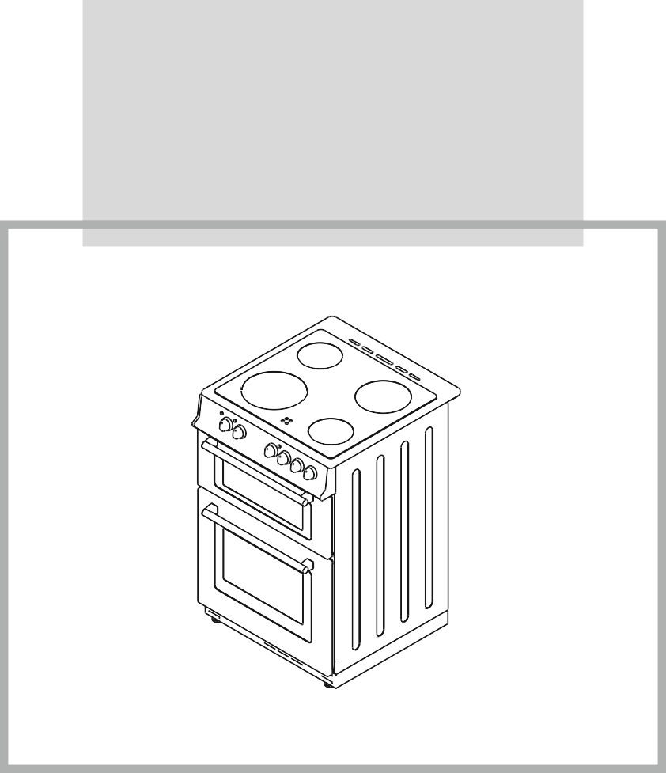
BEL FS50EDOC BLK/444443928 BEL FS50EDOC WHI/444443927 BEL FS50EDOFC BLK/444443930 BEL FS50EDOFC WHI/444443929 BEL FS50EDOPC STA/444443931

OPERATING AND INSTALLATION INSTRUCTIONS OF
ELECTRIC DOUBLE OVEN

Dear Customer,
Thank you for purchasing this Cooking Appliance. The safety precautions and recommendations in these instructions are for your own safety and that of others. They will also provide a means by which to make full use of the features offered by your appliance.
Please keep this booklet in a safe place. It may be useful in future, either to yourself or to others in the event that doubts should arise relating to its operation.
This appliance must be used only for its intended purpose, that is for the domestic cooking of foodstuffs. Any other form of usage is to be considered as inappropriate and therefore dangerous.
The manufacturer declines all responsibility in the event of damage caused by improper or incorrect use of the appliance.

CE Declaration of conformity
This cooking appliance has been designed to be used only for cooking. Any other use (such as heating a room) is improper and dangerous.
This cooking hob has been designed, constructed and marketed incompliance with:
- Safety requirements of the ''LVD'' Directive 2006/95/EC;
- Safety requirements of the ''EMC'' Directive 2004/108/EC;
- Requirements of the Directive 93/68/EC.

CONTENTS:
  - LAYOUT OF COOKER
  - WARNINGS
  - INSTALLATING YOUR COOKER
  - USING THE PRODUCT
  - CLEANING AND MAINTENANCE
  - SERVICE AND TRANSPORT

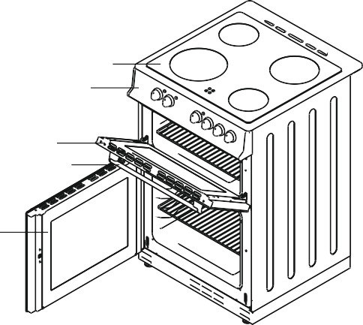
5
1
2
3
4

List of Components
- Cooktop
- Control panel
- Top oven door
- Oven door handle
- Main oven door
- Grid
- Fan cover (BEL FS50EDOFC BLK / BEL FS50EDOFC WHI / BEL FS50EDOPC STA)
- Supply leg

6 Rack 2
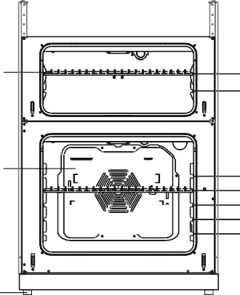
Rack 1

7 Rack 5
Rack 4
Rack 3
Rack 2
Rack 1

8

PLEASE READ THE ENTIRE INSTRUCTION MANUAL CAREFULLY BEFORE USING YOUR APPLIANCE. MAKE SURE TO KEEP THE MANUAL SOMEWHERE SAFE IN CASE YOU NEED IT FOR FUTURE REFERENCE.
THIS INSTRUCTION MANUAL HAS BEEN WRITTEN WITH OUR OTHER COOKER MODELS IN MIND, AS WELL AS YOUR MODEL, THEREFORE SOME OF THE FEATURES THAT YOU SEE EXPLAINED IN THIS MANUAL WILL NOT BE APPLICABLE TO YOUR COOKER.
PLEASE PAY PARTICULAR ATTENTION TO THE INSTRUCTIONS THAT HAVE ACCOMPANYING PICTURES WHEN READING THIS MANUAL.
General Safety Warnings
- This appliance can be used by children aged from 8 years and above and persons with reduced physical, sensory or mental capabilities or lack of experience and knowledge if they have been given supervision or instruction concerning use of the appliance in a safe way and understand the hazards involved. Children shall not play with the appliance. Cleaning and user maintenance shall not be made by children without supervision.
- WARNING: The appliance and its accessible parts become hot during use. Care should be taken to avoid touching heating elements.
Children less than 8 years of age shall be kept away unless continuously supervised.
- WARNING: Unattended cooking on a hob with fat or oil can be dangerous and may result in fire. NEVER try to extinguish a fire with water, but switch off the appliance and then cover flame
e.g. with a lid or a fire blanket.
- WARNING: Danger of fire: do not store items on the cooking surfaces.

- WARNING: If the surface is cracked, switch off the appliance to avoid the possibility of electric shock.
- For hobs incorporating a lid, any spillage should be removed from the lid before opening. And also the hob surface should be allowed to cool before closing the lid.
- The appliance is not intended to be operated by means of an external timer or separate remote- control system.
- WARNING: In order to prevent tipping of the appliance, the stabilizing brackets must be installed. (For detail information please read the anti-tilting kit set guide.)
- During use, the appliance becomes hot. Care should be taken to avoid touching heating elements inside the oven.
- During use, handles held for short periods in normal use can get hot.
- Do not use harsh abrasive cleaners or sharp metal scrapers to clean the oven door glass and other surface since they can scratch the surface, which may result in shattering of the glass or damage to the surface.
- Do not use steam cleaners for cleaning the appliance.

- WARNING: Ensure that the appliance is switched off before replacing the lamp to avoid the possibility of electric shock.
- CAUTION: Accessible parts may be hot when the cooking or grilling is in use. Young children should be kept away.
- Your appliance is produced in accordance with all applicable local and international standards and regulations.
- Maintenance and repair work must be made only by authorized service technicians. Installation and repair work that is carried out by unauthorized technicians may endanger you. It is dangerous to alter or modify the specifications of the appliance in any way.
- Prior to installation, ensure that the local distribution conditions (nature of the gas and gas pressure or electricity voltage and frequency) and the requirements of the appliance are compatible. The requirements for this appliance are stated on the label.
- CAUTION: This appliance is designed only for cooking food and is intended for indoor domestic household use only and should not be used for any other purpose or in any other application, such as for non-domestic use or in a commercial environment or room heating.
- Do not try to lift or move the appliance by pulling the door handle.
- All possible security measures have been taken to ensure your safety. Since the glass may break, you should be careful while cleaning to avoid scratching. Avoid hitting or knocking on the glass with accessories.
- Ensure that the supply cord is not wedged during the installation. If the supply cord is damaged, it must be replaced by the manufacturer, its service agent or similarly qualified persons in order to prevent a hazard.
- While the oven door is open, do not let children climb on the door or sit on it.
Installation Warnings
- Do not operate the appliance before it is fully installed.
- The appliance must be installed and put into use by an authorized technician. The producer is not responsible for any damage that might be caused by defective placement and installation by unauthorized people.
- When you unpack the appliance, make sure that it is not damaged during transportation. In case of any defect; do not use the appliance and contact a qualified service agent immediately. As the materials used for packaging (nylon, staplers, styrofoam...etc) may cause harmful effects to children, they should be collected and removed immediately.
- Protect your appliance against atmospheric effects. Do not expose it to effects such as sun, rain, snow etc.
- The surrounding materials of the appliance (cabinet) must be able to withstand a temperature of min 100°C.

During usage
- When you first run your oven a certain smell will emanate from the insulation materials and the heater elements. For this reason, before using your oven, run it empty at maximum temperature for 45 minutes. At the same time you need to properly ventilate the environment in which the product is installed.
- During usage, the outer and inner surfaces of the oven get hot. While opening the oven door, step back to avoid the hot steam coming out of the oven. There may be a risk of burns.
- Do not put flammable or combustible materials, in or near the appliance when it is operating.
- Always use oven gloves to remove and replace food in the oven.
- Do not leave the cooker while cooking with solid or liquid oils. They may catch fire on condition of extreme heating. Never pour water on to flames that are caused by oil. Cover the saucepan or frypan with its cover in order to choke the flame that has occured in this case and turn the cooker off.
- Always position pans over the centre of the cooking zone, and turn the handles to a safe position so they cannot be knocked or grabbed.
- IIf you are not using the appliance for a long time, turn it off. Keep the main control switch off. Also when you do not use the appliance, keep the gas valve off.
- Make sure the appliance control knobs are always in the "0" (stop) position when it is not used.
- The trays incline when pulled out. Be careful not to let hot liquid spill over.
- When the door or drawer of the oven is open, do not leave anything on it. You may unbalance your appliance or break the cover.
- Do not put heavy things or flammable or ignitable goods (nylon, plastic bag, paper, cloth...etc) into the drawer. This includes cookware with plastic accessories (e.g. handles).
- Do not hang towels, dishcloths or clothes from the appliance or its handles.
During cleaning and maintenance
- Always turn the appliance off before operations such as cleaning or maintenance. You can do it after unplugging the appliance or turning the main switches off.
- Do not remove the control knobs to clean the control panel.
TO MAINTAIN THE EFFICIENCY AND SAFETY OF YOUR APPLIANCE, WE RECOMMEND YOU ALWAYS USE ORIGINAL SPARE PARTS AND TO CALL ONLY OUR AUTHORIZED
SERVICE AGENTS IN CASE OF NEED.

PART 3: INSTALLING YOUR COOKER
Manufactured with the best quality parts and material, this modern, functional and practical cooker aims to meet all your cooking needs. Read the manual carefully to familiarise yourself with the functions of the appliance so that you know how to use it successfully and safely. The information below contains rules that are necessary for positioning it correctly and for any service work that may need to be done. All information should be read without fail, especially by the technician who will position the appliance.
CONTACT A QUALIFIED AND AUTHORIZED TECHNICIAN TO INSTALL YOUR COOKER

POSITIONING THE COOKER
    - There are several factors to consider when choosing a place for your cooker. Follow our advice below in order to prevent any problems and dangerous situations from happening.
    - Furniture can be placed in the surrounding area of the cooker, providing that the furniture's height does not exceed the height of the cooker panel.
    - When choosing a place for your cooker, do not to place it near a refrigerator and make sure there are no flammable or combustible materials in the surrounding area that could catch fire with a cooker nearby, such as curtains, oil, cloth etc.
    - Make sure there is at least a 2cm gap between the back cover of the cooker and the wall to help the air circulate.
    - Any furniture near the cooker must be made of materials that are resistant to heat 50°C more than the room temperature.
    - This double oven cooker is designed to fit between two kitchen cabinets spaced over 500mm apart. The space each side of the cooker needs to be enough to allow the oven to be taken in and out in case it needs servicing.
    - You can place this cooker with cabinets on one or both sides as well as in a corner position. It can also stand alone.
    - The furniture close to cooker must be manufactured resistant to heat more than 50 C° of the room temperature.
    - The cooker is designed to fit between kitchen cabinets spaced over 500 mm apart. The space either side of the cooker need only be sufficient to allow withdrawal of the cooker for servicing. It can be used with cabinets on one side or both sides as well as in a corner setting. It can also be used free-standing.

3.2 ADJUSTING THE LEVELLING LEGS
This cooker stands on 4 levelling legs. As the legs are initially on a lower position, you must adjust them to make sure the cooker is balanced before using it. If you need to balance the cooker, the legs can be adjusted by turning them clockwise. You can raise the cooker by a maximum of 15mm with the levelling legs. If you have had to adjust the cooker with the levelling legs make sure to move the cooker by lifting it rather than dragging it. The levelling leg can be adjusted by hand or a suitable size coin.
3.3 ELECTRIC CONNECTION AND SAFETY

When it comes to connecting you appliance, please follow the instructions below carefully.
    - Before carrying out the electrical connection, make sure that the current carrying capacity of your mains electricity supply and your socket is suitable for the maximum power rating of the cooker.
    - Before proceeding with the electrical connection, verify that the current carrying capacity of the system and the socket is adequate for the maximum power rating of the oven.
    - Electrical installation of the residence and the electrical current plug in use must be earthed and conform to safety regulations.
    - A circuit breaker with a contact opening of at least 3 mm must be installed inside the supply circuit.
    - Do not use adaptors, multiple sockets and/or extension leads.
    - Fused switch must be accessible once the oven has been installed.
IMPORTANT: The following diameters of the supply cables must be used in the case of a one phase connection:

Rated power on nameplate: | Diameter of supply cable: | Rated power on nameplate: | Diameter of supply cable:
5000W -8700W at 220V: | 3 x 2.5 mm² | > 8700W at 220 V | 3 x 4.0 mm²
5000W -9100W at 230V: | 3 x 2.5 mm² | > 9100W at 230 V | 3 x 4.0 mm²
5000W -9500W at 240V: | 3 x 2.5 mm² | > 9500W at 240 V | 3 x 4.0 mm²

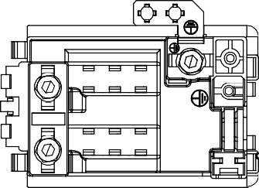
Connection diagram is given below.

This appliance must be earthed.
For this connection, ‘ Twin and Earth 6242Y’ type cable should be used.
L N
PE

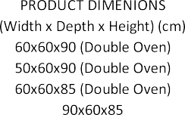
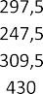
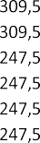

3.4 INSTALLING THE ANTI-TILTING BRACKET
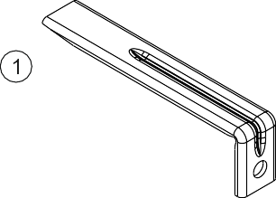

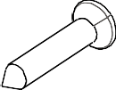

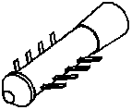
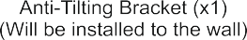
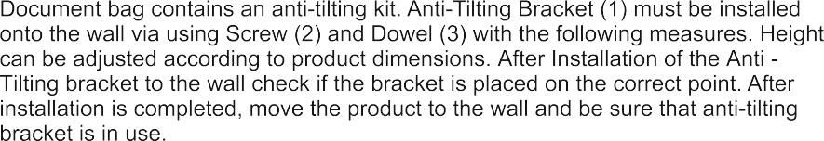
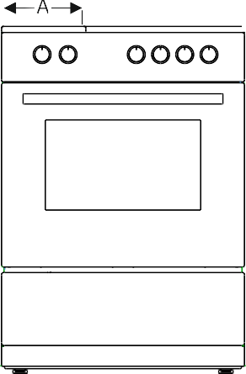
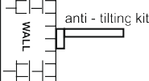
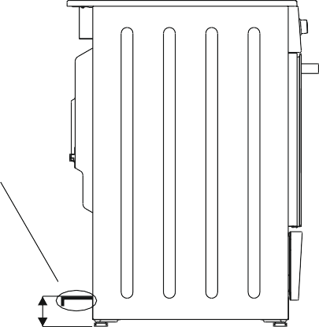

11

PART 4: USING THE PRODUCT

4.1 TECHNICAL SPECIFICATIONS FOR TOP AND MAIN OVENS

TOP OVEN OF 50x60 COOKER | RATING
Top Heating Element | 500W
Bottom Heating Element | 600W
Grill Heating Element | 1400W
MAIN OVEN OF 50x60 COOKER | RATING
Top Heating Element | 1000W
Bottom Heating Element | 1000W
Ring Heating Element | 2000W
CERAMIC HOB | RATING
145mm Radiant | 1200W
180mm Radiant | 1700W
The availability of a heating element varies according to the specification of products.

4.2. USING YOUR COOKER
The control panel of the cooker is shown below.
BEL FS50EDOFC BLK / BEL FS50EDOFC WHI

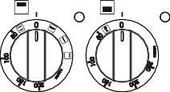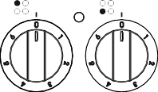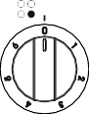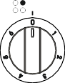
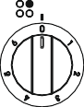
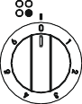
BEL FS50EDOPC STA
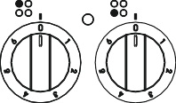
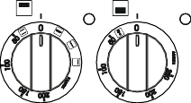

BEL FS50EDOC BLK / BEL FS50EDOC WHI

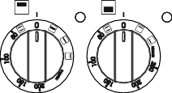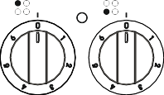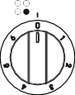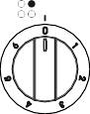

4.3. USING THE COOKTOP BURNERS
The hob part of the cooker is operated by 4 control knobs, one for each burner. Each control knob has 7 positions on the control panel for a more precise heat control. Position “0” is the off position and the other 6 positions are ideal for different cooking styles. See our recommendations below:
1: This keeps heat at a constant and minimum temperature which is ideal for heating soups and other liquids.
2-3: These two middle heat positions are good for simmering and heating foods.
4-5-6: These settings are ideal for boiling, frying and cooking larger quantities of food.
The knob rotation direction may differ according to the product specification.
We recommend you use pans with a flat base for an equal heat dispersion to the food.
Make sure the cookware is a suitable size for the size of the hob heating element and that the pan is centred on the heating element for the most efficient usage of the hob.

pot WRONG und
bottom is ro
pot buttom is small
WRONG
pot butt WRONG t sit well
om does no
CORRECT
After using any hob,please make sure that it is switched off.
Never touch any heating element after it has been turned off because it keeps its heat for a while afterwards.
Some ceramic models may have hot surface warning light.
Clean the cooker with a wet cloth after use. Stubborn marks can come off easier with water and cleaning detergent.

4.4 USING THE OVEN
BEL FS50EDOPC STA

4.4.1 Using your digital timer
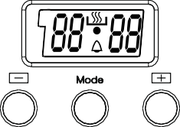  A | Setting the clock:  You must set the clock before you can use the oven.  ·When your oven is connected to a power supply for the first time, the symbol (A) in the corner and the clock showing 00:00 will be flashing.  ·Press the (+) and (-) keys at the same time and the symbol [insert symbol here] with a black dot beneath it will appear on the screen.  ·When the dot begins to flash, you can set the time by using the (+) and (-) buttons.  ·When you finish setting the time, the dot will stop flashing.  When you first connect the oven to the power supply and then control display starts to flash, you cannot operate the oven via these buttons until you have set the time. When you have set the time and the [insert symbol] symbol appears, you can then operate the oven.  In the event of a power cut, the time will go back to 00:00, so remember to readjust it again.

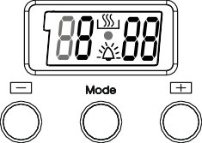  A | Minute minder:  This function uses the digital timer to countdown a pre- set time and alert you of the end of the time with an audible warning.  Press the MODE key in the middle. The display will show 0:00 and the symbol will start to flash. Use the (+) and (-) keys to set the amount of time you want the oven to count down from whilst the symbol is still flashing. A few seconds after you have selected the time, the symbol will stop flashing and it will remain lit to show the time is set.  The audible warning time can be set to countdown a time ranging between 0 and 23.59.  When the time is up, an audible warning will sound and the  symbol will start to flash. Press any key to stop the beeping sound and the symbol will disappear from the screen.  This function will only warn you of the end of a pre-set time. The oven cannot be activated via this function.
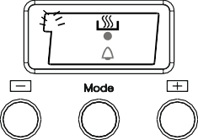  A du r | Semi-Automatic Time Adjustment According to Cooking Time  This function is used to cook for a set duration.  - Put the food you want to cook in the oven.  - Use the control knobs to select the cooking function and temperature you want depending on the food.  - Next, keep pressing MODE until you see “dur” appear on the screen and the “A” symbol is flashing.  - Adjust the cooking period/time for the food you want to cook, using the (+) and (-) buttons  - A cooking time between 0 and 10 hours can be set.

- A few seconds after you have set the time, the current day's time will appear again on the screen.
- The “A” symbol stops flashing, the [cooking symbol] will appear and both will remain lit to show the time is set.
- The oven will continue to operate on the set function and the timer will begin.
- Once the set time is up, the oven will stop operating and will give an audible warning.
- The “A” symbol will begin to flash
- Press any button to stop the audible warning
- Turn the function and thermostat control knobs to “0”
- You can now manually operate the oven again
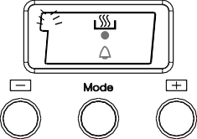  A En d | Semi-Automatic Programming according to Finish Time  Use this programme if you want your cooking to cook for a certain duration but also finish at a certain time of day.  - Put the food you want to cook in the oven.  - Use the control knobs to select the cooking function and temperature you want depending on the food.  - Keep pressing MODE until you see “End” appear on the screen and the symbol “A” and the day's time is flashing.  - Adjust the time to the time of day that you want the cooking to finish by using the (+) and (-) buttons.  - You can set a time up to 10 hours after the current day's time.  - A few seconds after you have set the time, the current day's time will appear again on the screen.  - The “A” symbol stops flashing, the will appear and both will remain lit to show the time is set.  - The oven will continue to operate on the set function and the timer will begin.  - Once the set time is up, the oven will stop operating and will give an audible warning.  - The “A” symbol will begin to flash  - Press any button to stop the audible warning  - Turn the function and thermostat control knobs to “0”  - You can now manually operate the oven again.  If you want to cancel and return the oven to manual operation, press the (+) and (-) buttons at the same time.

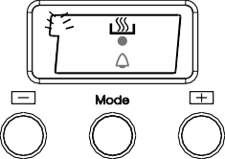  A du r  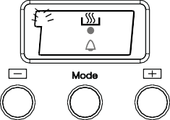  A En d | Full-Automatic Programming:  This function will get the oven to begin operating at a certain time depending on the cooking duration and end time you have set.  Step 1:  - Put the food you want to cook in the oven.  - Use the control knobs to select the cooking function and temperature you want.  - Next, keep pressing MODE until you see “dur” appear on the screen and the “A” symbol is flashing.  - Adjust the cooking period/time for the food you want to cook, using the (+) and (-) buttons  - A cooking time between 0 and 10 hours can be set.  - A few seconds after you have set the time, the current day's time will appear again on the screen.  - The “A” symbol stops flashing, the will appear and both will remain lit to show the time is set.  Step 2:  - Then keep pressing MODE again until you see “End” appear on the screen and the symbol “A” and the day's time is flashing with the addition of the cooking period.  - Adjust the time to the time of day that you want the cooking to finish by using the (+) and (-) buttons.  - You can set a time up to 10 hours after the current day's time.  - A few seconds after you have set the time, the current day's time will appear again on the screen.  - The “A” symbol stops flashing, the will appear and both will remain lit to show the time is set.  Step 3:  - The oven will start at the time calculated by deducting the cooking period from the set finishing time.  - Once the set time is up, the oven will stop operating and will give an audible warning.  - The “A” symbol will begin to flash  - Press any button to stop the audible warning  - Turn the function and thermostat control knobs to “0”  - You can now manually operate the oven again

4. 4. 2 Using the Top Oven
The switch for top oven allows you to select the oven fonctions. The symbols and their functions are briefly explained in the following lines. The detailed information for their usage will also be explained in the following pages.


Top and bottom heating function Top heating function
Grill function
Double grilling function

Top and bottom heating function
During this function, the top and bottom heating elements ensure that food is cooked equally top and bottom. To operate, turn the top oven's control knob until you see the relevant symbol, then set desired temperature and let it pre-heat for 10 minutes. Make sure you turn the top oven knob to “0” after cooking, take the cooking tray out and put it in a safe place to cool. Keep children away from the hot oven during and after grilling, until it has cooled completely.

Top heating function
This function is appropriate for frying the upper side of allready cooked food and heating food, instead of cooking. Turn your top oven's switch as it will show the sign of this function and place the tray on the grid.
At the end of heating period, turn the top oven switch off. Take the cooking tray out and put it onto a safe place. Keep the children away from hot oven during and after heating, until it is cool completely.
Warning: Top oven door must be kept closed during this function.

Grill Function
This function will grill dishes and snacks. Please use the grill pan supplied with your cooker when you come to grill to prevent food splatters from dripping down to the shelves below. For more grilling details, see the grilling chart .
To operate, turn the control knob to the correct symbol and then turn the knob to “0”

when you finish grilling. Take the hot grill pan out the oven by using the handle and put the pan onto a secure surface. Keep children away from the hot oven during and after grilling, until it has cooled completely.
Warning: Top cavity door should be kept open during this function.  Double grilling function
This function is used for wider area grilling. Please use the grill pan supplied with your cooker when you come to grill to prevent food juices and splatters from dripping down to the shelves below. For more grilling details, see the grilling chart. To operate, turn the control knob to the correct symbol and then turn the knob to “0” when you finish grilling. Take the hot grill pan out the oven by using the handle and put the pan onto a secure surface. Keep children away from the hot oven during and after grilling, until it has cooled completely.
Warning: Top oven door should be kept open during this function.

4.4.3 Using the Main Oven
Use the main oven control knob to select a cooking function. The symbols and their functions for this oven are listed below and a more in-depth explanation of the functions will be in the following pages.

Defrost function
Fan and ring heating function
Top and bottom heating function (BEL FS50EDOC BLK / BEL FS50EDOC WHI)
Bottom heating function (BEL FS50EDOC BLK / BEL FS50EDOC WHI)
Top heating function (BEL FS50EDOC BLK / BEL FS50EDOC WHI)

Defrost function
To use the defrost function, place your frozen food in the oven on a shelf that's on the third slot from the bottom and turn the control dial to the defrost symbol. We recommend you place an oven tray under the defrosting food to catch any melting ice that drips off it whilst thawing. This function will not cook or bake your food, it will only help to defrost it.

Fan and ring heating function
This function spreads heated air equally in the oven and it is appropriate for single or more trays cooking.
Turn your main oven's switch and set the temperature. If available, adjust the digital programmer. Place the tray on the grid. It is recommended to preheat for 10 minutes. If you have two trays of food that you will cook in your oven; you must use that heat for your oven, heat of which of the heats that is appropriate for your food while adjusting the cooking heat. Cooking two trays of food requires additional cooking period according to the single tray cooking. In general, foods in two trays are not cooked at the same time. So, take the tray that you observed that is cooked, from the oven, go on cooking for the other tray of food. As there will be heat transfer between two trays during the cooking of two trays of food, the cooking quality will be lower than the single tray. While cooking double trays, you can get a better cooking result by changing the places and ways of trays if needed. For details, please see the cooking table.
At the end of cooking period, as in all other cooking processes; turn the top oven switch and thermostat switch off. Take the cooking tray out and put it onto a safe place.Keep the children away from hot oven during and after cooking, until it is cool completely.

Top and bottom heating function
During this function, the top and bottom heating elements ensure that food is cooked equally top and bottom. To operate, turn the main oven's control knob until you see the relevant symbol, set the desired temperature and let it pre-heat for 10 minutes. To see what you can cook on this function, see the cooking table. Make sure you turn the top oven knob to “0” after cooking, take the cooking tray out and put it in a safe place to cool. Keep children away from the hot oven during and after operating, until it has cooled completely.

Bottom heating function
This function is appropriate for heating food rather than cooking it. Turn your main oven's switch as it will show the sign of this function and place the tray on the grid.
At the end of heating period, turn the main oven switch off. Take the cooking tray out and put it onto a safe place. Keep the children away from hot oven during and after heating, until it is cooled completely.

Top heating function
This function is appropriate for frying the upper side of allready cooked food and

heating food, instead of cooking. Turn your main oven's switch as it will show the sign of this function and place the tray on the grid.
At the end of heating period, turn the main oven switch off. Take the cooking tray out and put it onto a safe place. Keep the children away from hot oven during and after heating, until it is cooled completely.

4.5. USING THE GRILL PAN HANDLE SET

Warning : Always use an oven glove to protect your hand when using the grill as all the metal parts can become very hot!
This grill pan has a detachable handle, so make sure the handle is centralised and attached securely as in the picture on the next page.
Do not leave the handle in position when grilling. If the handle is left on the pan when grilling, it will get extremely hot.

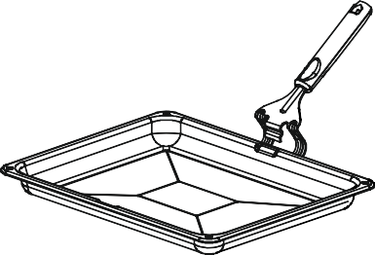
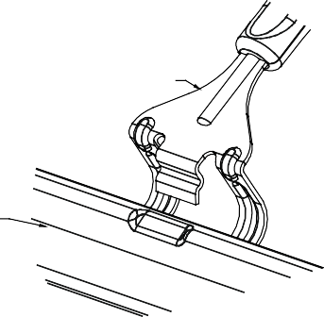
Grill Pan Handle

Grill Pan

Wire grid
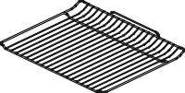 | Wire grid is used to grill or to place different cookwares on it.  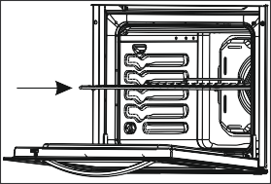  WARNING- Fit the grid correctly into any corresponding rack in the oven cavity and push it to the end.

4.6. HEAT DEFLECTOR

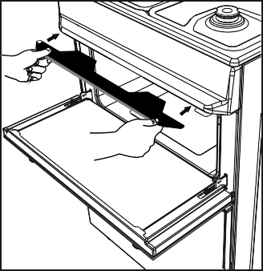
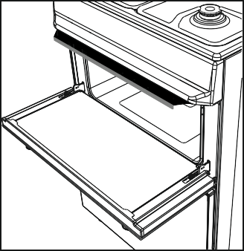
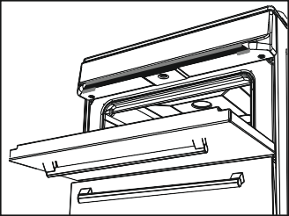




Warning:
When operating the grill for periods in excess of 15 minutes, always fit the heat deflector provided, avoiding exposure to exposure to excessive control knob temperature. Care should be taken when returning the grill door to the vertical closed position, avoiding hand contact with the deflector. The heat deflector should be allowed to cool prior to removal.


22

4.7. COOKING RECOMMENDATIONS

Top oven cooking chart
Food | Cooking Temperature | Time(min.) | Rack position
Small Cakes | 160-185 | 20-25 | 1(From Bottom)
Burgers | Max position | 20-25 | 2(From Bottom)
Beef | Max position | 25-30 | 2(From Bottom)
Toast | Max position | 5-10 | 2(From Bottom)
    - Main oven cooking chart

Food | Cooking Temperature | Time(min.) | Rack position
Small Cakes | 160-185 | 20-25 | 2-3(From Bottom)
Fatless Sponge Cake | 150-160 | 30-40 | 2(From Bottom)

PART 5: CLEANING AND MAINTENANCE

5.1 GENERAL
- Before cleaning your cooker, make sure that all control knobs are in the “0” position and that the oven has cooled down.
- Before you clean, check whether the cleaning equipment and detergents you use are appropriate for the cooker, and what is recommended by the manufacturer.
- Use cream cleaners or liquid cleaners which do not contain particles. Do not use caustic (corrosive) creams, abrasive cleaning powders, rough wire wool or hard tools, as they may damage the cooker surfaces.
- Do not use cleaners that contain particles, as they might scratch enamelled and painted parts of your cooker.
- If you spill excess cleaning liquid on the cooker, wipe it up immediately as it may cause damage to the enamel.
- Do not use steam cleaners for cleaning any part of the cooker.
5.2 CLEANING THE CERAMIC HOB

Make sure you unplug and turn off the cooker before cleaning it.
- Before you start cleaning, make sure the hob has completely cooled down
- Do not use cleaners that contain particles, as they might scratch the glass.
- Use cream or liquid detergent
- After using cleaning detergent, wipe the hob down with cold water and a soft cloth to ensure no cleaning liquid is left on the surface.
- Sugary or sweet foods must be cleaned straightaway after the glass has cooled down
- Do not use cleaning materials meant for steel as they may damage the glass
- Dust on the surface must be cleaned with a wet cloth

Colour changes to the ceramic glass
Colour changes to the ceramic glass may be for a number of reasons:
- Spilt food has not been cleaned off the surface
- Using incorrect dishes on the hob which erodes the surface.
- Using the wrong cleaning materials
Any changes in colour to the ceramic glass does not affect the structure or durability of the ceramic and is not due to a change in the material.

5.3 REMOVING AND REASSEMBLING THE OVEN DOOR

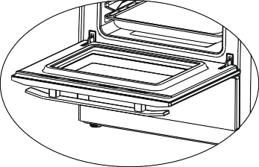
To remove the oven door;
1
  - Open the oven door(1).
  - Open the saddle bracket up to end position(2).
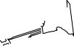
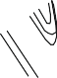

  - Close the door till it almost reaches trod the full closed position as shown in 3
Saddle bracket
Recessed form
2
figure and remove the door by pulling it towards yourself.
NOTE: To re-assemble the door follow the opposite
rules of removal.

Please pay attention that the recessed forms should be positioned properly on the hinge counterparts as shown on 2nd figure.
3
!

5.4 MAINTENANCE

Replacing the Oven Light
We recommend you have the oven light changed by an authorised technician. The rating of the new lamp should be 230V, 25 Watt, Type E14.
- Unplug the cooker and make sure it has cooled down properly.
- Remove the lid in front of the light.
- Take the old bulb out.
- Insert a new bulb that has a heat resistance of 300°C.
- Put the protective lid back in front of the light.

PART 6: SERVICE AND TRANSPORT
6.1 TROUBLESHOOTING BEFORE CONTACTING A REPAIR SERVICE

If the oven is not working:
- Make sure the cooker is plugged in and switched on.
- Check other appliances to make sure there hasn't been a power cut.
- If your model has a timer, make sure the timer is set properly because it may not be regulating the time.

If the oven does not heat:
- Make sure the heat has been adjusted on the control knob.

If the interior oven lamp is not lighting
- Make sure the electricity being supplied to the oven is controlled.
- If the oven lamp is faulty then you can change them as recommended in section 5.2 in the manual

If food is not cooking equally on upper and lower sections:
- Try repositioning the shelves
- Change the length of cooking duration and heat level according to the manual

If you still have any problems with the issues above after trying the required steps, then please call in an authorised technician.
6.2 HOW TO TRANSPORT YOUR COOKER

Keep the original packaging materials in a safe place so that if you need to transport the cooker again, you can use its original packaging. Follow the instructions that are printed on the packaging to pack it securely.
If you no longer have the original packaging then make sure that all exterior panels and glass surfaces of the product are well protected before moving it.
This cooker must be transported in an upright position.

 | Brand
 | Model |  | BEL FS50EDOC BLK BEL FS50EDOC WHI
 | Type of Oven |  | ELECTRIC
 | Mass | kg | 44,6
Upper Cavity | Energy Efficiency Index - conventional |  | 119,1
Upper Cavity | Energy Efficiency Index - fan forced |  | -
Upper Cavity | Energy Class |  | B
Upper Cavity | Energy consumption (electricity)  - conventional | kWh/cycle | 0,81
Upper Cavity | Energy consumption (electricity)  - fan forced | kWh/cycle | -
Upper Cavity | Heat Source |  | ELECTRIC
Upper Cavity | Volume | l | 31
Lower Cavity | Energy Efficiency Index - conventional |  | 105,0
Lower Cavity | Energy Efficiency Index - fan forced |  | -
Lower Cavity | Energy Class |  | A
Lower Cavity | Energy consumption (electricity)  - conventional | kWh/cycle | 0,82
Lower Cavity | Energy consumption (electricity)  - fan forced | kWh/cycle | -
Lower Cavity | Heat Source |  | ELECTRIC
Lower Cavity | Volume | l | 55
 | Number of cavities |  | 2
 | This oven complies with EN 60350-1
Energy Saving Tips

Oven
- Cook the meals together, if possible.

- Keep the pre-heating time short.

- Do not elongate cooking time.

- Do not forget to turn-off the oven at the end of cooking.

- Do not open oven door during cooking period.

 | Brand
 | Model |  | BEL FS50EDOFC BLK BEL FS50EDOFC WHI BEL FS50EDOPC STA
 | Type of Oven |  | ELECTRIC
 | Mass | kg | 44,6
Upper Cavity | Energy Efficiency Index - conventional |  | 119,1
Upper Cavity | Energy Efficiency Index - fan forced |  | -
Upper Cavity | Energy Class |  | B
Upper Cavity | Energy consumption (electricity)  - conventional | kWh/cycle | 0,81
Upper Cavity | Energy consumption (electricity)  - fan forced | kWh/cycle | -
Upper Cavity | Heat Source |  | ELECTRIC
Upper Cavity | Volume | l | 31
Lower Cavity | Energy Efficiency Index - conventional |  | -
Lower Cavity | Energy Efficiency Index - fan forced |  | 103,7
Lower Cavity | Energy Class |  | A
Lower Cavity | Energy consumption (electricity)  - conventional | kWh/cycle | -
Lower Cavity | Energy consumption (electricity)  - fan forced | kWh/cycle | 0,81
Lower Cavity | Heat Source |  | ELECTRIC
Lower Cavity | Volume | l | 55
 | Number of cavities |  | 2
 | This oven complies with EN 60350-1
Energy Saving Tips

Oven
- Cook the meals together, if possible.

- Keep the pre-heating time short.

- Do not elongate cooking time.

- Do not forget to turn-off the oven at the end of cooking.

- Do not open oven door during cooking period.

Brand
Model |  | BEL FS50EDOC BLK BEL FS50EDOC WHI BEL FS50EDOFC BLK BEL FS50EDOFC WHI BEL FS50EDOPC STA
Type of Hob |  | Electric
Number of Cooking Zones |  | 4
Heating Technology-1 |  | Radiant
Size-1 | cm | Ø14,5
Energy Consumption-1 | Wh/kg | 192,0
Heating Technology-2 |  | Radiant
Size-2 | cm | Ø14,5
Energy Consumption-2 | Wh/kg | 192,0
Heating Technology-3 |  | Radiant
Size-3 | cm | Ø18,0
Energy Consumption-3 | Wh/kg | 192,0
Heating Technology-4 |  | Radiant
Size-4 | cm | Ø18,0
Energy Consumption-4 | Wh/kg | 192,0
Energy Consumption of Hob | Wh/kg | 192,0
This hob complies with EN 60350-2
Energy Saving Tips

Hob
- Use cookwares having flat base.

- Use cookwares with proper size .

- Use cookwares with lid.

- Minimize the amount of liquid or fat.

- When liquid starts boiling , reduce the setting.



The symbol on the product or on its packaging indicates that this product may not be treated as household waste. Instead it shall be handed over to the applicable collection point for the recycling of electrical and electronic equipment. By ensuring this product is disposed of correctly, you will help prevent potential negative consequences for the environment and human health, which could otherwise be caused by inappropriate waste handling of this product. For more detailed information about recyling of this product, please contact your local city office, your household waste disposal service or the shop where you purchased the product.

