User Manual
FRF60W

CONTENTS


Safety information 2
Safety instructions. 4
Operation 6
First use. 8
Daily use 9
Hints and tips 10
Care and cleaning 11
Troubleshooting 13
Installation 16
Technical information 20

Before the installation and use of the appliance, carefully read the supplied instructions. The manufacturer is not responsible if an incorrect installation and use causes injuries and damages. Always keep the instructions with the appliance for future reference.
Children and vulnerable people safety
- This appliance can be used by children aged from 8 years and above and persons with reduced physical, sensory or mental capabilities or lack of experience and knowledge if they have been given supervision or instruction concerning use of the appliance in a safe way and understand the hazards involved.
- Do not let children play with the appliance.
- Cleaning and user maintenance shall not be made by children without supervision.
- Keep all packaging away from children.
General Safety
- This appliance is intended to be used in household and similar applications such as:
  - Farm houses; staff kitchen areas in shops, offices and other working environments
  - By clients in hotels, motels, bed and breakfast and other residential type environments
- Keep ventilation openings, in the appliance enclosure or in the built-in structure, clear of obstruction.
- Do not use mechanical devices or other means to accelerate the defrosting process, other than those recommended by the manufacturer.
- Do not damage the refrigerant circuit.
- Do not use electrical appliances inside the food storage compartments of the appliance, unless they are of the type recommended by the manufacturer.
- Do not use water spray and steam to clean the appliance.

- Clean the appliance with a moist soft cloth. Only use neutral detergents. Do not use abrasive products, abrasive cleaning pads, solvents or metal objects.
- Do not store explosive substances such as aerosol cans with a flammable propellant in this appliance.
- If the supply cord is damaged, it must be replaced by the manufacturer, its Authorised Service Centre or similarly qualified persons in order to avoid a hazard.

Installation
Only a qualified person must install this appliance.
WARNING!
- Remove all the packaging.
- Do not install or use a damaged appliance.
- Obey the installation instruction supplied with the appliance.
- Always be careful when you move the appliance because it is heavy. Always wear safety gloves.
- Make sure the air can circulate around the appliance.
- Wait at least 4 hours before connecting the appliance to the power supply. This is to allow the oil to flow back in the compressor.
- Do not install the appliance close to radiators or cookers, oven or hobs.
- The rear of the appliance must stand against the wall.
- Do not install the appliance where there is direct sunlight.
- Do not install this appliance in areas that are too humid or too colds, such as the construction appendices, garages or wine cellars.
- When you move the appliance, lift it by the front edge to avoid scratching the floor.

Electrical connection
Risk of fire and electrical shock.
WARNING!
- The appliance must be earthed.
- Make sure that the electrical information on the rating plate agrees with the power supply. If not, contact an electrician.
- Always use a correctly installed shockproof socket.
- Do not use multi-plug adapters and extension cables.
- Make sure not to cause damage to the electrical components (e.g. mains plug, mains cable, compressor). Contact the Authorised Service Centre or an electrician to change the electrical components.
- The mains cable must stay below the level of the mains plug.
- Connect the mains plug to the mains socket only at the end of the installation. Make sure that there is access to the mains plug after the installation.
- Do not pull the mains cable to disconnect the appliance. Always pull the mains plug.

Use
Risk of injury, burns, electrical shock or fire.
WARNING!
- Do not change the specification of this appliance.
- Do not put electrical appliances (e.g. ice cream makers) in the appliance unless they are stated applicable by the manufacturer.
- Be careful not to cause damage to the refrigerant circuit. It contains isobutane (R600a), a natural gas with a high level of environmental compatibility. This gas is flammable.
- If damage occurs to the refrigerant circuit, make sure that there are no flames and sources of ignition in the room. Ventilate the room.
- Do not let hot items to touch the plastic parts of the appliance.
- Do not put soft drinks in the freezer compartment. This will create pressure on the drink container.
- Do not store flammable gas and liquid in the appliance.
- Do not put flammable products or items that are wet with flammable products in, near or on the appliance.
- Do not touch the compressor or the condenser. They are hot.

- Do not remove or touch items from the freezer compartment if your hands are wet or damp.
- Do not freeze again food that has been thawed.
- Obey the storage instructions on the packaging of frozen food.

Care and cleaning
Risk of injury or damage to the appliance.
WARNING!
- Before maintenance, deactivate the appliance and disconnect the mains plug from the mains socket.
- This appliance contains hydrocarbons in the cooling unit. Only a qualified person must do the maintenance and the recharging of the unit.
- Regularly examine the drain of the appliance and if necessary, clean it. If the drain is blocked, defrosted water collects in the bottom of the appliance.

Disposal
Risk of injury or suffocation.
WARNING!
- Disconnect the appliance from the mains supply.
- Cut off the mains cable and discard it.
- Remove the door to prevent children and pets to be closed inside of the appliance.
- The refrigerant circuit and the insulation materials of this appliance are ozone- friendly.
- The insulation foam contains flammable gas. Contact your municipal authority for information on how to discard the appliance correctly.
- Do not cause damage to the part of the cooling unit that is near the heat exchanger.

Control panel


1 2
3
4 5

- Green On/Off Power Indicator Light
- Temperature Regulator and On/Off Switch
- Yellow Action Freeze Indicator Light
- Acoustic Signal Stop and Action Freeze Switch
- Red Alarm Indicator Light

Switching on
Leave the appliance to stand upright for 4 hours after installation.
- Insert the plug into the wall socket.
- Turn the Temperature Regulator clockwise to a temperature lower than
<< - 16 °C >> position.
The Green On/Off Indicator Light will light up and Red Alarm Indicator Light will blink.
The lighting up of the Green On/Off Indicator Light means that the appliance is switched on.
The blinking of the Red Alarm Indicator Light and the acoustic alarm means an improper temperature in the freezing compartment. Press the Acoustic Signal Stop and Action Freeze Switch to deactivate the acoustic alarm. The alarm indicator continues to flash until the normal conditions are restored.

When switching on the freezer for the first time, the Red Alarm Indicator Light will blink until the internal temperature has reached a level required for the safe conservation of frozen food.

Switching off
- To turn off the appliance, turn the Temperature Regulator to the O position.
The Green On/Of Indicator Light will switch off.
- To disconnect the appliance from the power, disconnect the mains plug from the wall socket.

Red Alarm Indicator Light
Under normal operating conditions, the internal temperature of the freezer will ensure the long-term conservation of the stored food.
The temperature increase above a certain level in the freezer (-12 °C, for example due to an earlier power failure) is indicated by

flashing the Red Alarm Indicator Light and sounding the acoustic alarm.
- Press the Acoustic Signal Stop. The acoustic alarm switches off.
The Red Alarm Indicator Light continues to flash until the internal temperature has reached a level required for the safe conservation of frozen food.
fresh food in the freezer, the Yellow Action Freeze Indicator Light will illuminate. The compressor will now run continuously, to ensure that the fresh food is frozen as quickly as possible.

Temperature regulation

CAUTION!
The temperature within the appliance is controlled by the Temperature Regulator situated on the control panel.
To operate the appliance, proceed as follows:
  - turn the Temperature Regulator toward lower settings to obtain the minimum coldness.
  - turn the Temperature Regulator toward higher settings to obtain the maximum coldness.
- Place the food in the freezing compartment or compartments and leave the Action Freeze function for a further 24 hours.
- Once the food is completely frozen, press the Action Freeze button for 2- 3 seconds and the Yellow Action Freeze Indicator Light will go out.
It is possible to deactivate the function at any time by pressing the Action Freeze button for 2-3 seconds.
- Move frozen food from the freezing compartments into the storing compartments to make room for another freezing.
If the Action Freeze button is accidentally left on, the freezer will not be damaged, but energy will be wasted and it will be automatically switched off 48 hours later. The Action Freeze Indicator Light will also go out.

A medium setting is generally the most suitable.
However, the exact setting should be chosen keeping in mind that the temperature inside the appliance depends on:
  - room temperature
  - how often the door is opened
  - the quantity of food stored
  - the location of the appliance.

Action Freeze function
If more than 3-4 kg of food is to be frozen:
1. Press the Action Freeze button for 2-3 seconds to activate the Action Freeze function 6-24 hours before placing the

Cleaning the interior
Before using the appliance for the first time, the interior and all internal accessories should be washed with lukewarm water and some neutral soap to remove the typical smell of a brand-new product, then dried thoroughly.
Do not use detergents or abrasive powders, as these will damage the finish.
CAUTION!

Refer to Safety chapters.
WARNING!

Freezing fresh food
The freezer compartments are suitable for freezing fresh food and storing frozen and deep-frozen food for a long time.
The maximum amount of food that can be frozen in 24 hours is specified on the rating plate, a label located on the inside of the appliance.
To freeze fresh food activate the Action Freeze function.
The freezing process lasts 24 hours: during this period do not add other food to be frozen.

Storage of frozen food
When first starting-up or after a period out of use, before putting the products in the compartment let the appliance run at least 2 hours on the higher settings.
In the event of accidental defrosting, for example due to a power failure, if the power has been off for longer than the value shown in the technical characteristics chart under "rising time", the defrosted food must be consumed quickly or cooked immediately and then re-frozen (after cooling).

Thawing
Deep-frozen or frozen food, prior to being used, can be thawed in the refrigerator compartment or at room temperature, depending on the time available for this operation.
Small pieces may even be cooked still frozen, directly from the freezer: in this case, cooking will take longer.

Normal operating sounds
The following sounds are normal during operation:
- A faint gurgling and bubbling sound from coils sound when refrigerant is pumped.
- A whirring and pulsating sound from the compressor when refrigerant is pumped.
- A sudden cracking noise from inside appliance caused by thermic dilatation (a natural and not dangerous physical phenomenon).
- A faint click noise from the temperature regulator when the compressor switches on or off.

Hints for energy saving
- Do not open the door frequently or leave it open longer than absolutely necessary.

Hints for freezing
To help you make the most of the freezing process, here are some important hints:
- the maximum quantity of food which can be frozen in 24 hours is shown on the rating plate;
- the freezing process takes 24 hours no further food to be frozen should be added during this period;
- freeze only top quality, fresh and thoroughly cleaned, foodstuffs;
- prepare food in small portions to enable it to be rapidly and completely frozen and to make it possible subsequently to thaw only the quantity required;
- wrap up the food in aluminium foil or polythene and make sure that the packages are airtight;
- do not allow fresh, unfrozen food to touch food which is already frozen, thus avoiding a rise in temperature of the latter;
- lean foods store better and longer than fatty ones; salt reduces the storage life of food;
- water ices, if consumed immediately after removal from the freezer compartment, can possibly cause the skin to be freeze burnt;
- it is advisable to show the freezing in date on each individual pack to enable you to keep tab of the storage time.

Hints for storage of frozen food
To obtain the best performance from this appliance, you should:
- make sure that the commercially frozen foodstuffs were adequately stored by the retailer;
- be sure that frozen foodstuffs are transferred from the foodstore to the freezer in the shortest possible time;
- not open the door frequently or leave it open longer than absolutely necessary;
- once defrosted, food deteriorates rapidly and cannot be refrozen;
- do not exceed the storage period indicated by the food manufacturer.

General warnings
Refer to Safety chapters.
WARNING!
Unplug the appliance before carrying out any maintenance operation.
CAUTION!
4. If accessible, clean the condenser and the compressor at the back of the appliance with a brush.
This operation will improve the performance of the appliance and save electricity consumption.

Defrosting the freezer
This appliance contains hydrocarbons in its cooling unit; maintenance and recharging must therefore only be carried out by authorized technicians.
Never use sharp metal tools to scrape off frost from the evaporator as you could damage it. Do not use a mechanical device or any artificial means to speed up the thawing process other than those recommended by the manufacturer. A temperature rise of the frozen food packs, during defrosting, may shorten their safe storage life.
CAUTION!

Periodic cleaning
The accessories and parts of the appliance are not suitable for washing in a dishwasher.
Do not pull, move or damage any pipes and/or cables inside the cabinet.
CAUTION!
About 12 hours prior to defrosting, set a lower temperature, in order to build up sufficient chill reserve for the interruption in operation.

Take care of not to damage the cooling system.
CAUTION!

When moving the cabinet, lift it by the front edge to avoid scratching the floor.
CAUTION!
The equipment has to be cleaned regularly:
- Clean the inside and accessories with lukewarm water and some neutral soap.
- Regularly check the door seals and wipe clean to ensure they are clean and free from debris.
- Rinse and dry thoroughly.
A certain amount of frost will always form on the freezer shelves and around the top compartment.
Defrost the freezer when the frost layer reaches a thickness of about 3-5 mm.
- Switch off the appliance, or pull out electrical plug from the wall socket.
- Remove any stored food, wrap it in several layers of newspaper and put it in a cool place.
Do not touch frozen goods with wet hands. Hands can freeze to the goods.
WARNING!

- Leave the door open and insert the plastic scraper in the appropriate seating at the bottom centre, placing a basin underneath to collect the defrost

water.
In order to speed up the defrosting process, place a pot of warm water in the freezer compartment. In addition, remove pieces of ice that break away before defrosting is complete.
- When defrosting is completed, dry the interior thoroughly and keep the scraper for future use.
- Switch on the appliance.
After 4 hours reload the previously removed food into the freezer compartment.

Periods of non-operation
When the appliance is not in use for long periods, take the following precautions:
- Disconnect the appliance from electricity supply.
- Remove all food.
- Defrost (if necessary) and clean the appliance and all accessories.
- Leave the door/doors open to prevent unpleasant smells.
If the cabinet will be kept on, ask somebody to check it once in a while to prevent the food inside from spoiling in case of a power failure.
WARNING!

WARNING!
Refer to Safety chapters.
What to do if...
PROBLEM | POSSIBLE CAUSE | SOLUTION
The appliance does not op- | The appliance is switched | Switch on the appliance.
erate. | off.
 | The mains plug is not con- | Connect the mains plug to
 | nected to the mains socket | the mains socket correctly.
 | correctly.
 | There is no voltage in the | Connect a different electrical
 | mains socket. | appliance to the mains sock-
 |  | et. Contact a qualified elec-
 |  | trician.
The appliance is noisy. | The appliance is not suppor- | Check if the appliance
 | ted properly. | stands stable.
Power indicator light is flash- | An error has occurred in | Contact a qualified electri-
ing. | measuring the temperature. | cian or contact the nearest
 |  | Authorized Service Centre.
 | The appliance is not working | Contact a qualified electri-
 | properly. | cian or contact the nearest
 |  | Authorized Service Centre.
The compressor operates | Temperature is set incor- | Refer to "Operation" chap-
continually. | rectly. | ter.
 | Many food products to be | Wait some hours and then
 | frozen were put in at the | check the temperature
 | same time. | again.
 | The room temperature is too | Refer to climate class chart
 | high. | on the rating plate.
 | Food products placed in the | Allow food products to cool
 | appliance were too warm. | to room temperature before
 |  | storing.
 | The door is not closed cor- | Refer to "Closing the door".
 | rectly.
There is too much frost and | The door is not closed cor- | Refer to "Closing the door".
ice. | rectly or the gasket is de-
 | formed/dirty.

TROUBLESHOOTING

PROBLEM | POSSIBLE CAUSE | SOLUTION
 | The water drainage plug is not correctly positioned. | Position the water drainage plug in the correct way.
 | Food products are not wrap- ped properly. | Wrap the food products bet- ter.
 | Temperature is set incor- rectly. | Refer to "Operation" chap- ter.
Door is misaligned or inter- feres with ventilation grill. | The appliance is not levelled. | Refer to "Levelling".
The temperature in the ap- | The temperature regulator is | Set a higher/lower tempera-
pliance is too low/too high. | not set correctly. | ture.
 | The door is not closed cor- rectly. | Refer to "Closing the door".
 | The food products' tempera- ture is too high. | Let the food products tem- perature decrease to room temperature before storage.
 | Many food products are stored at the same time. | Store less food products at the same time.
 | The thickness of the frost is greater than 4-5 mm. | Defrost the appliance.
 | The door has been opened often. | Open the door only if neces- sary.
 | There is no cold air circula- tion in the appliance. | Make sure that there is cold air circulation in the appli- ance.

If the advice does not lead to the desired result, call the nearest Authorized Service Centre.

FRIGIDAIRE-Customer Care and Service
Service and spare parts.
Please contact your Authorised Service Force Centre on: 03445 616616 (Your call will automatically be routed to your local
centre). For the address of your local centre please visit www.serviceforce.co.uk
Please ensure you read the information under "What to do if" in your instruction booklet before contacting us for service. Servicing and/or installation of your product, including electrical connections should be carried out by a suitably qualified engineer. in the user manual you will find some useful information on how to deal with minor faults and how to take care of your product.

When contacting us for Service please ensure that you have your purchase receipt and the following information available:
- Model No.............................
- Serial No..............................
- Product No..........................
- Purchase Date....................
Customer Care. Please contact Frigidaire, Addington Way, Luton, Bedfordshire, LU49QQ. Telephone No. 03445 610528

Closing the door
- Clean the door gaskets.
- If necessary, adjust the door. Refer to "Installation".
- If necessary, replace the defective door gaskets. Contact the Authorised Service Centre.

Refer to Safety chapters.
WARNING!

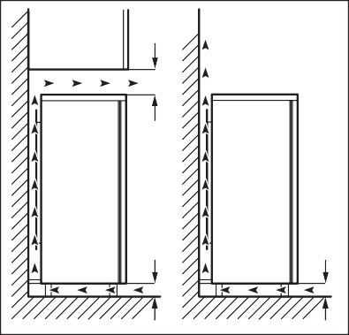
Positioning
100 mm
15 mm
15 mm
This appliance can be installed in a dry, well ventilated indoor where the ambient temperature corresponds to the climate class indicated on the rating plate of the appliance:

CLIMATE AMBIENT TEMPERATURE
CLASS
SN +10°C to + 32°C

N +16°C to + 32°C

ST +16°C to + 38°C

T +16°C to + 43°C

Some functional problems might occur for some types of models when operating outside of that range. The correct operation can only be guaranteed within the specified temperature range. If you have any doubts regarding where to install the appliance, please turn to the vendor, to our customer service or to the nearest Authorised Service Centre.

Levelling
When placing the appliance ensure that it stands level. This can be achieved by two adjustable feet at the bottom in front.


Location
It must be possible to disconnect the appliance from the mains power supply; the plug must therefore be easily accessible after installation.
The appliance should be installed well away from sources of heat such as radiators, boilers, direct sunlight etc. Ensure that air can circulate freely around the back of the cabinet. To ensure best performance, if the appliance is positioned below an overhanging wall unit, the minimum distance between the top of the cabinet and the wall unit must be at least 100 mm . Ideally, however, the appliance should not be positioned below overhanging wall units. Accurate levelling is ensured by one or more adjustable feet at the base of the cabinet.

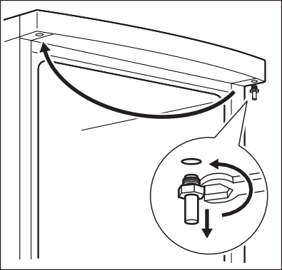
Door reversibility
2
1
Before carrying out any operations, remove the plug from the power socket.
WARNING!

- Tilt back the appliance carefully so that the compressor cannot touch the floor.
To carry out the following operations, we suggest that this be made with another person that will keep a firm hold on the doors of the appliance during the operations.
CAUTION!
- Unscrew both adjustable feet.

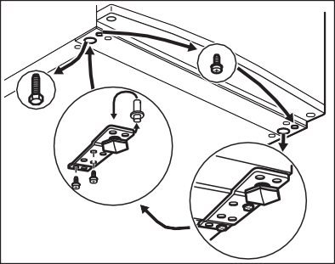
- Unscrew the screws of the door bottom hinge.
- Take off the appliance door by pulling it slightly downwards.
- Unscrew the top door hinge pin of the appliance then screw it back on the other side.

- Fit the appliance door on the upper door hinge pin.
- Remove the lower hinge. Put over the pin in the direction of the arrow.
- Unscrew and install the screw on the opposite side.
- Install the lower hinge on the opposite side leaving the position of the door unchanged.
- Screw in the one screw in the place set free on the other side as well as the adjustable feet (2 pieces).
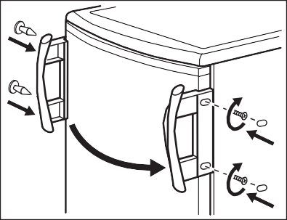
- Remove and install the handle on the opposite side.
4
1
2
3

Reposition, level the appliance, wait for at least four hours and then connect it to the power socket.
CAUTION!

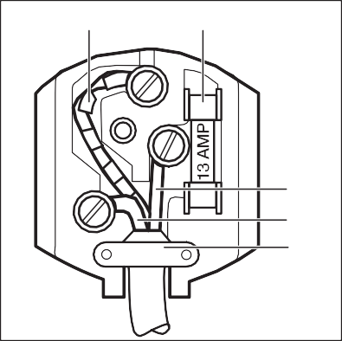
A
B
C
D E

Electrical Connection
Do a final check to make sure that:
- All screws are tightened.
- The magnetic seal adheres to the cabinet.
- The door opens and closes correctly.
If the ambient temperature is cold (i.e. in Winter), the gasket may not fit perfectly to the cabinet. In that case, wait for the natural fitting of the gasket. In case you do not want to carry out the above mentioned operations, contact the nearest Authorised Service Centre. The Authorised Service specialist will carry out the reversibility of the doors at your cost.

Any electrical work required to install this appliance should be carried out by a qualified electrician or competent person.
CAUTION!

This appliance must be earthed.
The manufacturer declines any liability should these safety measures not be observed.
WARNING!
The wires in the mains lead are coloured in accordance with the following code:
  - A - green and yellow: Earth
  - C - brown: Live
  - D - blue: Neutral
As the colours of the wires in the mains lead of this appliance may not correspond with the coloured markings identifying the terminals in your plug, proceed as follows:
- Connect the wire coloured green and yellow to the terminal marked either with the letter “E“ or by the earth symbol
or coloured green and yellow.
- Connect the wire coloured blue to the terminal either marked with the letter “N“ or coloured black.
- Connect the wire coloured brown to the terminal either marked with the “L“ or coloured red.
- Check that no cut, or stray strands of wire is present and the cord clamp (E) is secure over the outer sheath.
Make sure the electricity supply voltage is the same as that indicated on the appliance rating plate.
- Switch on the appliance.
The appliance is supplied with a 13 amp fuse (B). In the event of having to change the fuse in the plug supplied, a 13 amp ASTA approved (BS 1362) fuse must be used.

A cut off plug inserted into a 13 amp socket is a serious safety (shock) hazard. Ensure that it is disposed of safely.
WARNING!

TECHNICAL INFORMATION

Technical data
Height | mm | 850
Width | mm | 595
Depth | mm | 635
Rising time | Hours | 24
Voltage | Volts | 230 - 240
Frequency | Hz | 50
The technical information are situated in the rating plate, on the external or internal side of the appliance and in the energy label.

ENVIRONMENT CONCERNS

Recycle the materials with the symbol . Put the packaging in applicable containers to recycle it. Help protect the environment and human health and to recycle waste of electrical and electronic appliances. Do not
dispose appliances marked with the symbol with the household waste. Return the
product to your local recycling facility or contact your municipal office.

21

*

23

212001056-A-072015

