Instructions for use
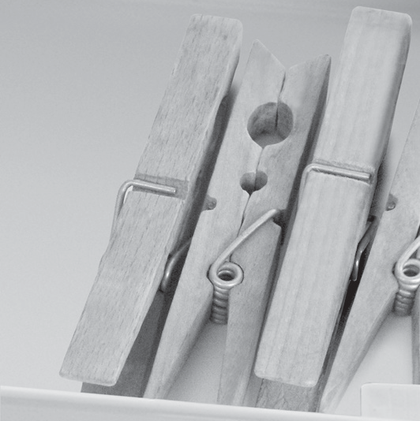
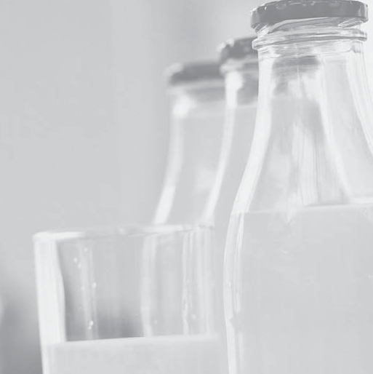


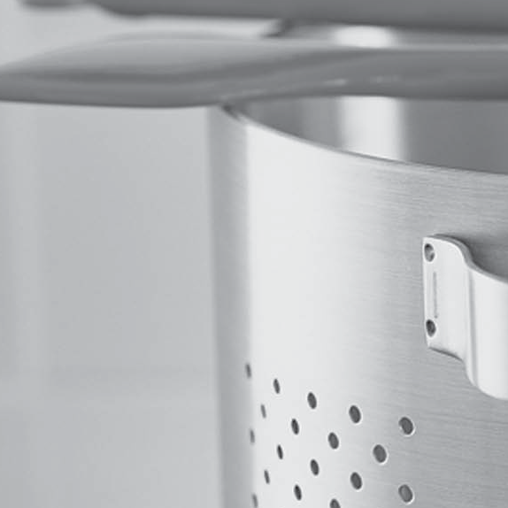

ENGLISH Instructions for use Page 3

INDEX
Chapter 1: INSTALLATION 4
  - INSTALLING SINGLE APPLIANCE 4
  - INSTALLING TWO APPLIANCES 4
  - ADJUST DOORS (IF AVAILABLE) 4
Chapter 2: FUNCTIONS 5
  - ON/STAND BY 5
  - SMART DISPLAY* 5
  - 6TH SENSE FRESH CONTROL / PROFRESH 5
  - DOOR OPEN ALARM 5
  - VACATION 5
  - FAST COOL 5
  - ZERO DEGREES DRAWER* 6
  - FAN 6
  - TEMPERATURE SETTING 6
  - NO-FROST REFRIGERATOR COMPARTMENT 6
  - LED LIGHT SYSTEM* 7
  - HUMIDITY CONTROLED CRISPER* 7
Chapter 3: USE 7
  - HOW TO INCREASE FRIDGE STORAGE CAPACITY 7
  - NOTES 7
Chapter 4: FOOD-STORAGE TIPS 7
  - AIR VENTILATION 7
  - HOW TO STORE FRESH FOOD AND BEVERAGE 7
  - WERE TO STORE FRESH FOOD AND BEVERAGE 8
Chapter 5: FUNCTIONAL SOUNDS 8
Chapter 6: RECOMMENDATION IN CASE OF NO USE OF THE APPLIANCE 9
  - ABSENCE / VACATION 9
  - MOVING 9
  - POWER FAILURE 9
Chapter 7: MAINTENANCE AND CLEANING 9
Chapter 8: TROUBLESHOOTING GUIDE 10
  - BEFORE CONTACTING AFTER-SALES SERVICE… 10
  - FAILURES 10
Chapter 9: AFTER-SALES SERVICE 11
Others:
REVERSE DOOR SWING (VERSION_1) 12
REVERSE DOOR SWING (VERSION_2) 14
NOTE:
The instructions apply to several models, so there may be differences. Sections which only apply to
certain appliances are indicated with an asterisk (*).
Functions which are dedicated specially for your already bought model of product you will find in
QUICK START GUIDE.

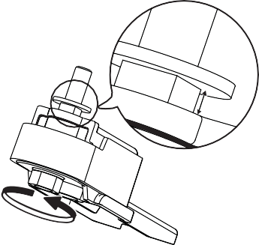
- INSTALLATION
max
5 mm

INSTALLING SINGLE APPLIANCE

To guarantee adequate ventilation, leave a space on both sides and above the appliance.
The distance between the rear of the appliance and the wall behind the appliance should be at least 50mm.
A reduction of this space will increase the Energy consumption of product.

INSTALLING TWO APPLIANCES

During installing the freezer 1 and the fridge 2 together ensure that the freezer is located on the left and the fridge on the right (as shown on the drawing). Left side of refrigerator is equipped with special device in order to avoid condensation problems between appliances.

We recommended installing two appliances together using the linking-kit 3 (as shown on the drawing).
You can buy it in Service.

ADJUST DOORS (IF AVAILABLE)
To level the doors using the adjustable lower hinge (select models)
If the refrigerator door is lower than the freezer door, raise the refrigerator door by turning the adjustment screw counterclockwise using a M10 wrench.
If the freezer door is lower than the refrigerator door, raise the freezer door by turning the adjustment screw counterclockwise using a M10 wrench.



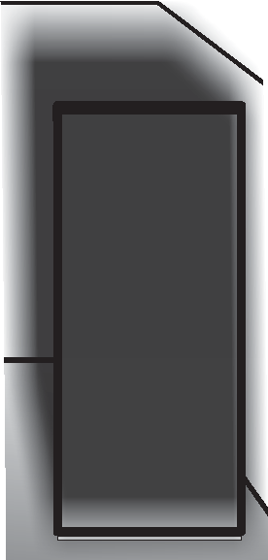
50mm
50mm

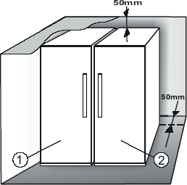

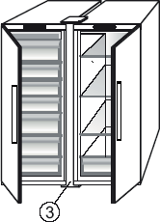

FUNCTIONS

ON/STAND BY
This function turns On/Stand-by the refrigerator. To put the product in Stand-by, press & hold the On/Stand-by
button for 3 seconds. When the appliance is in Stand-by, the light inside the refrigerator compartment does not work. Remember that this operation does not disconnect the appliance from the power supply. To switch the appliance On again, simply press the On/
Stand-By button .

SMART DISPLAY*
This optional function can be used to save energy. Please follow the instructions contained in the Quick Start Guide to activate/deactivate the function. Two seconds after activation of the Smart Display, the display goes off. To adjust the temperature or use other functions, it is necessary to activate the display by pressing any button.
After activation of the Smart Display, the display goes off, except the “ Sense Fresh Control” / “ProFresh” indicator. If Smart Display is active - to adjust the temperature or use other functions, it is necessary to activate the display by pressing any button.

After about 15 seconds without performing any action, the display goes off again and only the “ Sense Fresh Control” / “ProFresh” indicator remains visible. When function is deactivated the normal display is restored. The Smart Display is automatically disabled after a power failure. Remember that this function does not disconnect the appliance from the power supply, but only reduces the power consumed by external display.
Note: The declared appliance energy consumption refers to operation with the Smart Display function activated.

6TH SENSE FRESH CONTROL /
PROFRESH 
This function allows optimum storage conditions (regarding temperature and humidity) to be quickly reached inside the appliance. The fan must also be switched on for it to work properly. The “6th Sense Fresh Control” / “ProFresh” is activated by default To activate or deactivate this function – see enclosed Quick Start Guide.
After a power blackout or exit from Stand-by to normal mode, the “6th Sense Fresh Control” / “ProFresh” status resets to default i.e. active.

DOOR OPEN ALARM
The Alarm icon lights up blinking and the acoustic alarm sounds. The alarm is activated when the door is left open for more than 2 minutes. To disengage the door alarm close the door, or press once Stop Alarm button to mute the acoustic alarm.

VACATION
This function can be activated to reduce the energy consumption of the appliance during a period of absence.
Before activating the feature, all perishable food should be removed from the refrigeration compartment and make sure that the door is closed properly, since the refrigerator will maintain a suitable temperature to prevent the formation of unpleasant odors (+12°C).
To activate/ deactivate press the Vacation mode button for 3 seconds. When the function is enabled, the related symbol will light up and the temperature of the refrigerator compartment will be set to a higher setpoint (the temperature display will show the new temperature setpoint of +12°C).
Changing the temperature setpoint will automatically deactivate the function.

Attention:
    - Incompatibility with the “Fast Cool” function
To guarantee optimal performance, the “Vacation” and “Fast Cool” functions cannot be used at the same time. Therefore, if the “Fast Cool” function has been already engaged, it has to be disengaged first to activate the “Vacation” function (and vice-versa).

FAST COOL
The use of this function is recommended when placing a very high quantity of food in the refrigerator compartment.
Using Fast Cool function it is possible to increase the cooling capacity in the refrigerator compartment.
To maximize the cooling capacity, please keep the fan switch on.

Attention:
    - Incompatibility with the “Vacation” function
To guarantee optimal performance, the “Vacation” and “Fast Cool” functions cannot be used at the same time. Therefore, if the “Vacation” function has been already engaged, it has to be disengaged first to activate the “Fast Cool” function (and vice-versa).

ZERO DEGREES DRAWER*
The Zero Degrees Drawer is specifically designed to maintain a low temperature and a suitable humidity level, in order to keep foods fresher for longer (e.g. meat, fish, fruit and winter vegetables).
Activating and deactivating the box
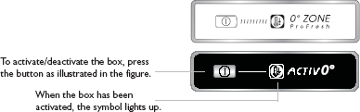

The temperature inside the box, when active, is approximately 0°. The following factors are vital for the “Zero Degrees” box to work properly:
- the refrigerator compartment must be switched on
- the temperature of the refrigerator compartment must be between +2°C and +5°C
- the box must be inserted to enable activation
- no special functions must have been selected (Standby, Vacation – where applicable).
If one of these special functions has been selected, the “Zero Degrees” box must be deactivated manually, and any fresh food inside it removed. If manual deactivation does not take place, the box will be deactivated automatically after 8 hours.

Note:
- if the symbol does not light up when the function is activated, check that the drawer is properly inserted; if the problem persists, contact your nearest authorized After-sales Service
- if the function is active and the drawer open, the symbol on the control panel may be deactivated automatically. If the drawer is inserted, the symbol will become active again
- irrespective of the state of the function, a slight noise may be heard: this is normal and is not a cause for concern.
- when the function is not active, the temperature in the drawer depends on the general temperature inside the refrigerator.
In this case, we recommend it is used to store fruit and vegetables which are not sensitive to cold temperatures (fruits of the forest, apples, apricots, carrots, spinach, lettuce, etc.).
Important: when the function is activated and there are foodstuffs with a high water content, condensation may form on shelves. In this case, disable the function temporarily.
  - FAN
The Fan improves temperature distribution inside the product, allowing better preservation of stored food. By default, the fan is switched on. It is advisable to keep the fan switched on, so that the 6th Sense Fresh Control / ProFresh function can work properly and also when the ambient air temperature is above 27 ÷ 28°C or if you notice drops of water on the glass shelves or in sever humidity conditions. Please note that when the fan is switched on it will not continuously work. The fan will start/stop working depending on the temperature and/or humidity level inside the product. It is therefore absolutely normal if the fan does not move even if the fan is switched on.
To activate or deactivate this function – see enclosed Quick Start Guide.
Attention: Switching- off the Fan deactivate the 6th Sense Fresh Control / ProFresh function.

Note:
Do not obstruct the air intake area with food items. To guarantee the right performance at lower ambient temperature (colder than 18°C) and to minimize Energy Consumption, turn off the fan.
To turn off the fan please see above procedure.
If the appliance has the Fan it can be equipped with the

antibacterial filter.
Remove it from the box placed in the crisper drawer and insert into the cover of fan.
The replacement procedure is included in the filter box.

TEMPERATURE SETTING
The appliance is normally factory-set for operation at the recommended temperature of 5°C. The internal temperature can be adjusted between 8°C and 2°C, proceeding as follows:
    - Press the temperature setting button (°C). The storage temperature can be changed by -1°C with each pressure of the button: the value changes cyclically between 8°C and 2°C.
Note: Displayed set points correspond to the average temperature throughout the whole refrigerator

NO-FROST REFRIGERATOR COMPARTMENT
Refrigerator compartment defrosting is completely automatic.
Droplets of water on the rear wall inside the refrigerator compartment indicate that the automatic defrost phase is in progress. The defrost water is automatically run into a drain hole and collected in a container, where it evaporates.

LED LIGHT SYSTEM*
The light system inside the fridge compartment uses LEDs light, allowing a better lightning as well as very low energy consumption. If the LED light system does not work, please contact the Service to replace it.

Important:
The refrigerator compartment light switches on when the refrigerator door is opened. If the door is kept open for more than 10 minutes the light will be automatically switched off.

USE

HOW TO INCREASE FRIDGE STORAGE CAPACITY
You can increase storage capacity by removing the “ZERO DEGREES DRAWER”*
In this case proceed as follows:
- switch off the box
- pull out the drawer and the white plastic shelf underneath the box.
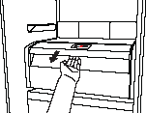
Note: the upper shelf and the side support cannot be removed. To restore
“Zero Degrees Drawer” operation, make sure you replace the white plastic shelf underneath the
box before inserting the drawer and reactivating the function. To optimise energy consumption, we recommend you
deactivate the “Zero Degrees Drawer” and remove it.

FOOD-STORAGE TIPS
The refrigerator is the ideal storage location for ready meals, fresh and preserved food, dairy products, fruit and vegetables and beverage.

AIR VENTILATION
    - The natural circulation of air in the refrigerator compartment results in zones with different temperatures. It is coldest directly above the fruits and vegetables crisper and at the rear wall. It is warmest at the top front of the compartment.
    - Insufficient ventilation results in an increase in energy consumption and reduction of the refrigerating performance.

2.12.HUMIDITY CONTROLED CRISPER*
The salad crispers fitted inside the fridge have been specially designed for the purpose of keeping fruit and vegetables fresh and crisp. Open the humidity regulator (position B) if you want to store food in a less humid environment like fruit, or close it (position A) to store food in a more humid environment like vegetable.
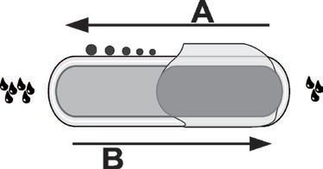

NOTES
    - Do not block the air outlet area (on the back wall inside the product) with food products.
    - If the freezer is provided with a flap, it is possible to maximize the storage volume by removing the flap.
    - All shelves, flaps and pull-out baskets are removable.
    - The internal temperatures of the appliance may be affected by the ambient temperature, frequency of door opening, as well as location of the appliance. Temperature setting should take into consideration these factors.
    - Unless otherwise specified the appliance accessories are not dishwasher safe.
    - Use Smart Display function as frequently as possible.

HOW TO STORE FRESH FOOD AND BEVERAGE
    - Use recyclable plastic, metal, aluminum and glass containers and cling film to wrap foods.
    - Always use closed containers for liquids and for food that may give off or be tainted by odor or flavor transfer or cover them.
    - Foods which give off a large amount ethylene gas and those that are sensitive to this gas, such as fruit, vegetables and salad, should always be separated or wrapped so as not to reduce the storage life; for example do not store tomatoes together with kiwi fruits or cabbage.
    - Do not store food too close together to enable sufficient air circulation.
    - To avoid bottles falling over, you can use the bottle holder (available on selected models).
    - If you have a little quantity of food to store in the refrigerator, we recommend to use the shelves above the crisper for fruits and vegetables since this is the coolest area of the compartment.

WERE TO STORE FRESH FOOD AND BEVERAGE
    - On the fridge shelves: ready meals, tropical fruits, cheeses, deli.
    - In the coldest area – Zero Degrees drawer* (the one above Cooler Compartment): meat, fish, cold cuts, cakes
    - In the fruits and vegetables crisper: fruits, salad, vegetables.
    - In the door: butter, jams, sauces, pickles, cans, bottles, beverage cartons, eggs

FUNCTIONAL SOUNDS
Sounds coming from your appliances are normal since it has a number of fans and engines to regulate performances that switch on and off automatically.

Some of the functional sounds can be reduced
through
- Leveling the appliance and installing it on an even surface
- Separating and avoiding contact between the appliance and furniture.
Some of the functional sounds you might hear:

EXAMPLE OF FOOD ARRANGEMENT
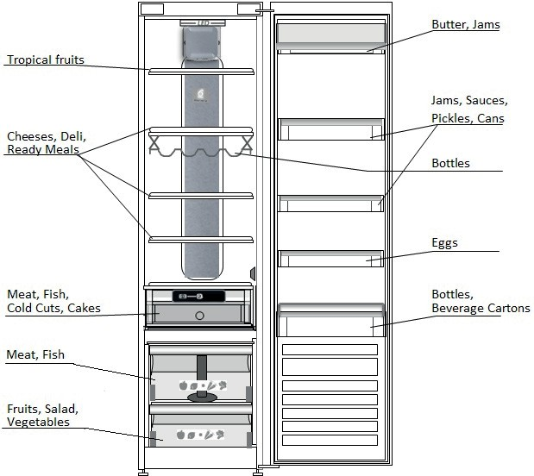

- Checking if the internal components are correctly placed.
- Checking if bottles and containers are not in contact with each other.

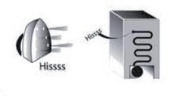
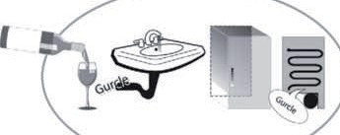

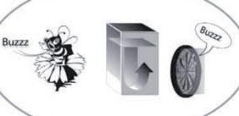
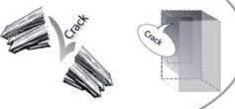
A hissing sound when switching on the appliance for the first time or after a long pause.
A gurgling sound when refrigerant fluid enters into the pipes.
BRRR sound is from the compressor running.

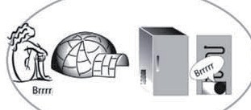
Buzzing sound when water valve or fan start working.
A cracking sound when compressor starts or when ready ice drops into ice box abrupt clicks when compressor switches on and off.
The CLICK is from the thermostat which adjusts how often the compressor is running.

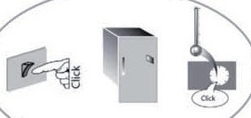

*Available on selected models only. Please check on the QUICK START GUIDE if this function is actually available on your model.

- RECOMMENDATION IN CASE OF NO USE OF

THE APPLIANCE

ABSENCE / VACATION
In case of vacation its recommended to use up food and to disconnect the appliance to save energy.

MOVING
- Take out all internal parts.
- Wrap them well, and fix them together with adhesive tape so that they do not bang together or get lost.
- Screw the adjustable feet so that they do not touch the support surface.
- Close and fix door with adhesive tape and, again using adhesive tape, fix the power cable to the appliance.

POWER FAILURE
In the event of a power failure, call the local office of your electricity supply company and ask how long it is going to last.
Note: Bear in mind that a full appliance will stay cold longer than a partially filled one.
If food is found to be in a poor condition, it is best to throw it away.
For power failures lasting up to 24 hours.
1. Keep the door of the appliance closed. This will allow the stored food to stay cold as long as possible.
For power failures lasting more than 24 hours.
1. Try to use up the food, which is more easily perishable.

MAINTENANCE AND CLEANING
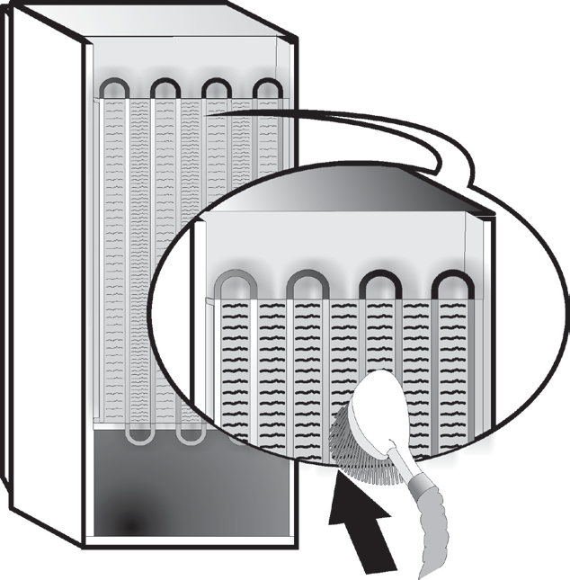
Before any cleaning or maintenance operation, unplug the appliance from the mains or disconnect the electrical power supply.
Periodically clean the appliance with a cloth and a solution of lukewarm water and neutral detergent specifically for refrigerator interiors. Never use abrasives. Never clean
refrigerator parts with flammable fluids. The fumes can create a fire hazard or explosion. Clean the outside of the appliance and the door seal with a damp cloth and dry with a soft cloth. Do not use steam cleaners.
Condenser placed in the rear of the appliance should be cleaned regularly using a vacuum cleaner.
Condenser placed in the rear of the appliance should be cleaned regularly using a vacuum cleaner.

Important:
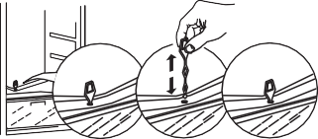
- The buttons and control panel display must not be cleaned with alcohol or alcohol-derived substances, but with a dry cloth.
- The refrigeration system pipes are located near the defrost pan and can become hot. Periodically clean them with a vacuum cleaner.
To ensure continuous and correct flow of defrost water, regularly clean the inside of the draining hole on the back of the refrigerator near the fruit and vegetable drawer, using the tool provided .
Before cleaning the “Zero Degrees Drawer” (including the outside), remove the drawer so as to disconnect the box from the electricity supply.
Clean the box and all its parts regularly, using a cloth and a solution of warm water and neutral detergent specifically formulated for refrigerator interiors (take care not to immerse the white plastic shelf underneath the box in water).
Never use abrasive detergents.

TROUBLESHOOTING GUIDE

BEFORE CONTACTING AFTER-SALES SERVICE…
Performance problems often result from little things you can find and fix yourself without tools of any kind.

PROBLEM | SOLUTION
The appliance is not working: | - Is the power cable plugged into a live socket with the proper voltage?  - Have you checked the protection devices and fuses of the electrical system in your home?
If there is water in the defrost pan: | - This is normal in hot, damp weather. The pan can even be half full. Make sure the appliance is level so that the water does not overflow.
If the edges of the appliance cabinet, which come in contact with the door seal, are warm to the touch: | - This is normal in hot weather and when the compressor is running.
If the light does not work: | - Have you checked the protection devices and fuses of the electrical system in your home?  - Is the power cable plugged into a live socket with the proper voltage?  - In case the LEDs are broken the user must call the Service for exchange of the same type available only at our After-sales Service Centers or authorized dealers.
If the motor seems to run too much: | - Motor running time depends on different things: number of door openings, amount of food stored, temperature of the room, setting of the temperature controls.  - Is the condenser (back the appliance) free of dust and fluff?  - Are the door properly closed?  - Are the door seals properly fitted?  - On hot days or if the room is warm, the motor naturally runs longer.  - If the appliance door has been left open for a while or if large amounts of food have been stored, the motor will run longer in order to cool down the interior of the appliance.
If the appliance temperature is too  high: | - Are the appliance controls correctly set?  - Has a large amount of food been added to the appliance?  - Check that the door is not opened too often.  - Check that the door close properly.
If the doors do not open and close properly: | - Check that food packages are not blocking the door.  - Check that the internal parts or automatic ice maker are not out of position.  - Check that the door seals are not dirty or sticky.  - Ensure the appliance is level.

FAILURES
In the event of operation alarms, they will also be displayed in the digits LEDs, (e.g. Failure1, Failure 2, etc...) call After-sales Service and specify the alarm code. The acoustic alarm sounds, the Alarm icon lights up and the F letter on the digit display blinks according to failure code described below:

Failure code | Visualization
Error 2 | F letter blink on/off at 0,5 sec. Blinks ON 2 times then remain off for 5 seconds. Pattern repeats. |  x2
Error 3 | F letter blink on/off at 0,5 sec. Blinks ON 3 times then remain off for 5 seconds. Pattern repeats. | x3
Error 6 | F letter blink on/off at 0,5 sec. Blinks ON 6 times then remain off for 5 seconds. Pattern repeats. | x6

AFTER-SALES SERVICE
Before contacting After-Sales Service:
Switch the appliance on again to see if the problem has been solved. If it has not, disconnect the appliance from the power supply and wait for about an hour before switching on again.
If, after performing the checks described in the Troubleshooting Guide and switching the appliance on again, your appliance still does not work properly, contact the After-sales Service, explain the problem.

Specify:
- the model and appliance serial number (stated on the rating plate),
- the nature of the problem,

- the Service number (the number after the word SERVICE on the data plate on the inside of the appliance),
- your full address,
- your telephone number and area code.

Note:
The direction of door opening can be changed. If this operation is performed by After-sales Service it is not covered by the warranty.

(1)
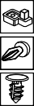      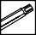        6a.    6b. |     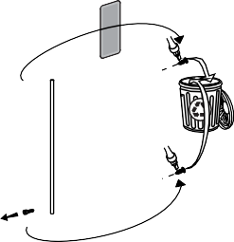  1.
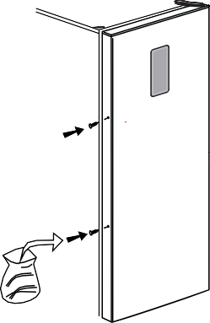  2. | 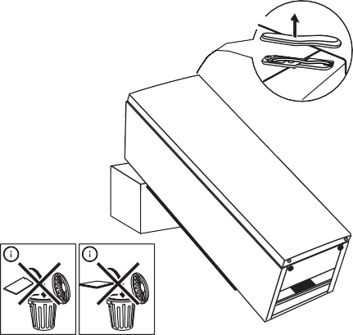  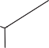    3.
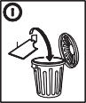  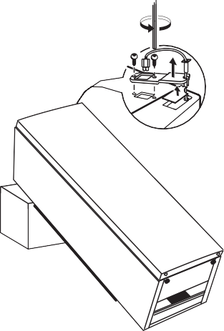    4. |     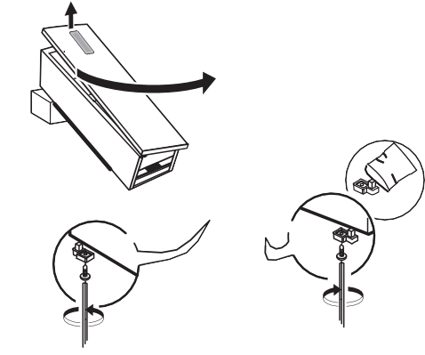  5.  A

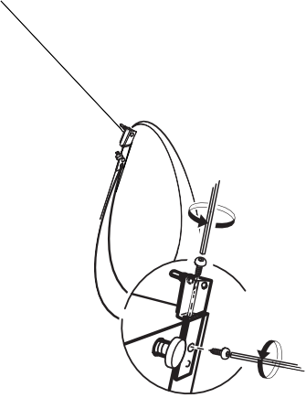  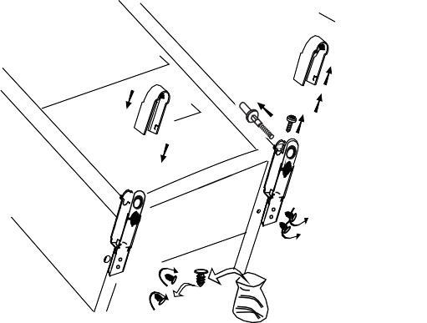  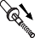  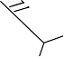      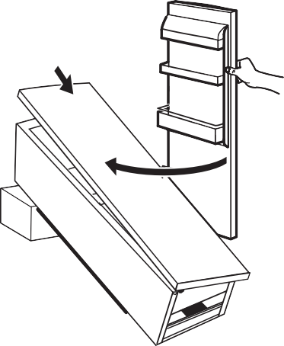  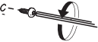  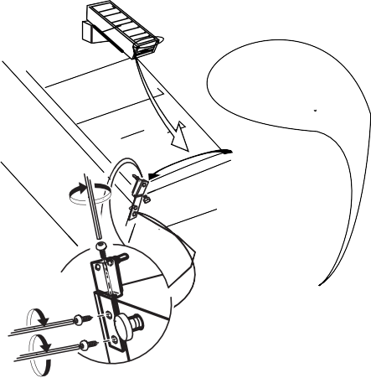  6a. | 6b.
7.  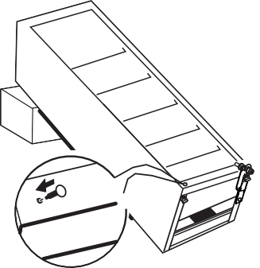 | 8.  
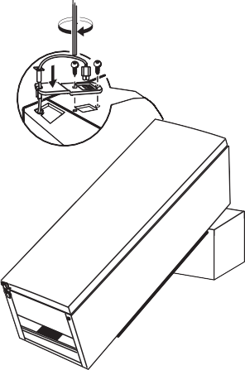    9. | 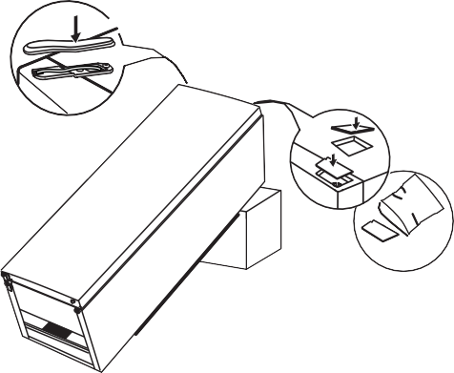    10.

(2)

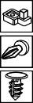          6a.    6b. |     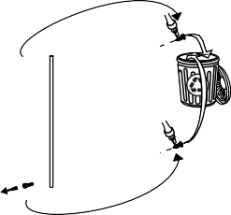  1.
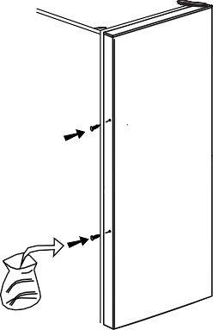  2. | 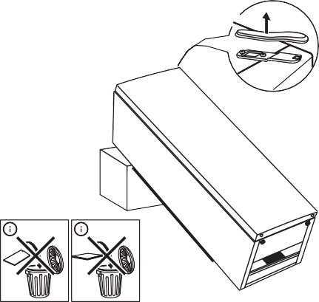  3.
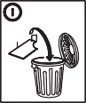  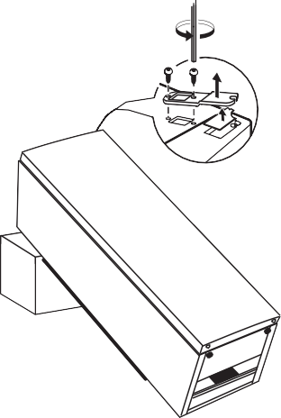  4. | 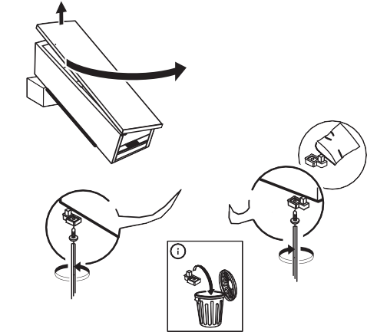  5.  A

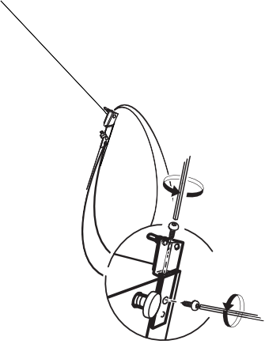  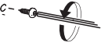  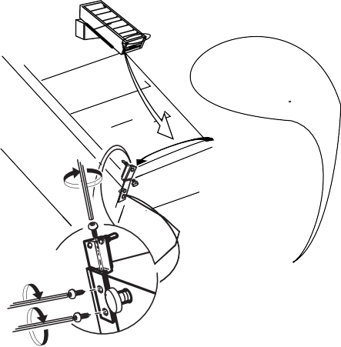  6a. | 6b.
7. | 8.
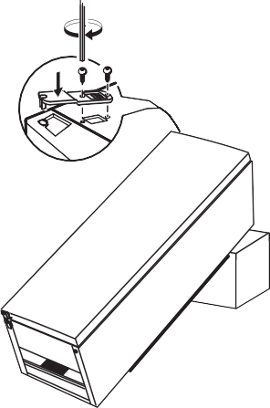  9. | 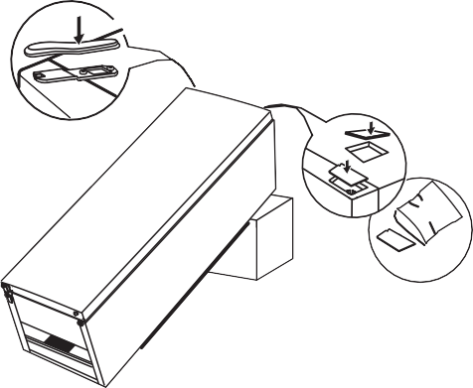  10.

400010864714
195141820.00
DE GB



Copyright Whirlpool Europe s.r.l. 2014. All rights reserved - http://www.whirlpool.eu
01/16

