
USER MANUAL
PLASTIC KETTLE
Model number: 2164025

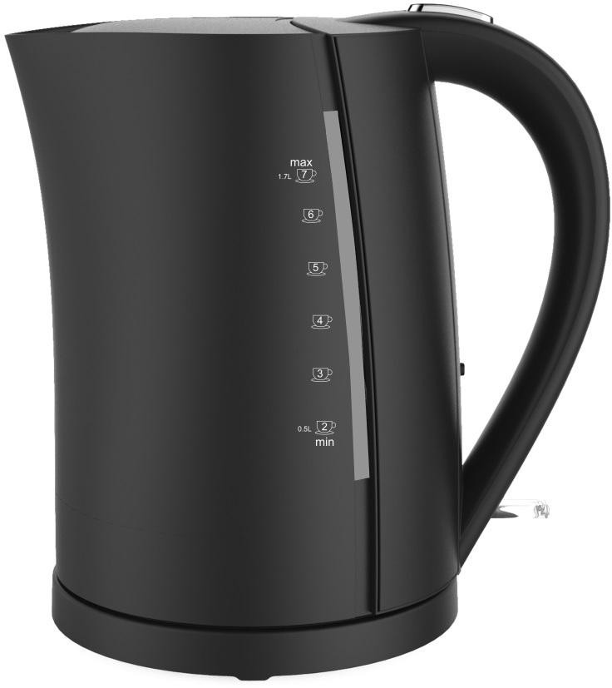

CONTENTS

PART IDENTIFICATION Page 2

IMPORTANT SAFEGUARDS Page 3

BEFORE FIRST USE Page 5

INSTRUCTIONS FOR USE Page 5

CLEANING AND MAINTENANCE Page 6

TROUBLESHOOTING Page 6

PLUG WIRING & FUSE Page 7

3 YEAR GUARANTEE Page 8

Please read these instructions carefully and keep them for future reference.

PART IDENTIFICATION

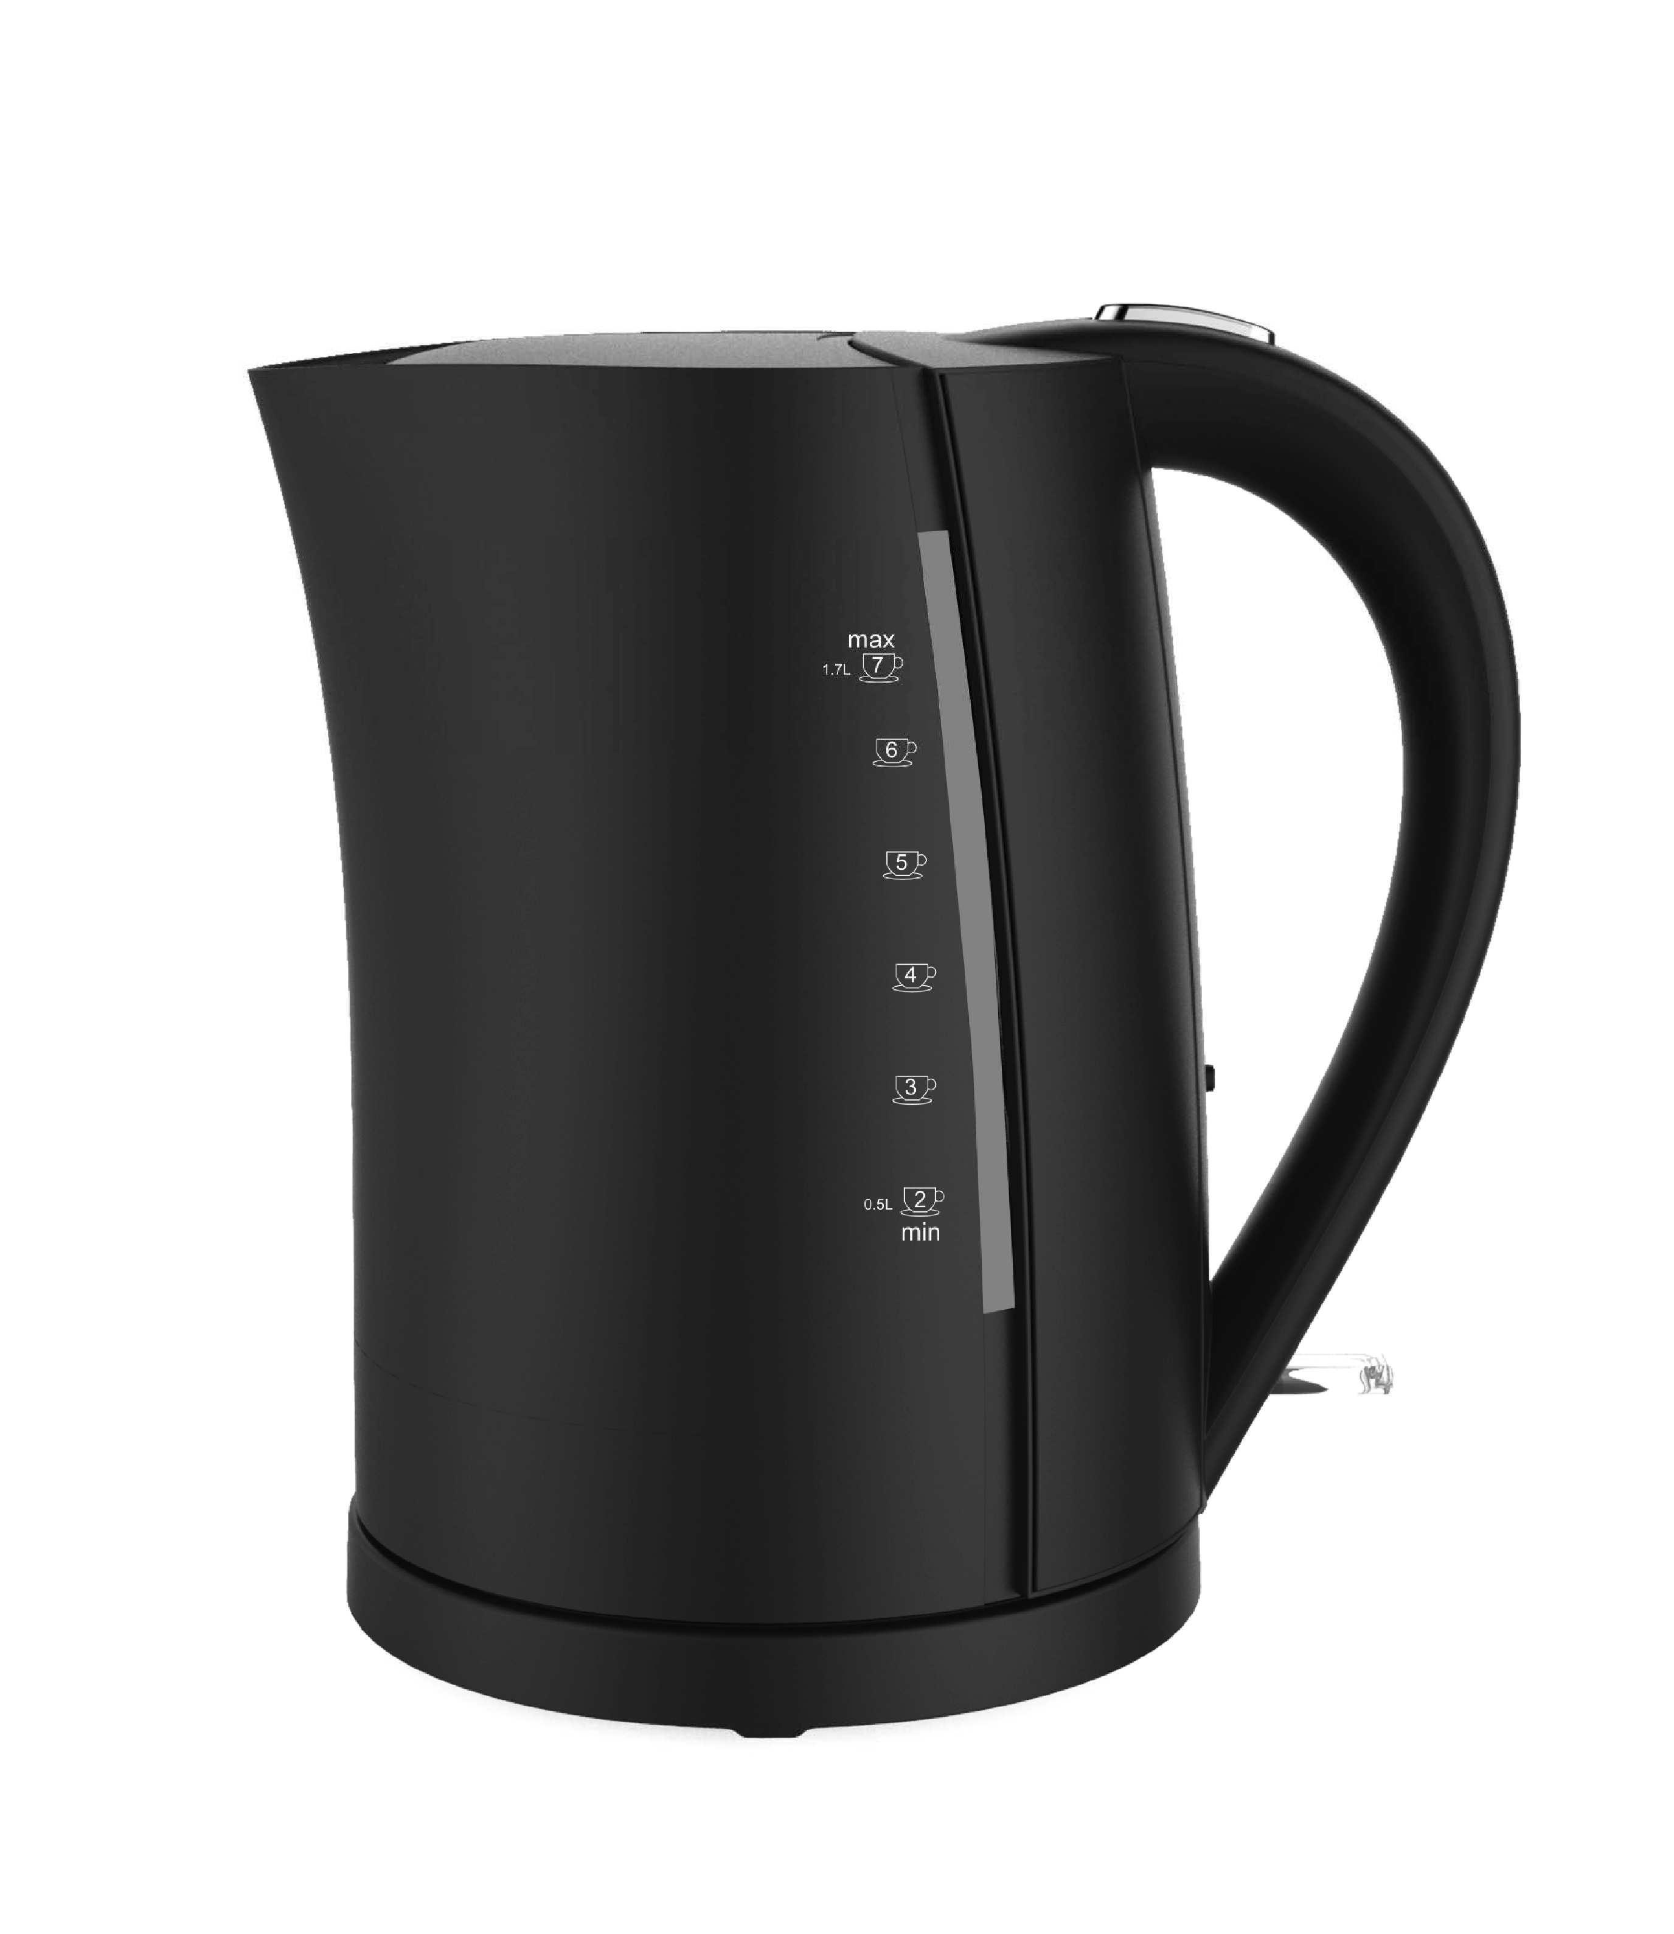
Lid
Lid button

Body Handle

Power switch

Power base

IMPORTANT SAFEGUARDS

Keep safe by following basic safety precautions, including:

 Before you connect the kettle to the mains supply, make sure that the voltage indicated on the rating plate, located on the bottom of the water kettle matches the mains voltage in your home. If it does not, contact your dealer and do not use the kettle.
The kettle will switch off automatically when the water has boiled. If you want to stop the heating process before the kettle automatically switches off, press the on/off switch handle up.
After the kettle has switched off automatically (or has been switched off manually) it may need time to cool down. After 15- 20 secs, the kettle can be switched on again.
Always fill the kettle with water before switching it on.
If the kettle ever boils dry, the power indicator will goes on. Lift the on/off switch and unplug. Allow 15 minutes to cool before refilling with cold water. The safety cutout will automatically reset during this time.
Place the kettle on a stable flat surface.
Ensure that the kettle is switched off before removing it from its stand.
Do not remove the kettle from its stand during operation. Never immerse the kettle or cord in water or any other liquid. Do not allow liquid to penetrate the electrical parts of this kettle.
Prevent children from pulling on the mains cord or knocking the kettle over.
Ensure that the mains lead does not overhang the worktop surface.

Before cleaning the kettle disconnect from the power supply and wait until it was cooled down.
Only use the cord supplied with this kettle. If a replacement is required, only approved components may be used.
The outside surface of the kettle may get hot during use, please take care when using the kettle.
Never fill in water more than the maximum acceptable water level.
If the supply cord is damaged, it must be replaced by the manufacturer, its service agent or similarly qualified persons in order to avoid a hazard.
If the kettle is overfilled, boiling water may be ejected.
Keep electrical appliance out of reach from Children or infirm persons. Do not let them use the appliance without supervision.
 This appliance is intended to be used in household and similar applications such as：staff kitchen areas in shops, offices and other working environments; farm houses; by clients in hotels, motels and other residential type environments; bed and breakfast type environments.
This appliance can be used by children aged from 8 years and above and persons with reduced physical, sensory or mental capabilities or lack of experience and knowledge if they have been given supervision or instruction concerning use of the appliance in a safe way and understand the hazards involved. Children shall not play with the appliance.
Cleaning and user maintenance shall not be made by children without supervision.
Keep the appliance and its cord out of reach of children less than 8 years, when it is switched on or cooling down.

Domestic Household use only

BEFORE FIRST USE

- Remove all packaging and contents.
- Fill kettle to the maximum water level, boil then discard. Repeat this 3 times.
- Position the kettle on a flat level surface so that the steam will not hit any other kitchen appliance or cupboard.
- Ensure that cable cannot be grasped by a child and doesn’t overhang the work top.

INSTRUCTIONS FOR USE
- Open the lid and fill with clean water to you desired level ensuring it’s between the minimum and maximum levels.
- Ensure lid is closed and place on power base.
- Insert plug into a suitable power socket ensuring that the cable cannot be grasped by children.
- Move the switch to the on position and allow kettle to boil.
- Once kettle has boiled it will automatically switch off, to switch off manually move switch to the off position or lift kettle off the power base.
- Carefully lift kettle off the power base and pour the boiled water into your desired receptacle.

CLEANING AND MAINTENANCE
- Ensure that the kettle is turned off and the power base is disconnected from the mains power supply.
- Allow for the kettle to cool down fully.
- Wipe the kettle inside and out with a damp cloth and avoid using any abrasive cleaners or solvents as this will damage the finish. Only use a mild detergent solution for stubborn marks but ensure that the little has been rinsed well to avoid tainting.
- Descale your kettle on a regular basis. Follow the decaling guidelines on your preferred descaler.
- Remove filter and clean by rinsing under a tap and replace. (Do not use the kettle without the filter in place)

TROUBLESHOOTING

FAULT | ANALYSIS | TROUBLESHOOTING
I can see water on the power base | DON’T WORRY – this is escaped steam that has  vented through the base | Dry with cloth
Kettle has boiled dry | The kettle will automatically switch off | Place kettle on the work surface, not on the power base and allow for it to cool, fill with  water and try again.

PLUG WIRING & FUSE
This appliance is fitted with a moulded plug. To change the fuse remove the fuse cover on the underside of the plug and remove the fuse that is inside. Replace the fuse with a 13A fuse that is compliant with BS1362.

Should you need to replace the plug, cut the cable as close to the plug as possible and strip the wires back and wire into the new plus as follows, fit the green/yellow wire to E or , the blue wire to N, and the brown wire to L. Fit the cord grip. Ensure your plug is fitted with a 13 Amp fuse and the cord grip is tightened.

Dispose of the old molded plug responsibly

Earth wire (yellow/green)

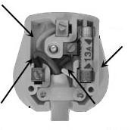
13 Amp Fuse

Neutral wire (Blue)

If in doubt, call an electrician.
Rated Voltage: AC 220 – 240V~50Hz Power Consumption: 1850-2200W Product code: 2164025

Live wire (Brown)

3 YEAR GUARANTEE

This product is covered by 3 year guarantee.
Please retain your receipt in the unlikely event that you need to claim under your 3 year guarantee. It’s a good idea is to staple your receipt to your instruction manual for safe keeping as you will need to present it as proof of purchase if you need to return this item.
How to claim on our guarantee:

Take your product into any of our supermarkets’ Customer Services counter, alternatively you can call our customer services team on 0345 611 6111.
When claiming:

You will be required to bring /send proof of purchase.
If the defects above become apparent during the guarantee period we will replace your product with the same product if it is still available in our store. If the product is no longer available we will replace it with a substitute product of an equivalent specification or offer the value of the returned item against a different product at our discretion.

What is not covered:

Damage caused by unexpected wear and tear or incorrect storage. Deliberate damage.
Damage caused by not adhering to the care instructions provided. If there is evidence of product misuse and abuse.
If the product is deemed to be unsanitary we can refuse to accept the return at our discretion.
If the component that has failed during the guarantee period is part of a set, only the defective component will be replaced.
Accidental damage – this may be covered by your household content insurance.

Revision 2
