

ETHNICITY PAY GAP REPORT 2021

Ethnicity (Black, Asian, Mixed & Other Ethnic-B.A.M.E) Pay Gap Report 2021

INTRODUCTION
At the University of Wolverhampton, we are committed to providing equality of opportunity in all we do, to create a vibrant university environment that supports the development and progression of all staff and students.
The commitment to monitoring and addressing any inequalities in remuneration, including any gender and ethnicty pay gaps is reflected in our Workforce Development Strategy, aiming to embed equality and diversity in our approach to reward.
In October 2020 we were awarded Advance HE’s Race Equality Charter Mark Bronze award. This included a ‘Race Equality Action Plan’ to address areas such as underrepresentation and disproportionality between White and B.A.M.E. staff and students.
A Race Equality Action Plan Delivery Group (RECAP) with clear terms of reference has been set up which is responsible for monitoring our work on addressing ‘race’ inequality including the Race Equality Charter Action Plan action plan. This is supported by a ‘staff experince’ sub group.
We also have a very active BAME Staff Network that works with the University to address the unique challenges staff from ethnic minority backgrounds face within higher education and, more broadly, tackle racial inequalities through projects such as the ‘Race Equality Charter’.
Currently there is discussion, which is led by our B.A.M.E. Staff Network about terminology used to identify staff and students from ethnic minority backgrounds as many see that the current B.A.M.E is not truly reflective of them.

ETHNICTIY PAY GAP
The Ethnicity Pay Gap compares the average hourly pay (mean and median) of staff from Black, Asian and minority ethnic groups and staff from white ethnic groups. As with the gender pay gap, it reflects the distribution of staff from different ethnic groups across the grades of employment at the University, with an ethnicity pay gap typically indicating a greater proportion of staff from white ethnic groups holding posts at senior grades and a greater proportion of minority ethnic staff holding posts at more junior grades.
This is our first ethnicity pay gap report, however we did do calculations for the ethnicity pay gap in 2018. We will be doing annual ethnicity pay gaps going forward. We will also look at disaggregating the B.A.M.E. data by comparing pay for a number of ethnic groups.

OUR ETHNICTY PAY GAP
For the purpose of our report, the data is based on the snapshot of our workforce as of of 31st March 2021, when our workforce consisted of 2051 staff out of which 2015 were White, 669 B.A.M.E and 45 Unknown staff.
The report incorporates all appropriate additional payments, alongside the proportioning of any bonus payments if paid. There were no bonuses for 2021. Staff are removed from the calculation for instances of half pay, no pay, starters, leavers and other pay deductions.The data is then utilised to create an overall hourly paid rate per job an individual undertakes.
OUR WORKFORCE COMPOSITION
The breakdown of the staff population covered is White 74%, BAME 24% and Unknown 2%.

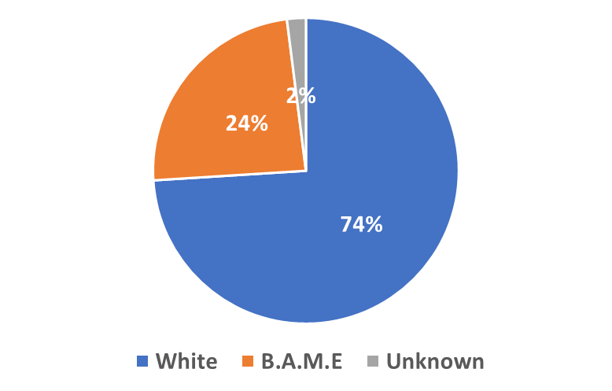

OUR MEAN AND MEDIAN PAY GAPS
The mean gender pay gap is the difference in the average hourly pay for all B.A.M.E staff compared to all White staff. The median gender pay gap represents the difference in pay between the mid-point hourly pay rate of B.A.M.E.and White staff.

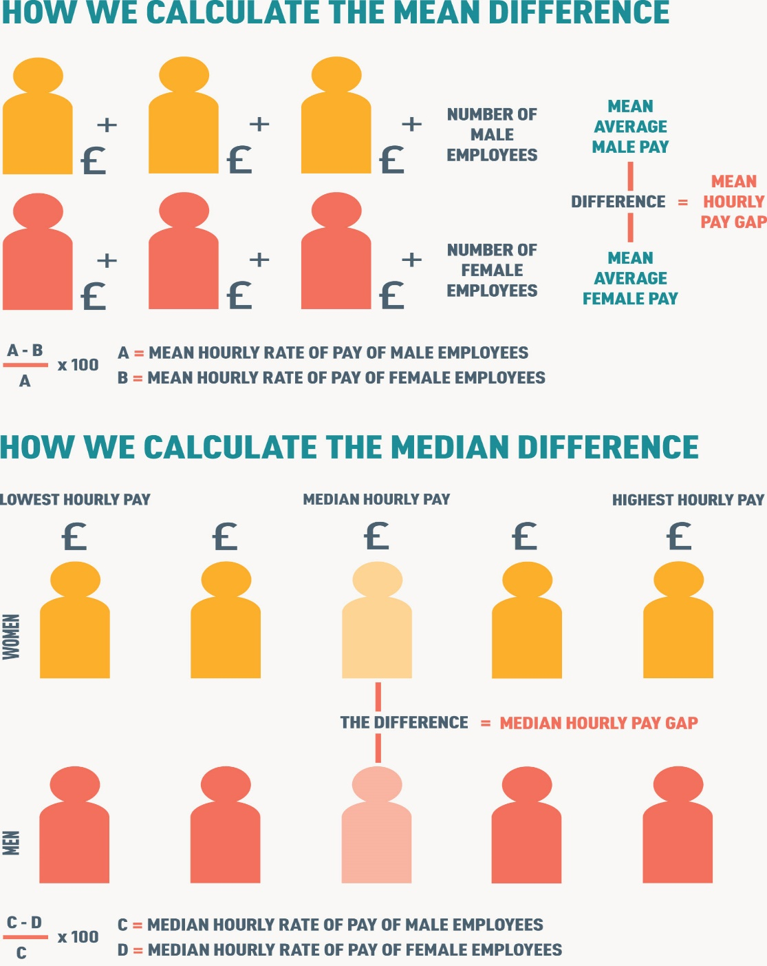
OUR ETHNICITY PAY GAP CALCULATIONS
Mean (average) ethnicity pay gap 8.8%

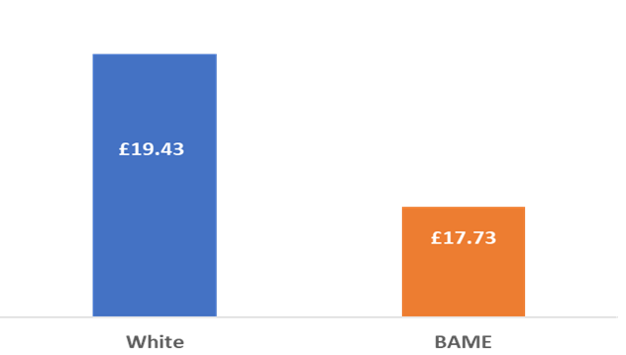

Median (middle) ethnicity pay gap 13.7%

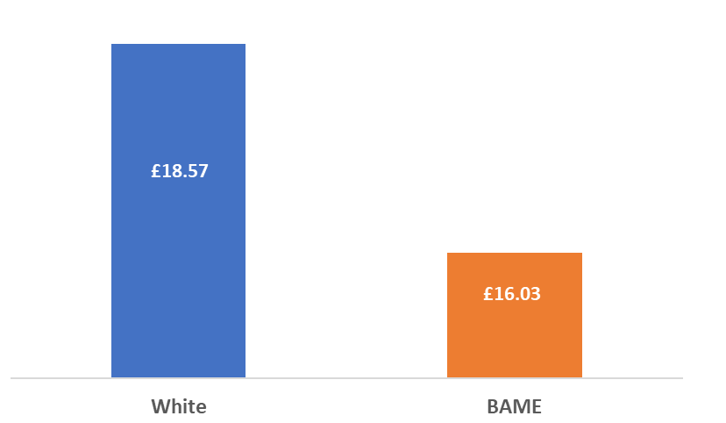

The median hourly rate for white staff sits at £18.57 which is around the bottom of UW9/top of UW8. The median for BAME sits at £16.03 the same as for Female staff in the Gender Pay Gap 2021, the top of UW7 (F27).
The graph below shows that there has been no change in the ethnicity mean pay gap from 2018, which was the last time we conduceted an ethnicity pay gap. However there has been a decrease in median pay gap by 4.7%.

We are encouraged by our reduction in median ethnicty pay gap which means that we are moving towards a more comparable average rate of pay between B.A.M.E. and White staff employed at the University. However we recognise that this is a long term commitment and will take some time to see significant change.
BONUS PAYMENTS BY ETHNICITY

Due to the Pandemic there were no Bonuses paid to any staff for this reporting period.

WORKFORCE PAY DATA WITHIN QUARTILES

The gender pay gap regulations require us to publish the proportion of men and women within four quartile pay bands, which are created by dividing the total number of employees into four equal parts from the lowest to the highest hourly pay. For consistency we have carried out the same exercise for B.A.M.E and White staff.

The following establishment chart (excludes V/L and casual staff) show the percentages of B.A.M.E and White in each pay quartile.

OUR PAY QUARTILES

The pay quartiles in the chart opposite are based on the University of Wolverhampton pay grades, with UW 1 being the lowest paid grade.

Q1. UW1 – UW4
Q2. UW5 – UW7
Q3. UW8 – UW10 (F42)
Q4. UW10 (F43) >
March 2021
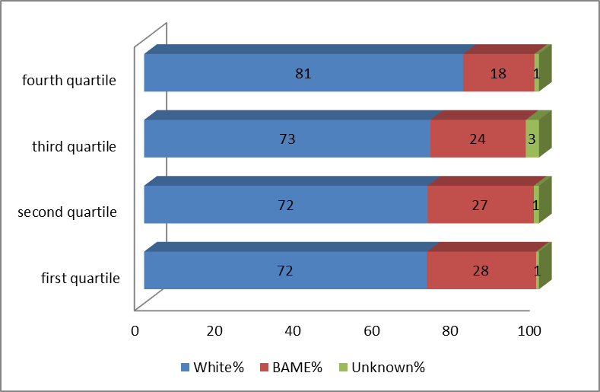

Quartile analyses identifies that B.A.M.E employees are overrepresented in the two lower pay quartiles and underrepresented in the two upper pay quartiles based on their percentage in the overall workforce.

The lower quartile represents the 25% lowest hourly paid employees at the university and the upper quartile represents the 25% highest hourly paid employees).

Based on the data submitted for our successful bronze ‘Race Equality Charter Mark, there was an increase of B.A.M.E. staff in quartile 3 from July 2020 to March 2021.

These increases would have had an impact and are a positive sign that we are moving towards reducing our median ethnicty pay gap and increasing the percentage of B.A.ME.staff in the higher middle quartile.

FACTORS INFLUENCING OUR ETHNICITY PAY GAP
Our ethnicity pay gap is due to a disproportional representation of B.A.M .E staff across lower paid job roles (otherwise known as “horizontal segregation”).
This uneven distribution of B.A.M.E. employees on the lower grades and White employees on higher grades, continues to contribute to the overall ethnicity pay gap of the University.

WHAT WE ARE DOING TO ADDRESS THE PAY GAP
We have a number of actions within our overall Race Equality Action Plan (https://www.wlv.ac.uk/media/departments/equality-and-diversity-unit/documents/Race-Equality-Action-Plan-University-of-Wolverhampton.pdf) that will impact on reducing the ethnicity pay gap. This includes targets to increase the number of B.A.M.E staff in senior roles. Some of these actions are detailed below:
ACADEMIC PROGRESSION & INCREASING LEADERSHIP OPPORTUNITIES
Some of the actions we have started in order to increase the number of B.A.M.E. staff into senior roles thru our promotions process include:
Analaysing data on the conferment process (Academic Staff promotions) and benchmarking against previous years. The data is presented to the RECAP delivery group as well as the Joint ED Committee. Recent data analysis highlighted the need to increase applications from BAME staff. To address this with the support of the BAME Staff Network we organised a bespoke workshop for BAME staff on our academic staff promotions conferment process for last year (2021). We will repeat this before the annual conferment process going forward.
We also reviewed and updated the Conferment Handbook to provide applicants with examples of how they can evidence their achievements against the criteria for each route, for all levels - Professorial, Reader and Associate Professor.
A working group has been set up to develop an internal BAME staff leadership programme, which once developed will be rolled out annually.
We are currently setting up a reverse mentoring programme for BAME staff student reverse mentors who will work with senior leaders as mentees. To deliver this work we have partnered with the ReMEDI Project Ltd (a spin out company from the University of Nottingham). They will also train staff within the University of Wolverhampton to enable us to develop reverse mentoring capability internally, to ensure that reverse mentoring is not a ‘one-off’ initiative and we will run future iterations independently.
We believe that this work will impact on the decision-making of senior leaders as the mentors share their lived experiences and seek to challenge them. This will also give an insight for B.A.M.E. mentors into leadership roles.
RECRUITMENT PRACTICES
There are a number of actions within our ‘race equality charter action plan to address the under representation of BAME staff, particularly within senior roles as identied during analysis of staff data for the ‘race equality charter’ submission. The actions we have completed thus far include:

Review of vacancy adverts and job descriptions that has been led by the talent attraction manager leading to a number of changes and guidance for recruiting managers. The BAME and disabled staff networks were consulted in developing a standard positive action statement which is incorporated in adverts for all University vacancies:

“The University of Opportunity for Students and Staff” As part of our commitment to ensuring that the diversity of our staff body reflects those of the student and local communities we serve, we particularly welcome applications from candidates of Black, Asian, or Ethnic Minority heritage, and candidates who are disabled (including people who may not define themselves as disabled, but nevertheless encounter challenges)

The recruitment and selection panel composition guidance/policy for recruiting managers has also been updated and communicated to all staff. This includes the requirement to have to a BAME member of staff on all interview panels for senior roles. An example of how this policy is being monitored at Faculty level is that the administrators for the Faculty for Education, Health and Wellbeing are keeping records and are required to escalate to the Dean if there are interview panels without BAME colleagues.

With the support of the BAME Staff Network we recruited and trained a pool of volunteers from our BAME staff to sit on these recruitment panels for senior roles.

Regular meetings have been held with these volunteers to identify any issues or concerns they have and what further support they require. The main concern expressed is that of resourcing and acknowledging the contribution of the volunteers. We are working on how to address this, drawing from the experience of other Universities.

Data will be collated and analysed to see what the impact has been of having a BAME staff member on the panels on our recruitment targets for people from BAME backgrounds, as well as capturing the experience of the volunteers and others on these diverse panels to identify lessons learnt and good practice.

STATEMENT BY OUR INTERIM VICE CHANCELLOR

‘The University of Wolverhampton is fully committed to promoting and enabling equality of opportunity and demonstrating inclusivity for all our staff and students.

I am pleased that we have now produced our first full ethnicity pay gap report and we are committed to producing this on an annual basis. It is positive to see that the median ethnicity pay gaps have decreased from an initial analysis that we did back in 2018. However, this is not the time for complacency and we will continue to strive to reduce and eradicate this gap.

Equality, diversity and inclusion is at the heart of everything we do and all of our senior staff members have an annual objective to help drive the diversification of the University’s staff base, including development of career structures and promotion of leadership programmes for our Black, Asian and Minority Ethnic (B.A.M.E.) staff to increase representation in senior roles.

Along with colleagues across the University, key members of our senior management team are responsible for our race equality advancement work which champions equality, diversity and inclusion and implements the principles of the Race Equality Charter programme, in which we hold a Bronze award at an institutional level.

We will continue to develop enabling opportunities for advancement amongst our diverse workforce and I will continue to meet with the Office holders of all our Staff Networks, including the B.A.M.E. Staff Network, to discuss and address issues of concern.

Our Ethnicity Pay Gap Report 2021 highlights the important work that we are doing to close our gap and demonstrates our commitment to advancing race equality within our institution.’’

Professor Ian G. Campbell

