Your University at your side

Counsellors at the University of Wolverhampton:
- provide free and confidential individual counselling
- offer non-judgemental support and understanding
- are professionally trained
- are experienced in dealing with a wide range of problems

Counselling can:
- help you to develop your strengths
- offer you the chance to focus on and understand your difficulties
- enable you to make positive decisions and changes
- help you to develop the skills and resources to cope
- help prevent small problems from becoming bigger.
Bullying

Get in touch
You can make an appointment to see a counsellor by filling out the Contact Us form at www.wlv.ac.uk/SSW, alternatively, you can come along to one of our drop-in services. For more information go to the web address above and click on the Mental Health and Wellbeing option. From here you will find a wealth of useful information and self-help tools as well as our Drop-ins and Group activities.



Bullying
Bullying is not acceptable

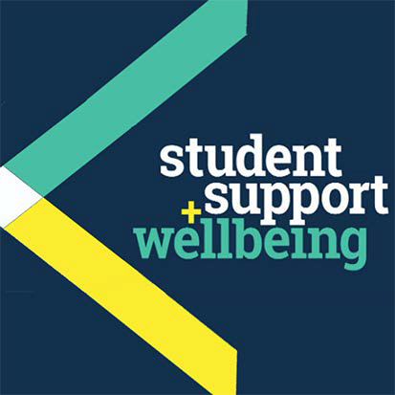

University Counselling Service

What is bullying?

Bullying is often persistent and unobservable and can come in the form of criticism, nit-picking, being excluded or singled out, or physically or verbally abused etc.. It can be overt or covert, and imposed by one or more people.
Bullies bully because they themselves feel inadequate (although they often do not realise this), and they want to project their feelings onto others and away from themselves.
Bullying can occur anywhere: at home, at university,
at work or in social situations. Bullying can also occur in cyberspace.
Cyber-bullying: some people feel they are being cyber-bullied. This might mean discreet or indiscreet threatening behaviour by a named or anonymous individual or being shut out of social discussions online.
Usually there is little or no control of what is being posted online, leaving the victim feeling helpless and vulnerable.
No matter what type, bullying is unacceptable

Myths or common misperceptions of bullying

“Bullying toughens you up”
“It’s a part of life, you’ll get over it” “Just ignore it and it will go away”
“There is no bullying here, its’ all in your mind, you’re just being over-sensitive”
(Adapted from www.antibullying.net)

Consequences of being bullied How might you feel…

You might feel:
- angry
- tearful
- lonely and

The effects of bullying can undermine your self confidence and self worth. It can lead to difficulties in building new friendships and trusting people, which may consequently impact on your future. It can sometimes lead a person into becoming a bully him/herself.
Coping with being bullied whilst at university, can be mentally, emotionally and physically draining.
How might you behave…
You might:
- withdraw from work or academic commitments
- withdraw from social activities
- become preoccupied
- experience poor concentration
- be unable to cope with daily tasks
- experience sleep and/or appetite disturbance
- experience a sense of shock, helplessness and/or irritability.

What might help?
- Letting someone you trust know - enables you to manage what is happening more effectively, allowing you the space to become stronger.
- Using confidential support services around you, eg. University Counselling Service or the Students’ Union
- provides you with space to discuss your options, allowing you to work out if you want to take things further or not, and provides you with some coping strategies etc..
- Finding ways to manage what is happening - helps you consider ways to keep yourself safe. There may be things you can do to prevent certain unwanted behaviours occurring.
- Noting things down – it may help in the long term to note down dates, times and places when the bullying has taken place.
- Finding your voice - allows you to start asserting yourself and no longer feel victimised.
- Valuing yourself - makes you question ‘is it really acceptable to bully and be bullied?’

How to help a friend experiencing bullying

You can support someone who is being bullied by:
- listening to their struggles with it
- talking to them

Remember, the University of Wolverhampton has strict policies on harassment and bullying. For more information, see the ‘Student Guide’ under the “Harassment and Bullying Policies” section of the equality and diversity website:www.wlv.ac.uk/edu/policies

You might like to read:
Gardner, O with Buder, E & S. (2008) Letters to a Bullied Girl: Messages of Healing and Hope. New York: HarperCollins
Hinduja, S and Patchin, J. (2009)Bullying Beyond the Schoolyard: Preventing and Responding to Cyberbullying. California: Corwin Press
Simon, G.S. (2010) In Sheep’s Clothing: Understanding and Dealing with Manipulative People. Little Rock: Parkhurst Brothers Inc.

People you might want to contact:
- Your doctor
- The Samaritans – tel: 08457 90 90 90
- The Students’ Union - tel: 01902 322 038

Royal College of Psychiatrists:

www.rcpsych.ac.uk/healthadvice/atozindex.aspx
Advice from Mind:
www.mind.org.uk/information-support/mental-health- a-z/
Useful leaflets:
www.ntw.nhs.uk/pic/selfhelp/
Health A-Z at: www.nhs.uk Free meditation exercises:

http://franticworld.com/free-meditations- from- mindfulness/

Other useful websites: http://beatbullying.org http://antibullying.net

http://bullyonline.org

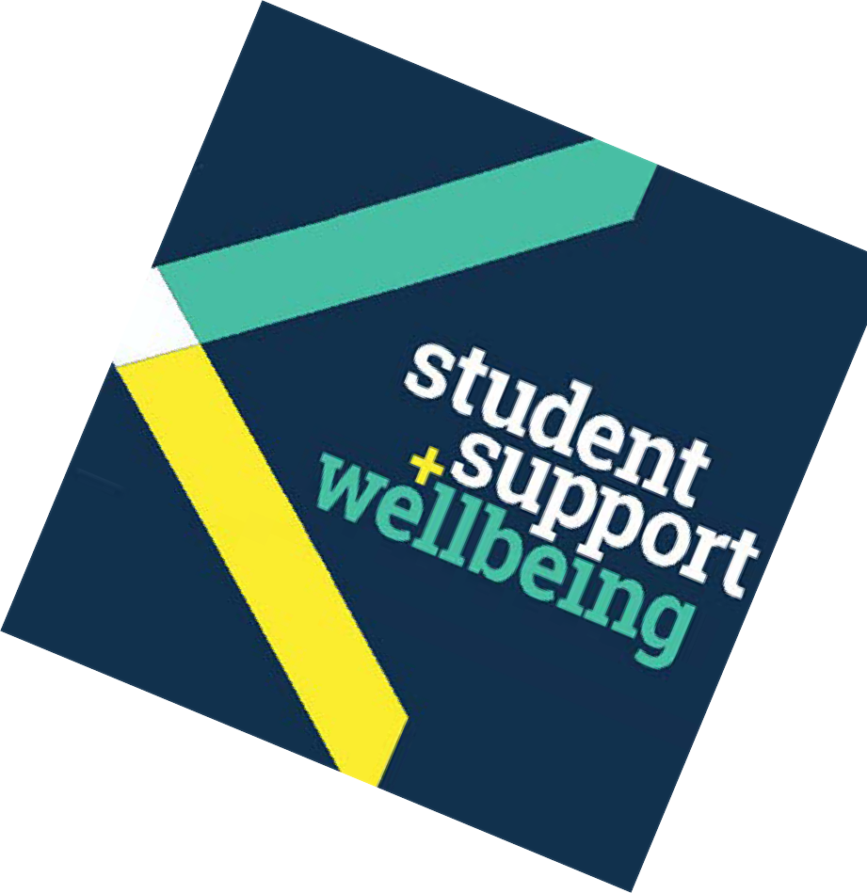isolated
- helpless
- demoralised
- frightened.
- encouraging them to empower themselves
- encouraging them to consider how they might get support
- checking online for anti-bullying websites, so they feel that they are ‘doing something’ without feeling pressured.

