Your University at your side

Counsellors at the University of Wolverhampton:
- provide free and confidential individual counselling
- offer non-judgemental support and understanding
- are professionally trained
- are experienced in dealing with a wide range of problems

Counselling can:
- help you to develop your strengths
Combating anger
- offer you the chance to focus on and understand your difficulties
- enable you to make positive decisions and changes
- help you to develop the skills and resources to cope
- help prevent small problems from becoming bigger.

Get in touch
You can make an appointment to see a counsellor by filling out the Contact Us form at www.wlv.ac.uk/SSW, alternatively, you can come along to one of our drop-in services. For more information go to the web address above and click on the Mental Health and Wellbeing option. From here you will find a wealth of useful information and self-help tools as well as our Drop-ins and Group activities.



Combating anger
How to handle your anger, or somebody elses’

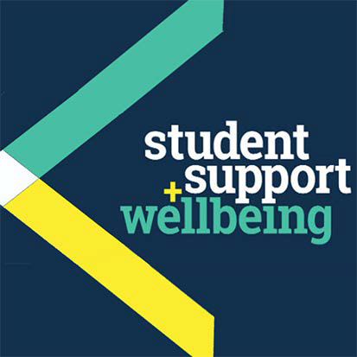

University Counselling Service

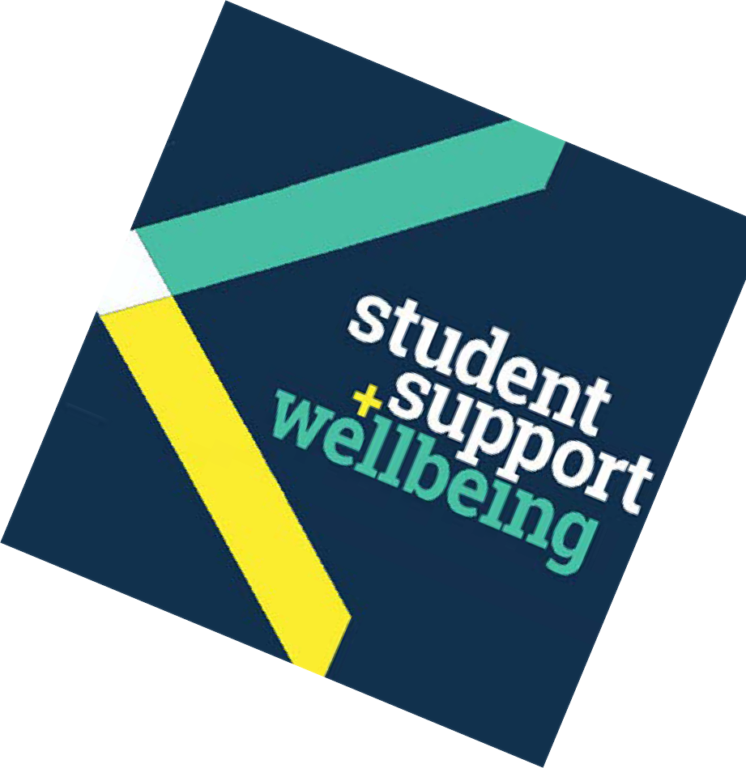Introduction
Feeling and expressing anger is a healthy response to certain events in our lives. For some of us, howeve,r anger is a constant or repetitive way of being. This kind of anger is physically bad for our health: it ruins our relationships and can leave us feeling depressed and alone.

What are the signs that our anger might be a problem?
- You’re unable to deal with difficult situations without becoming angry or aggressive.
- You need to get angry to make yourself feel bette.r
- People avoid you because they are wary of you, or try to please you to keep you calm.
- You avoid some people or situations because you know that you won’t be able to control your ange.r
- You often feel embarrassed or regret the way you have behaved.
- You have health problems that could be related to excessive anger, eg. high blood pressure.

Why do I get angry?
Here are a few examples of situations that could lead to the development of unhealthy anger:
- A recent traumatic or difficult event that has been damaging to us, eg. being betrayed by a loved one, or suffering a bereavement
- Past traumas may lead to excessive ange,rwhich stays with us, because we feel constantly under threat
- Anger sometimes feels to us like a more acceptable or ‘safer’ emotion to express than sadness or vulnerability
- Maybe you don’t know or haven’t realised you can behave differently
- Anger can be a symptom of a physical or psychological illness, eg. those that involve high levels of pain; an altered hormonal level; or a mental health difficulty.

How can I manage my anger?
- Look at whats’ ‘in’ the anger to see what other feelings or recent/past events may be underlying the ange.r If we peel back our anger, or look at what is behind it, do we find that it is covering up something else that is even less easy to deal with, e.g. sadness, shame, worthlessness etc.?

- Remember that refusing to acknowledge angry feelings will not make them go away.

- Try to understand what is the gain from letting rip with your anger eg. it might feel better afterwards; or send a message to others that you’re not a push-ove.r But maybe it’s a short term gain?

- Consider what else could bring you the same positive feelings, eg. being assertive, instead of aggressive.

- Think about ways to develop a less stressful, more relaxed way of life – perhaps increased exercise.

- Relax! Alter your breathing patterns so that you hold each breath for 5 seconds and then breathe out.

- Relax! Tense and relax all your muscles slowly in turn.

- Relax! Slowly count up to ten in your head, sing music in your head, or imagine a relaxing scene. These all have a de-stressing function.

- Avoid stimulants such as alcohol or drugs.

- Try practising some mindfulness exercises.

You might like to read:
Lindenfield, G. (2000)Managing Anger. London: Thorsons
Other leaflets in this series: Becoming Assertive

People you might want to contact:
- Your doctor
- NHS Direct – tel: 0845 46 47
- The British Association of Anger Management:
0345 1300 286 or visit: www.beatinganger.com

Other useful websites:
The Royal College of Psychiatrists
www.rcpsych.ac.uk/healthadvice/atozindex.aspx
Advice from Mind:
www.mind.org.uk/information-support/mental-health-a-z/
Useful leaflets:
www.ntw.nhs.uk/pic/selfhelp/
Health A-Z at:
www.nhs.uk
Free meditation exercises: http://franticworld.com/free-meditations- from-mindfulness/

