Other useful websites
MIND: the mental health charity
Dealing

mind.org.uk/information
The Royal College of Psychiatrists

rcpsych.ac.uk/mentalhealthinformation.aspx
NHS (Northumberland, Tyne & Wear)
Follow the links to a range of self-help guides

ntw.nhs.uk/pic


Your University at your side
Mental Health and Wellbeing at the University of Wolverhampton:
- provide free and confidential individual counselling
with depression
- offer non-judgemental support and understanding
- are professionally trained
- are experienced in dealing with a wide range of problems

Counselling can:
- help you to develop your strengths
- offer you the chance to focus on and understand your difficulties
- enable you to make positive decisions and changes
- help you to develop the skills and resources to cope
- help prevent small problems from becoming bigger

Get in touch
You can make an appointment to see a counsellor by filling out the Contact Us form at www.wlv.ac.uk/SSW, alternatively, you can come along to one of our drop-in services. For more information go to the web address above and click on the Mental Health and Wellbeing option. From here you will find a wealth of useful information and self-help tools as well as our Drop-ins and Group activities.

Dealing with depression
Developing a more positive outlook.



University Counselling Service

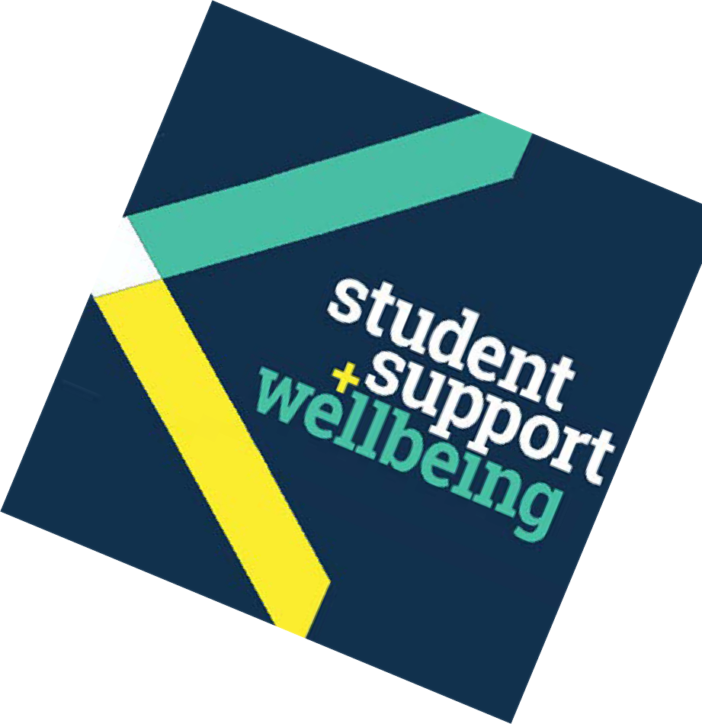Typical symptoms of depression
Everyone feels ‘down’ from time to time; our changing moods are a normal part of life. Usually the experience of feeling ‘down’ passes and we forget all about it. However, if the feeling is persistent, and more intense than simply ‘having a bad day’, then it could be depression.

The following list is not exhaustive, and is meant as a guide only. However, if several of these symptoms apply to you, and persist over time, you may be depressed.
- Sleep disturbance – not sleeping as much as usual; interrupted sleep or early waking on a regular basis; sleeping far more than usual.
- Change in appetite – eating much less/more than usual, resulting in weight loss/gain.
- Loss of interest in things which you used to find engaging and pleasurable.
- Feelings of worthlessness.
- Being more easily roused to anger, or prone to cry.
- Loss of energy and motivation.
- Loss of sex drive.
- Feeling ‘out of it’, not part of the world around you. Feeling that life is pointless, and maybe considering suicide.

Depression is quite a common experience. If you think you may be depressed, consider telling someone. Think about seeing a counsellor, and/or your GP.

Don’t worry: there is help out there to cope with depression and work towards feeling more positive about life again.

Possible causes of depression
It is not always possible to determine the cause of depression, but this does not usually mean that improvements in mood are unattainable. Depression seems to be linked to events or circumstances which we find deeply distressing, and are unable to change. Hormonal and chemical changes are sometimes said to be responsible. Some of the following may result in depression:
- the end of a relationship
- bereavement
- unemployment
- an accident, assault or other trauma
- moving to a new place
- the cumulative effects of several important
changes occurring in a relatively short space of time
- childhood difficulties
- feeling overwhelmed by too many responsibilities
- academic difficulties, fear of failure
- feeling isolated and uncared for
- feeling unable to express your feelings.

Helping yourself
Depression can be very isolating, because it encourages withdrawal. However, contact with other people helps fight depression. If possible, spend time with people who care about you.
- Confide in someone.
- Establish a routine which involves a range of varied activities, because external stimulation is helpful in disrupting cycles of negative thinking and lifting your mood.
- Try to get out each day. Some people find that daylight, and especially, bright sunlight, helps them.
- Exercise regularly. Exercise boosts energy and releases chemicals in the brain which fight depression.
- Try to eat regularly. Long periods with little or no food increases the likelihood of feeling depressed.
- Try to avoid being too hard on yourself. Instead, try to appreciate yourself more. Give yourself credit for any self- help steps you’re taking to improve your mood.
- Try to challenge your negative thinking.
- Cut down on alcohol and illegal drugs, as the after-effects can seriously dampen your spirits as a result of chemical changes in the brain.
- Consider learning some mindfulness techniques.

Help from your GP and Counselling
Doctors see many people who are suffering from depression. Your doctor will be able to discuss with you the merits of different forms of help.

Modern anti-depressants can be effective in helping to lift your mood in order that you can deal with any difficulties in your life that may be contributing to the depression. However, these may take up to three weeks to begin taking effect. They’re usually not addictive, and often, any side-effects are mild and short-lived.

Counselling can also offer a means to gain professional support, and a way to work through and understand some of the underlying causes of your depression.

On occasions, counselling and anti-depressants can actually work together as the most effective means of treatment.

You might find it helpful to:
  - attend one of our workshops on related
- subjects.
read some of our other leaflets: Dealing with anxiety and panic attacks; Overcoming the fear of failure; Dealing with
- stress; Developing confidence and self-esteem; Combating anger; Mindfulness.
read: Griffin, J. and Tyrell, I. (2004) How to lift depression[… fast]: the human givens approach. East Sussex: HG Publishing

Other people you might want to contact
- Your doctor
- NHS 111, calls are free from landlines and mobiles, tel:

111
- The Samaritans for 24-hour confidential support – tel: 01902 426 422 or 08457 90 90 90 or visit: samaritans.org.uk
- Campaign Against Living Miserably (mainly for men) on tel: 0800 585 858

Other useful websites
Depression Alliance:depressionalliance.org SANEline: sane.org.uk
Students Against Depression:studentdepression.org
MoodGYM (an online self-help package):

moodgym.anu.edu.au
MIND: the mental health charity:

mind.org.uk/information
The Royal College of Psychiatrists:

rcpsych.ac.uk/mentalhealthinformation.aspx

Some of the things students have said about the University Mental Health & Wellbeing Service:
“Counselling made issues more manageable.”
“Counselling has helped me to put my life into perspective and sort out my problems.”

