Stage 2 Local Assessment – Event Risk Assessment
Please use this risk assessment. We have pre-populated the form with a few hazards. If you have any additional required controls, then feel free to add these into the relevant cells but do not remove the existing control measures that have already been included. If you have any other hazards to add in, then please add these to the bottom of the form in the spaces provided.
Please use the below boxes to highlight any risks your activities could create. Pay particular attention to risks such as equipment usage, transport, number of attendees, catering, alcohol etc. and consider the potential risks associated with each area. Risks will have a rating before controls are put in place (uncontrolled risk level), and a further rating (controlled risk level) once controls are put in place. If any of your risks come out at the High Risk or Extreme Risk rating once controls are put in place, please defer the decision to Stage 3 by emailing freedomofspeech@wlv.ac.uk
Name
Name of School or Professional Services Directorate
Email address

Event details

Date of event
Length of event in hours
Title of event
Proposed location (if online, provide further details)
Expected number of attendees
Type of event (conference, exhibition, commercial event, lecture, public meeting, reception, seminar, talk, other – provide further details for other)
Purpose of event (careers, employability, knowledge exchange, teaching, research, training, other – provide further details for other)
If event is associated to a module, please provide the module name and module code

Please review the Freedom of Speech Comprehensive Source of Information to support your local assessment
Freedom of Speech - University of Wolverhampton

Some Indoor Events and Organisational factors to consider

Indoor Events | Organisation
Electrical hazards | Poor planning/ preparation
Inadequate lighting | Poor delivery/organisation
Temperature (too hot / cold?) | Lack of information, training, instruction
Slips, trips and falls | Unsafe behaviours
Insufficient or unsuitable space | Lack of first aid equipment or experience
Untidiness (trip / fire hazard) | Medical conditions of participants
Stairs – dark / steep / no handrail | Differing skills levels
Lack of fire escapes / extinguishers / procedures | Low level of fitness / strength
Poor ventilation | Aggression from participant
 | Aggression from public

Other Considerations:
Conduct of meeting
How will the chair:
- Deal with hecklers or any disturbance (specifying the circumstances in which the chair would ask stewards or security staff to intervene, and to what effect)
- Allow the expression of alternative views (for example in a debate format)
- Select individual members of the audience to put points or ask questions
- Ask individuals (speakers or audience members) to leave the event
- Terminate the meeting in the event of material disorder
Audience Safety
- Have the organisers planned for first aid and fire safety?
- Have stewards to the event been briefed on their role and responsibility?
- Are the organisers and stewards discussed when & how to liaise with university security?
- Are the arrangements for audience admission appropriate for the type of event?
Cameras, press and publicity
- Will the event be filmed or recorded? And if so, by whom?
- Will members of the press be in attendance?
Outside the venue (during the event)
What arrangements have been agreed with university security (and if necessary, the police) for crowd control and public order immediately outside the venue (for example in the event of there being several protestors or groups who have been denied access to the venue).
After the event
Events should be evaluated by the organiser as this will help highlight issues and tensions as well as possible risks associated with similar events held in the future. For example, an event might be assessed as low and go ahead but turns out to be highly controversial (during or after the event). Evaluation of events will help the university to understand why this event was controversial/ challenging and this record will add to knowledge for assessing future events that are similar.
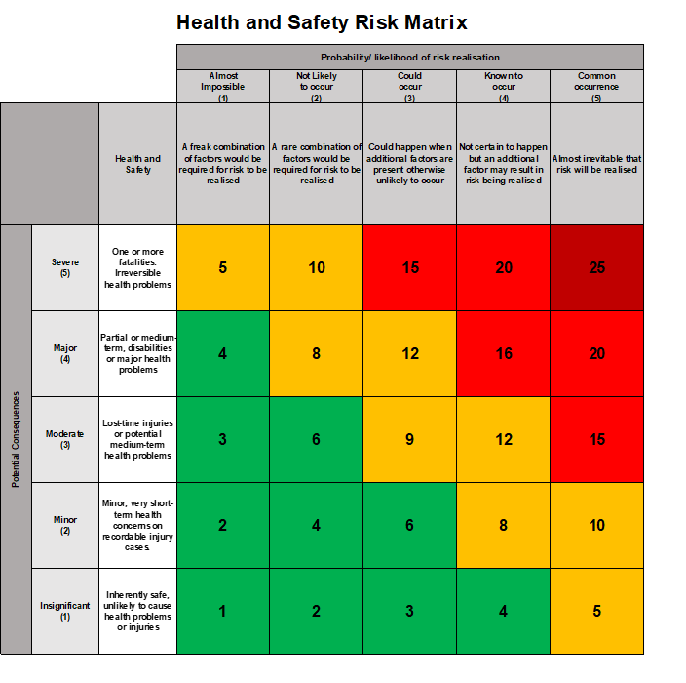


Hazards (things with the potential to cause harm) | Those at risk (people who could be harmed) | How could they be harmed? (nature of injuries, damage that could result) | Uncontrolled risk level (level of risk without control) | Required controls  (how the risk can be removed or reduced by for example engineered methods, safe systems of work, training and/ or personal protective equipment) | Controlled risk level (level of risk remaining when controls are in place)
Overcrowding | Attendees | Physical injury, crushing, stampede | 4X4  High Risk | Tickets associated with the event will not exceed the room capacity (Please Clarify Ticket Platform that will be used.) | 3X2  Low Risk
Fire | Attendees | Burns, death, smoke inhalation | 5X5  Extreme Risk | Those responsible for the event location/building will ensure that all fire exits are kept free from obstructions and will provide a briefing at the start of the session as to where the fire exits are, and where the fire assembly point is. If any attendees discover a fire or smoke, they should raise the alarm and exit the building. | 5X1  Medium Risk
Electrical Fire | Attendees | Burns, death, smoke inhalation | 5X5  High Risk | Most of these event types will take place on campus; all AV equipment associated with the rooms will be checked and tested regularly and inspected before use. As above, if a fire is detected attendees will raise the alarm and exit the building | 5X1  Medium Risk
Trip Hazards - Cables/Steps | Attendees | Physical injury, crushing, stampede | 4X4  High Risk | The organisers will ensure the room is accessible for all attendees and floors are kept spacious/free from debris. | 3X2  Low Risk
Random medical emergency | Attendees | Physical, mental, emotional injury | 4X4  High Risk | In the event of an emergency the organiser will follow the University of Wolverhampton emergency procedure and report the incident using the incident reporting form | 2X2  Low Risk
Hostile action towards speaker | Speaker, reputational damage | Physical, verbal abuse | 4X3  Medium Risk | Organisers will have submitted a guest speaker form within the required time frame for relevant checks. Attendees will be expected to conduct themselves with respectable behaviour. In the unlikely event, university security staff can be contacted. If the event is off campus, then the relevant authorities will be called (police/venue security etc.) | 2X2  Low Risk
Speaker content | Attendees, reputational damage | Emotional distress | 4X3  Medium Risk | Both the organiser and speaker will have read/understood/accepted The University of Wolverhampton freedom of speech code of practice.  Provide sufficient summary of content for any topic that is likely to cause upset. Attendees can leave the event at any time | 3X2  Low Risk
Speaker Event off campus | Attendees | Safety due to lack of security (event off campus) | 4X4  Medium Risk | The organiser will be responsible for coordinating with the venue in organising security.  Exec will be responsible for notifying the relevant authorities if necessary (Council, Police,)  Exec will be responsible in feeding this information back to the Opportunities Team | 4X2  Medium Risk
Complaints | Student Group/ Attendees/ Speaker | Complaint against the event or content | 4X3  Medium Risk | Any complaints received will be directed to and investigated under the Freedom of Speech Code of Practice. Complaints will be directed to freedomofspeech@wlv.ac.uk | 3X2  Low Risk
Please add any further risks associated to your event
Please add any further risks associated to your event
Please add any further risks associated to your event
Please add any further risks associated to your event

