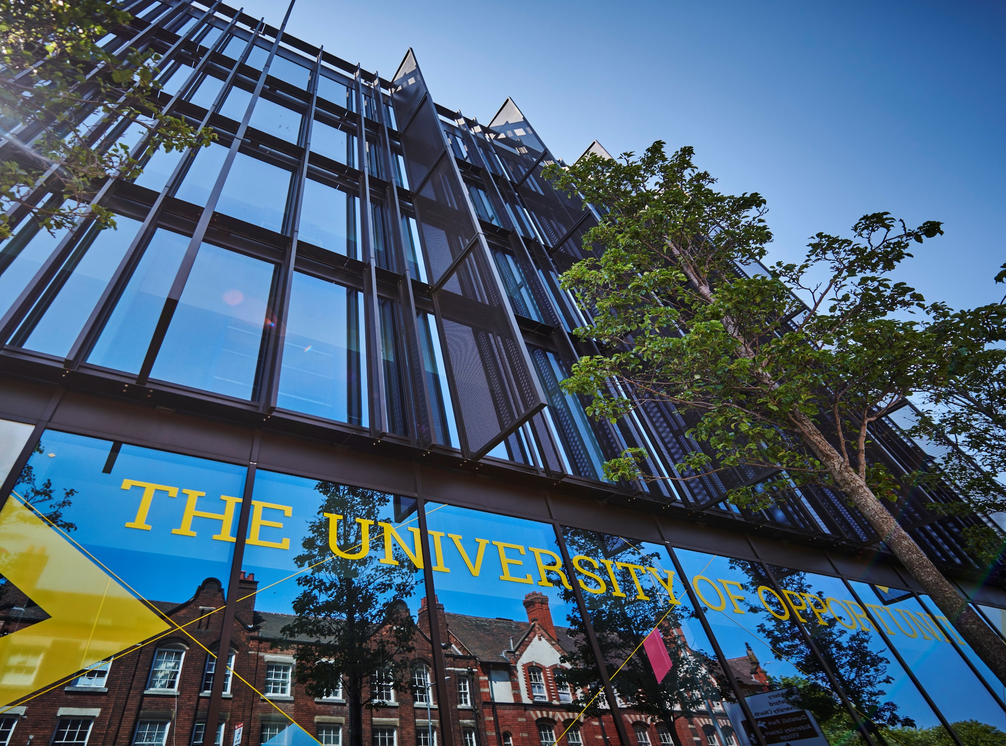



Confirmation of Acceptance
for Studies (CAS) Issuance
Policy




- Introduction

- Purpose

- Principles

- Scope
5. Details of Policy: Confirmation of Acceptance (CAS) Issuance
CAS withdrawals

Visa Decision Where CAS Is Issued

- Our University Responsibilities in Relation to This Policy

- Your Responsibilities as a Student in Relation to This Policy

- What To Do If You Need Support with This Policy

- Data Protection Requirements

- Training

- Exceptions

- Amendments

- Information and Resources

- Contact

POLICY

- Introduction

The University of Wolverhampton is committed to a fair and transparent policy in respect of the issuing of Confirmation of Acceptance for Studies (CAS). This Policy has been approved by the University’s Executive Board.

- Purpose

To maintain our UKVI sponsor status, the University of Wolverhampton must request and pass a Basic Compliance Assessment every year. Under current requirements, to pass a Basic Compliance Assessment, we must meet various requirements for the twelve months prior to our request, including a visa refusal rate of less than 10%, an enrolment rate of at least 90% and a course completion rate of at least 85%. These metrics are subject to change in accordance with UKVI requirements.

This policy is designed to ensure a Confirmation of Acceptance for Studies (CAS) is only issued to eligible and credible students, who are in a position to receive a visa, enrol and complete their studies.

- Principles

The objectives of this policy are to ensure applicants are aware of the terms and conditions associated with the issuing of Confirmation of Acceptance for Studies (CAS).

The implementation of this policy is in accordance with the University’s core values which are to be:

- Accountable; we take pride in what we do and how we do it, take responsibility for our actions and operate with transparency and integrity.
- Resilient; we have a positive outlook; we are adaptable and recover from setbacks.
- Inclusive; we are welcoming, respectful, collegiate and supportive.
- Ambitious; we are imaginative, confident, innovative and deliver excellence.

- Scope

The Confirmation of Acceptance for Studies (CAS) Issuance Policy applies to all international applicants to the University. The responsibilities and organisational arrangements for the policy lie with a variety of individuals within the University, details of which are set out as follows:

- International Recruitment
- International Admissions
- Visa Compliance and Advice

- Details of Policy

5.1 Confirmation of Acceptance (CAS) Issuance

A Confirmation of Acceptance for Studies (CAS) is an electronic document that generates a unique reference number required to apply for a student visa.

A CAS can be assigned no earlier than six months before the course start date for students outside the UK, and no more than three months before the course start date for students inside the UK.

The Admissions Unit will assess and issue CAS to any new students with a new course application. The Student Visa Compliance and Advice team will issue CAS to any continuing students with a visa extension application. A CAS will only be issued to applicants where:

- There is an unconditional offer to study the course and the student is in a position to enrol online.
- All academic evidence has been provided, assessed and approved.
- The applicant can meet all course-specific requirements, including DBS checks, police clearance, fitness to practice, and any other mandatory assessments and is in a position to enrol.
- All financial evidence has been provided, assessed and approved.
- A valid Academic Technology Approval Scheme (ATAS) certificate has been provided where required (Academic Technology Approval Scheme (ATAS) - GOV.UK).
- A valid Tuberculosis (TB) certificate has been provided where required (Tuberculosis tests for visa applicants: Check if you need a TB test for your visa application - GOV.UK).
- Academic progression is met.
- The University is satisfied the student is genuine and credible.
- Good immigration history.
- The student has passed an interview (where applicable).
- Parental consent and evidence is provided where the applicant is under the age of 18.
- The student meets all UKVI visa requirements (Student visa : Overview - GOV.UK).

The University may request further evidence or information before proceeding with CAS issuance. Each application will be assessed, and deferrals will be reassessed before CAS can be issued.

The University will not issue a CAS where requirements are not met. This includes but is not limited to:

- The applicant does not meet University or UKVI requirements.
- The applicant cannot meet all course-specific requirements, including DBS checks, police clearance, fitness to practice, and any other mandatory assessments.
- Academic progression is not met.
- Insufficient funds.
- An applicant fails to obtain an ATAS certificate where it is required.
- Applicant has provided fraudulent payments, documents or deception has taken place. No further application will be accepted.
- Breach in visa conditions.
- No evidence of return home where required.
- Previous immigration history concerns – Please see the Universities Visa Decision, Refusal and Refund Policy (https://www.wlv.ac.uk/about-us/corporate-information/wlv-policies/).
- The Student Visa Compliance and Advice team is not satisfied; university or UKVI requirements are being met.
- There is reason to believe issuing CAS would risk our University sponsor licence.

It is the applicant’s responsibility to ensure all CAS information is accurate and to inform the University of any errors straight away.

CAS issuance is subject to the University’s annual CAS allocation, which is determined at the discretion of the UK Home Office.

CAS issuance is subject to the approval of the University’s Student Visa Compliance and Advice team.

5.2 CAS withdrawals

The University of Wolverhampton has the right to withdraw a CAS where a student has not met University or UKVI conditions, including but not limited to latest arrival deadlines, enrolment requirements and right to study checks.

5.3 Visa Decision Where CAS Is Issued

The University of Wolverhampton must be informed of all visa application decisions as soon as an applicant receives this. The applicant (or Contracted Educational Advisor on their behalf) can do this by completing a task in e:Vision prior to enrolment or providing evidence of the decision to the Student Visa Compliance and Advice team.

Failure to provide evidence of a visa decision will impact the applicant/student’s ability to apply for a refund of deposit or further CAS.

- Our University Responsibilities in Relation to This Policy

The University will ensure consistent and fair application of the policy, ensuring you are informed of decisions taken in accordance with it.

- Your Responsibilities as am applicant in Relation to This Policy

You should thoroughly read this policy to understand how the terms apply to you; and adhere to each of the terms outlined, within this policy and its associated guidance.

- What To Do If You Need Support With This Policy

For further support with this policy please contact the International Admissions and Recruitment teams: Contact Admissions - University of Wolverhampton.

- Data Protection Requirements

When personal data is expected to be used under this policy, staff must adhere to applicable data protection laws. These are outlined in the University's Data Protection Policy and related policies (https://www.wlv.ac.uk/about-us/corporate-information/wlv-policies/). Any use of personal data should be detailed in the relevant privacy notice and processed in accordance with all data protection principles.

For processing activities that may carry high risk; completion of a Data Protection Impact Assessment (DPIA) may be required. This is determined by answering a series of screening questions included in the DPIA template. The Data Protection Team is available to provide assistance and guidance with any part of this process, please contact them via email: dataprotection@wlv.ac.uk.

Please note that whilst the Data Protection Act does not cover aggregate data, it must be ensured that small numbers held within aggregate data sets do not inadvertently identify individuals.

- Training

Training relating to this policy and briefing will be made available in a range of formats according to the needs of the trainee and different groups of staff, students and others.

- Exceptions
There are no exceptions to this policy.

- Amendments

This Policy was approved by the University’s Executive Board on 22 July 2025. The University may change this Policy at any time, and where appropriate. Where a policy is not due for review, but is found to require updating, it will remain published, unless the reasons for review render it obsolete.

- Information and Resources

Advice and Support:

Visa & Immigration - University of Wolverhampton

Applicant Information:

International - University of Wolverhampton

Pathway Programmes:

Visa Information | University of Wolverhampton International Study Centre

Policy Hub:

https://www.wlv.ac.uk/about-us/corporate-information/wlv-policies/

- Contact

For any queries, guidance and support relating to this policy please contact Admissions on + 44 1902 323505:

Contact Admissions - University of Wolverhampton.

For general queries, please contact the Corporate Compliance Team via email: compliance@wlv.ac.uk.

VERSION | 1.0 | AUTHOR/OWNER | Daniel Kidd  Dean of Students
Approved Date | 22 July 2025 | Approved By | University Executive Board
Review Date | 22 July 2028

