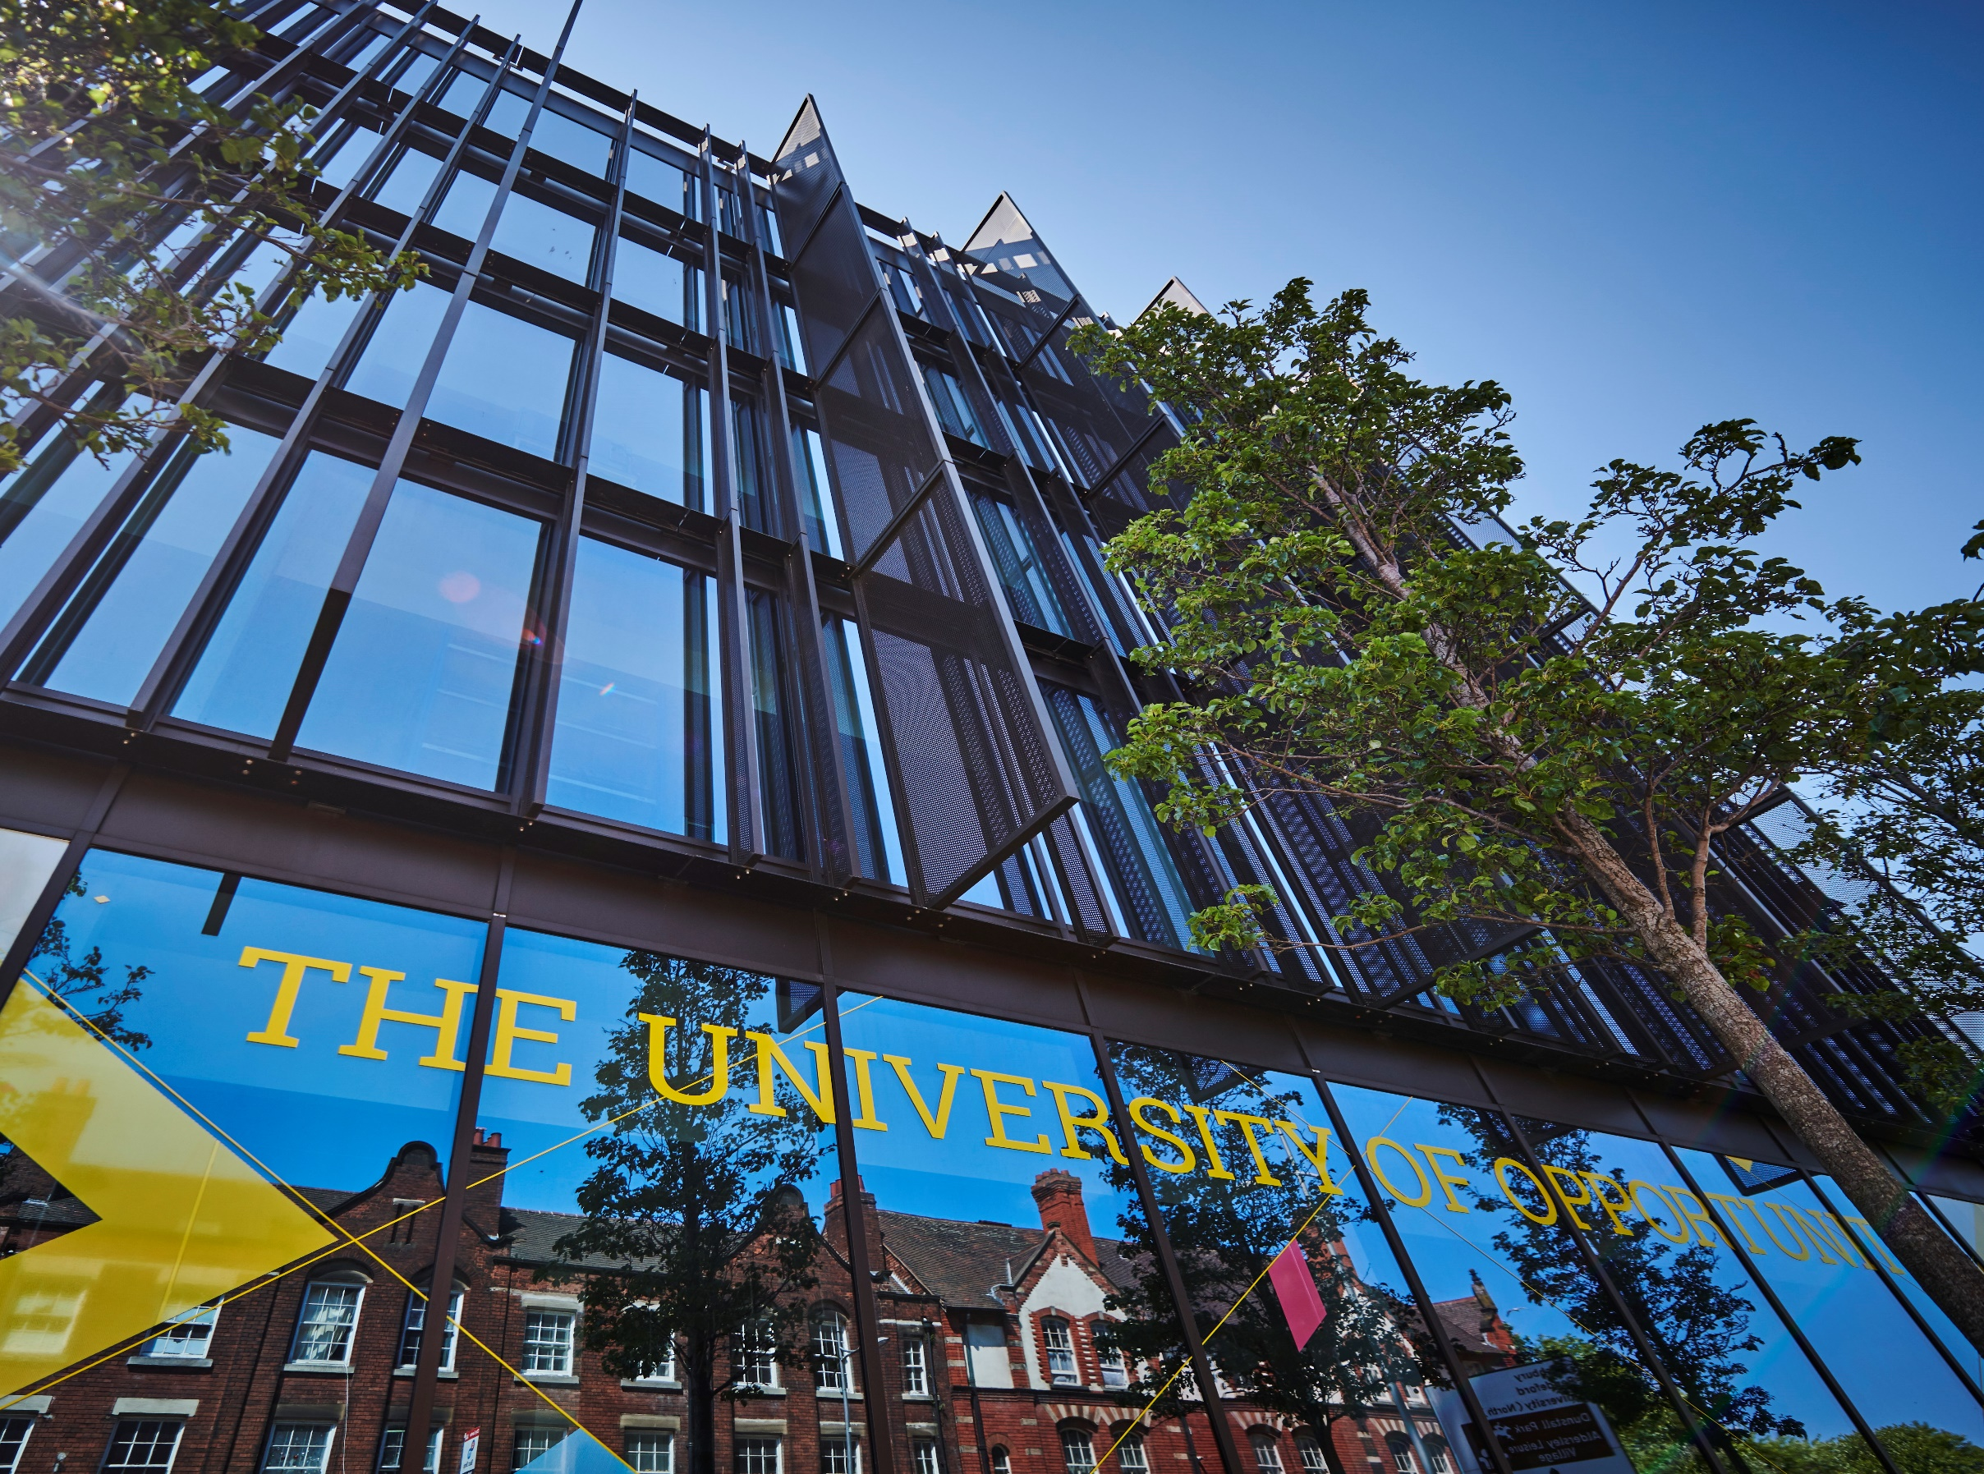
r



Criminal Convictions:
Applicants and Students, Policy and Procedure

Criminal Convictions:
Applicants and Students
Policy and Procedure



1. Introduction
2. Purpose
3. Principles
4. Scope
5. Roles and Responsibilities: Applicants
6. Roles and Responsibilities: Students
7. Records Retention
8. Training
9. Exceptions
10. Monitoring
11. Amendments
12. Information and Resources
13. Contact
14. Policy Governance
15. Appendix A: Procedure for monitoring students convicted of sexual offences.

POLICY/PROCEDURE

- Introduction

The University of Wolverhampton is dedicated to ensuring a safe environment for students, staff, and stakeholders. As a university of opportunity, we strive to recruit a diverse range of students from various backgrounds, assessing them based on their prior achievements and potential, including those with criminal convictions.
This policy, approved by the University’s Academic Board, details the university's approach to handling criminal convictions. It specifies the requirements for applicants and students to declare any relevant, unspent criminal convictions. This requirement is clearly communicated to all applicants in their offer letters and to all students through the University’s Terms and Conditions.

- Purpose

In order to manage and mitigate risk within the University, all applicants and students are required to declare, relevant unspent criminal convictions so the risk can be assessed. Having such a conviction does not automatically lead to rejection or exclusion. Instead, the nature of the offence and all pertinent details about the conviction are carefully evaluated to determine if there is any unacceptable risk of harm to the broader University community when considering admission, continuation on a course, or access to university-managed accommodation.

- Principles
The objectives of this policy are to ensure that all applicants and students declare any relevant, unspent criminal convictions, allowing the University to assess how these may impact the safety of the University Community and manage any associated risk.
The implementation of this policy is in accordance with the University’s core values which are to be:

- Accountable: we take pride in what we do and how we do it, take responsibility for our actions and operate with transparency and integrity.
- Resilient: we have a positive outlook; we are adaptable and recover from setbacks.
- Inclusive: we are welcoming, respectful, collegiate and supportive.
- Ambitious: we are imaginative, confident, innovative and deliver excellence.

All data collected by the University under this policy will be processed in compliance with the University’s data protection policy.

- Scope

The Criminal Convictions: Applicants and Students Policy and Procedure applies to all applicants and registered students at the University of Wolverhampton, including those studying with our collaborative partners. This policy covers convictions that may impact the university’s duty of care regarding the safety of our students, staff and visitors.

Applicants to and students on professional programmes where the relevant Professional, Statutory or Regulatory Body (PSRB) mandates the declaration of criminal convictions at an earlier stage (such as during the application process or throughout the course of study) and/or imposes stricter requirements, will be assessed separately.

Relevant criminal convictions are defined as including, but not limited to:

  - Any kind of violence, including threatening behaviour, offences concerning intent to harm and offences resulting in actual bodily harm.
  - Sexual offences, including those listed in the Sexual Offences Act 2003.
  - The unlawful supply of controlled drugs or substances, where the conviction concerns commercial drug dealing or trafficking.
  - Offences involving firearms.
  - Offences involving arson.
  - Offences involving terrorism or hate crime.

Applicants are not required to disclose a 'spent' conviction unless it is mandated by a specific Professional, Statutory, or Regulatory Body (PSRB) with stricter regulations for entry into a professional course. In such cases, the relevant details are provided in the "Entry Requirements".

- Roles and Responsibilities: Applicants

  - Review of Applicant Declaration (Head of UK and International Admissions.):

Applicant disclosure
In accordance with the University Terms and Conditions applicants are required to declare any, relevant unspent criminal convictions within 14 days of accepting an offer to study at the University. Declarations made after this period may result in the withdrawal of the offer.

Third Party disclosure
The University may receive disclosures from third-party organisations such as the Police, Offender Management or Probation Services.

If an applicant accepts an offer without self-disclosure by the relevant deadline (14 days from acceptance of the offer), their application may be considered fraudulent due to the withholding of relevant information, in line with the University’s Code of Practice on the Admission of Students. In such cases, the University reserves the right to cancel the offer and acceptance and/or withdraw the student from their programme and the University.

Following an initial declaration, or when information regarding a criminal conviction is provided to the University by a third party (e.g., Police or Probation Service), the Head of UK and International Admissions (or their designated nominee) will assess the relevance of the conviction. If the conviction is deemed not relevant, the applicant will be informed in writing, and the record of the disclosure will be deleted. If the conviction is deemed relevant, the applicant will be asked to provide further information within 14 days.

An initial assessment, based on the available information, will be conducted by the Head of UK and International Admissions in consultation with other senior staff if necessary. The Head of UK and International Admissions may determine that no further action is required. All assessments will be based on the relevance to the course for which the applicant has applied.

If the Head of UK and International Admissions determines that there is a potential risk to the University community, a Criminal Convictions Panel will be convened to assess this risk.

Where an applicant fails to declare a relevant unspent criminal conviction or provide any requested additional information, the University reserves the right to withdraw the offer or terminate the registration.

  - Criminal Convictions Panel: Applicants

This panel will comprise the Head of UK and International Admissions, the Associate Director of Complaints and Student Casework, the Designated Safeguarding Lead (or nominee), the Director of Student Life and a representative of the relevant Faculty. Guidance may also be sought from Legal Services. The panel may consider the case virtually or via correspondence without a formal meeting.

The Panel will consider whether there are unacceptable risks to the University community, considering:

  - The nature of the offence
  - The recency of the offence
  - The course applied for, particularly if this is a regulated course.
  - Any pattern of offending
  - Recommendations from referees and/or the Probation Officer/Offender Manager
  - Any mitigating circumstances
  - Any aggravating circumstances
  - Comments in the official documentation regarding the risk of re-offending.
  - Any conditions/requirements imposed as part of sentencing or probation.

The Panel will reach one of the following conclusions, which will be communicated to the applicant in writing within 5 working days of the panel meeting:

- Unmanageable Risk: The level of risk cannot reasonably be managed. The applicant cannot be admitted to the University at this time, and the offer will be revoked.

- Manageable Risk with Conditions: The level of risk can be managed through specific restrictions or conditions (e.g., exclusion from university-managed accommodation, limited access to certain services or facilities, and/or ongoing monitoring), these will be agreed upon with the applicant as a condition of the offer. If the applicant fails to agree, the offer will be withdrawn immediately. If, after enrolment, evidence is provided to the Complaints and Student Casework team to indicate that the student has failed to comply with any restrictions or conditions, the University will invoke the Student Disciplinary Procedure, which can lead to exclusion from the University.

- Acceptable Risk: The level of risk is deemed acceptable; the applicant can be admitted without any specific restrictions or conditions.

  - Applicant Appeals

Applicants who wish to appeal a decision of the Criminal Convictions Panel may do so by writing to the Director of UK Student Recruitment, Access, and Partnerships. The Director of UK Student Recruitment, Access and Partnerships will normally respond to any such appeal within 14 days, and this decision will be final.

  - Applicant Complaints

Applicants who wish to make a complaint about any decision, may do so through Admissions Complaints Procedure.

- Roles and Responsibilities: Students

Students are asked to declare annually, at enrolment, whether they have received any new criminal convictions. Where a criminal conviction is declared, or if information regarding a new criminal conviction is provided to the University by a Third Party (e.g. Police, Offender Management or Probation Services), enrolment will be automatically placed on hold, and a Criminal Convictions Declaration form will be sent to the student.
This means that the student will not be able to complete the enrolment process, will not be permitted to commence their studies, and their attendance will not be confirmed to any funding bodies (e.g. SFE) until the completed declaration form has been received and a decision reached by the Complaints and Student Casework team.

The student will be advised:
- not to attend any scheduled activities until this process has been concluded.
- that if the time taken for the process exceeds the enrolment period permitted in the academic regulations, they may need to take a break in studies or defer even if there is a successful conclusion to it.

If the student does not submit the Criminal Convictions Declaration form within 14 days they will not be permitted to complete enrolment and will be withdrawn from the course in line with the Academic Regulations.

  - Review of Student Declaration

Within 3 working days following receipt of the declaration, an initial assessment of the conviction will be made by the Associate Director of Complaints and Student Casework (or their designated nominee). The student will be notified in writing of the outcome of the initial assessment.

If the conviction is deemed not relevant and there are no associated risks to the University community, the record of the disclosure will be deleted, and the student will be permitted to enrol.

If the conviction is deemed to be relevant, further information will be requested. If no further information is received the student will not be permitted to complete enrolment and will be withdrawn from the course in line with the Academic Regulations.

If, following receipt of further information the Associate Director of Complaints and Student Casework determines that there is a potential risk to the University community, a Criminal Convictions Panel will be convened to assess the risk.

  - Criminal Convictions Panel: Students

This panel will comprise the Associate Director of Complaints and Student Casework, the Head of UK and International Admissions, the Designated Safeguarding Lead (or nominee), the Director of Student Life and a representative of the relevant Faculty. Guidance may also be sought from Legal Services. The panel may consider the case virtually or by correspondence without a formal meeting.

The Panel will consider whether there are unacceptable risks to the University community, considering:
  - The nature of the offence
  - The recency of the offence
  - The course applied for, particularly if this is a regulated course.
  - Any pattern of offending
  - Recommendations from referees and/or the Probation Officer/Offender Manager
  - Any mitigating circumstances
  - Any aggravating circumstances
  - Comments in the official documentation regarding the risk of re-offending.
  - Any conditions/requirements imposed as part of sentencing or probation.

The Panel will reach one of the following conclusions, which will be communicated to the student in writing, within 5 working days of the panel meeting:

- Unmanageable Risk: The level of risk cannot reasonably be managed It would not be reasonable for the individual to remain registered as a student.
If the student has not enrolled, they will not be permitted to enrol and will be withdrawn from the course in line with the Academic Regulations.
If the declaration is made after enrolment, the Student Suspension and Student Disciplinary Procedures will be invoked with a view to terminating the student’s registration.
- Manageable Risk with Conditions: The level of risk can be managed through specific restrictions or conditions (e.g., exclusion from university-managed accommodation, limited access to certain services or facilities, and/or ongoing monitoring). Any such restrictions will be agreed with the student as a condition of continued registration.
If the student has not enrolled and fails to agree they will not be permitted to enrol and will be withdrawn from the course in line with the Academic Regulations.
If the declaration is made after enrolment, and the student fails to agree with the restrictions/ conditions the Student Suspension and Student Disciplinary Procedures will be invoked with a view to terminating the student’s registration.
If the student fails to comply with the agreed restrictions/conditions, the University will invoke the Student Suspension and Student Disciplinary Procedures which can lead to exclusion from the University.
Where the conviction relates to a sexual offence and the student is on the “sex offenders register”, staff in the University will follow the agreed procedure set out in Appendix A.
- Acceptable Risk: The level of risk is deemed acceptable. The student can remain registered and continue their studies without any specific restrictions or conditions.

  - Student Appeals

Students who wish to appeal a decision of the Criminal Convictions Panel may do so by writing to the Dean of Students. The Dean of Students will normally respond to any such appeal within 14 days, and this decision will be final.

Where the decision of the Criminal Convictions Panel results in the Student Disciplinary Procedure being invoked, the appeal process is set out in the Student Code of Conduct and Disciplinary Procedure.

  - Student Complaints

Students who wish to make a complaint about any decision, may do so through Student Complaints Procedure.

- Records Retention
The University will only collect and process data for which there is a legitimate interest and will treat it in line with the University’s data protection policy. Information regarding relevant, unspent criminal convictions and any decisions of the Criminal Convictions Panel will be retained by the University with access restricted only to members of the Criminal Convictions Panel, the Director of Registry Services, and the Dean of Students, until the student completes the course, or the conviction becomes spent. In the case of any restriction to university managed accommodation, the restriction will be shared with relevant staff members managing the University’s accommodation services. Where other restrictions or conditions are imposed information will be shared with relevant staff only to the extent that is necessary to ensure the conditions are being met.

- Training
Staff involved in the implementation of this policy will be briefed on their responsibilities regarding this policy.
- Exceptions
Professional programmes, where the relevant Professional/Statutory/Regulatory Body (PSRB) requires criminal convictions to be declared earlier (e.g. in the application form) and/or where greater restrictions apply, are subject to alternative requirements regarding the declaration of criminal convictions details of which are provided in the Course Entry requirements.

- Monitoring and Review

Each cycle, the Admissions and Complaints and Student Casework teams will conduct a review of criminal conviction declarations and decisions reached. This review will incorporate each of the three faculties and other relevant colleagues across the university, including panel members.

This process will review and monitor the effectiveness of the Criminal Conviction policy, decisions and monitoring to ensure the safety and wellbeing of the University community.

- Amendments

This policy will be reviewed annually however, the University may change this policy at any time, and where appropriate. Where a policy is not due for review, but is found to require updating, it will remain published, unless the reasons for review render it obsolete.

- Information and Resources

This policy should be read in conjunction with the following policies and guidance:

- Admissions Policy and procedure
- Admissions complaints system: principles and procedure
- University of Wolverhampton Terms and Conditions
- Student Code of Conduct and Disciplinary Procedure
- Student Complaints Procedure

- Contact

For general queries, please contact the University by email or phone.

Applicants:

Email: admissions @wlv.ac.uk

Students:

Email: conductandappeals@wlv.ac.uk

Phone: 01902 322079

- Policy Governance

VERSION | 2.0 | AUTHOR/OWNER | Associate Director Complaints and Student Casework and Head of UK and International Admissions
Approved Date | 10 June 2026  23 June 2026 | Approved By | Academic Board (Principle)  Chairs Action (Final)
Review Date | 10 June 2029

Appendix A
Procedure for monitoring students convicted of sexual offences, including those on the “sex offenders register”,

A.1 Roles
There will be a minimum of two persons on the Sexual Offender monitoring panel.
- Associate Director Complaints and Student Casework
- Deputy - Head of Student Casework
- Director of Corporate Compliance
- Deputy - Head of Operational Safeguarding

A.2 Purpose
The panel will monitor:
- Adherence to conditions and/or restrictions set by the Criminal Convictions Panel
- General welfare and wellbeing
- Updates from Offender Management/Probation Services
- Academic engagement
- Personal safety and security

A.3 Monitoring
The frequency of meetings will be determined by the panel and may change over time. There will be a minimum of one meeting per semester.
Meetings may be conducted in person or online as deemed appropriate by the panel.
The student has the right to be accompanied, for support. The support person may not be a member of staff.
Offender Management/Probation Services may be invited to attend as required.
The student will be sent a summary of the meeting within 5 working days of the meeting which will summarise the discussion and list any action points.
Monitoring will continue until the student’s registration on the sex offender register has expired or they cease to be a registered student at the university, whichever comes first.

A.4 Failure to Engage and breaches of the conditions/restrictions.
Where a student fails to engage with the monitoring procedures or where there is evidence that they have breached the conditions or restrictions set by the Criminal Convictions Panel the Sexual Offender monitoring panel will notify the Criminal Convictions Panel. They may invoke the Student Suspension and Student Disciplinary Procedures which can lead to exclusion from the University.
Where appropriate, information will be shared with external agencies (e.g. Police, Offender Management or Probation Services) in accordance with data sharing agreements.

A.5 Sign Off Procedure
At the end of the monitoring period the Sexual Offender Monitoring panel will complete a summary form to confirm the end of the monitoring period. This will summarise the actions taken and where appropriate will include reference to any ongoing support needs and how the student can access that support.

A.6 Records Retention
The University will only collect and process data for which there is a legitimate interest and will treat it in line with the University’s data protection policy.
Monitoring information will be stored securely and will be retained by the University, in line with the University retention policy and with access restricted to members of the Sexual Offender Monitoring panel and their deputies. Information will be shared where it is necessary to inform student suspension and/or disciplinary proceedings.

