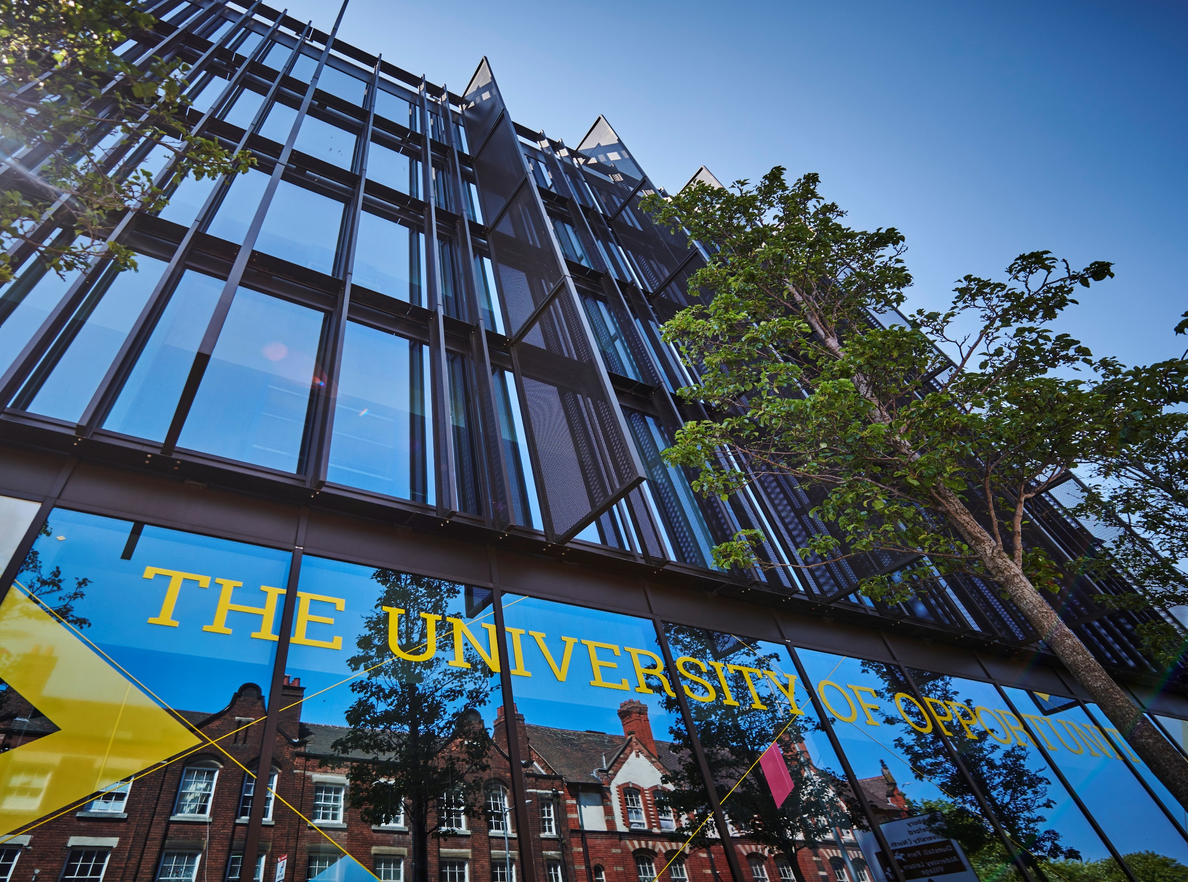



Visa Decision, Refusal and
Refund Policy




- Introduction

- Purpose

- Principles

- Scope

- Definition
6. Details of Policy
CAS Request Process
Visa Application Outcomes
Unsuccessful Decisions
Deposit Refunds
Refund Processing
Refund Administration Fee
Refund Timelines
Post Enrolment Withdrawal

- Our University Responsibilities in Relation to This Policy

8. Your Responsibilities as a Student in Relation to This Policy

9. What To Do If You Need Support with This Policy

10. Information and Resources

11. Data Protection Requirements

12. Training

13. Exceptions

14. Amendments

- Contact

POLICY

- Introduction

The University of Wolverhampton (the University) is committed to clear and fair terms for its international applicants with respect to visa decisions. This Policy has been approved by the University’s Executive Board.

- Purpose

  - To maintain our UKVI sponsor status, the University of Wolverhampton must request and pass a Basic Compliance Assessment every year. To pass a Basic Compliance Assessment, we must meet various requirements including ensuring our visa refusal rate is less than 10% for the twelve months prior to our request. These metrics are subject to change in accordance with UKVI requirements.

  - This policy is designed to address any issues that result in an applicant’s visa application being refused and protect our UKVI sponsor status by not issuing CAS to applicants who are likely to receive a visa refusal.

- Principles

  - The objectives of this policy are to address any issues that result in an applicant’s visa application being refused and protect our UKVI sponsor status by not issuing CAS to applicants who are likely to receive a visa refusal.
The implementation of this policy is in accordance with the University’s core values which are to be:

- Accountable; we take pride in what we do and how we do it, take responsibility for our actions and operate with transparency and integrity.
- Resilient; we have a positive outlook; we are adaptable and recover from setbacks.
- Inclusive; we are welcoming, respectful, collegiate and supportive.
- Ambitious; we are imaginative, confident, innovative and deliver excellence.

- Scope

The Visa Decision, Refusal and Refund Policy (and Procedure) applies to all applicants to the University who require a visa for the purposes of their study (full government student visa guidance can be located here: Student visa : Overview - GOV.UK).

- Definition

CAS is a confirmation of acceptance for studies that consists of an electronic document that generates a reference number that you will need to be able to apply for a visa. A CAS number confirms to UK Visa and Immigration (UKVI) that the University wishes to sponsor you to enable you to study in the UK.

- Details of Policy

  - CAS Request Process

    - The issuance of a CAS is subject to the University's CAS Issuance Policy and will only be issued to applicants upon completion of the CAS Request task in e:Vision, either directly by the applicant or by a Contracted Educational (CEA) Advisor on their behalf.

    - The CAS Request task asks the applicant to confirm the details that will be included on the CAS statement and asks them to confirm that they have the necessary funding and documents in place to ensure they meet visa application requirements.

    - Applicants must meet all requirements to be eligible for a CAS. Please see the University CAS Issuance Policy (https://www.wlv.ac.uk/about-us/corporate-information/wlv-policies/academic-policies/).

  - Visa Application Outcomes

    - The University of Wolverhampton must be informed of all visa application decisions as soon as an applicant receives this. The applicant (or Contracted Educational Advisor on their behalf) can do this by completing a task in e:Vision prior to enrolment or providing evidence of the decision to the Student Visa Compliance and Advice team (https://www.wlv.ac.uk/international/visa--immigration/).

    - Failure to provide evidence of a visa decision will impact the applicant/student’s ability to apply for a refund of deposit or further CAS.

  - Unsuccessful Decisions

    - If an applicant is unsuccessful in gaining a visa, the student or Contracted Educational
Advisor should provide full visa refusal documentation to the Admissions team (https://www.wlv.ac.uk/apply/contact-admissions/) or Student Visa Compliance and Advice team. The visa refusal document will be uploaded to the applicant’s record through e:Vision, and the main reason for refusal must be recorded in VIS.

    - If a refusal is considered incorrect by the Admissions Unit and Student Visa Compliance and Advice team, a second CAS will not be considered until the student has requested an administrative review (the Student Visa Compliance and Advice team can provide guidance for this process).

    - Applicants will not be allowed to request a further CAS, defer or reapply if their second visa application is refused. Presuming it is a first visa refusal, the University will consider the grounds for refusal before considering whether to issue a second CAS. The table below should guide when a second CAS is likely to be issued:

Refusal Reason | Consideration
Immigration history | If the refusal was on the grounds of the applicant’s immigration history and either the refusal document states that this decision will remain for any future visa applications, or it is clear that the applicant has misled the university, the applicant will not be allowed to defer or apply again to the university.
Unverifiable or unverified qualifications | If the refusal was on the grounds of the applicant’s qualifications not being verified by the Home Office or accepted as a true document, the applicant will not be allowed to defer or apply again to the  University unless they provide alternative equivalent qualifications to be reconsidered.
Maintenance requirements | All documentation used with the failed visa application is to be provided to the Student Visa Compliance and Advice team, along with new documentation. If the Student Visa Compliance and Advice team feels this new documentation is likely to result in a visa being issued, a second CAS may be issued.
Credibility interviews | A CAS will not be issued where there are credibility concerns, unless in exceptional circumstances where the Student Visa Compliance and Advice team feel the student will be able to convince the Entry Clearance officer (ECO) that the issues have been addressed.
CAS statement errors | These must be reviewed by the Admissions team to ensure the data held on SITS is corrected.
English language | A review of the English language level for the applicant must be undertaken by the Admissions team and a decision made as to whether the applicant has a sufficient level of English language for their course or whether a further English language course should be offered instead.
Deception/Fraud | A further CAS will not be issued where an applicant has been refused on the grounds of deception or fraud. A request of a refund of monies paid and further applications will not be accepted.

    - If a second CAS or deferral is not possible, applicants may apply for a refund of their deposit. This may not be possible in all instances. Please see the refunds section below for confirmation. As a responsible sponsor, the University of Wolverhampton reserves the right to refuse to issue a CAS in all instances in which we feel a student is likely to receive a visa refusal.

  - Deposit Refunds

    - Non-refundable Situations

No refund will be issued under any circumstances where the following applies:

- Where a student enters the UK on a student visa and subsequently changes their immigration status by claiming asylum.
- Where a student enters the UK but does not enrol and provides no evidence of return home.
- Where a student does not provide the Student Visa Compliance and Advice team evidence of the visa decision.
- Visa refusal resulting from the submission of fraudulent documents, deception, or acts of omission by the applicant.
- Repeated or avoidable visa refusals involving deception or misrepresentation.

    - Refund Processing

Subject to the above non-refundable stipulations, refunds will be processed only where the following apply:

- A formal written application must be submitted to the international Admissions Unit to initiate a refund request for a deposit. Upon approval of the refund by the Admissions Unit, the request will be forwarded to the Finance Department for further processing.
- The same method and account used for payment is available (unless agreed otherwise) to receive the refund.
- The refund request complies with all University policies, including visa and CAS compliance.
- Where a third party pays fees on a student’s behalf, any eligible refund will be made directly to that third party.

    - Refund Administration Fee

Where a refund is approved, a £250 Refund Administration Fee will be retained to cover the costs of university processing. These include, but are not limited to:

• Voluntary applicant withdrawal (prior to or after CAS issuance).
• Acceptance of a place at another institution.
• Failure to enrol by the deadline.
• Failure of a credibility interview (unless demonstrably University error).
• Withdrawn or unused CAS due to applicant actions.

A Refund Administration Fee of £250 will be applied to all tuition fee deposit refunds unless one of the following exceptional mitigating circumstances applies:

- The University is unable to deliver the course or has withdrawn the offer.
- The student is refused a visa due to reasons beyond their control (e.g. maintenance/documentation errors) and provides evidence that an administrative review has been submitted.
- Evidence of a significant personal or family emergency is provided.

    - Refund Timelines

Refunds will be processed within 20 working days from the date of receipt of a valid and complete request.

During the University’s December closure period, refund processing may be delayed by an additional 5 working days.

    - Post Enrolment Withdrawal

Students withdrawing after completing enrolment on their course will be subject to the provisions of the University’s Tuition Fee and Credit Control Policy (https://www.wlv.ac.uk/about-us/corporate-information/wlv-policies/academic-policies/).

- Our University Responsibilities in Relation to This Policy
The University will ensure consistent and fair application of the policy, ensuring you are informed of decisions taking in accordance with it.

- Your Responsibilities as an Applicant in Relation to This Policy

It is important that you read this policy in full, particularly in reference to a refund in the event of visa refusal.

- What To Do If You Need Support With This Policy

For further guidance or support with this policy please initially contact the Ask team via a service desk on campus, your e:Vision helpdesk, or through telephone on 01902 518 518.

- Information and Resources

Please see below links for information and guidance:

Policy Hub:
https://www.wlv.ac.uk/about-us/corporate-information/wlv-policies/

Admissions:
https://www.wlv.ac.uk/apply/contact-admissions/

Student Visa and Immigration:
https://www.wlv.ac.uk/international/visa--immigration/

Gov.UK guidance on Administrative Review:
https://www.gov.uk/ask-for-a-visa-administrative-review

Student Visa Gov.UK guidance:
Student visa : Overview - GOV.UK

- Data Protection Requirements

When personal data is expected to be used under this policy, staff must adhere to applicable data protection laws. These are outlined in the University's Data Protection Policy and related policies (https://www.wlv.ac.uk/about-us/corporate-information/wlv-policies/). Any use of personal data should be detailed in the relevant privacy notice and processed in accordance with all data protection principles.

For processing activities that may carry high risk; completion of a Data Protection Impact Assessment (DPIA) may be required. This is determined by answering a series of screening questions included in the DPIA template. The Data Protection Team is available to provide assistance and guidance with any part of this process, please contact them via email: dataprotection@wlv.ac.uk.

Please note that whilst the Data Protection Act does not cover aggregate data, it must be ensured that small numbers held within aggregate data sets do not inadvertently identify individuals.

- Training
Training relating to this policy and briefing will be made available in a range of formats according to the needs of the trainee and different groups of staff, students and others.
- Exceptions
There are no exceptions to this policy.

- Amendments

This Policy was approved by the University’s Executive Board on 10 February 2026. The University may change this Policy at any time, and where appropriate. Where a policy is not due for review, but is found to require updating, it will remain published, unless the reasons for review render it obsolete.

- Contact

For any queries, guidance and support relating to this policy please contact the Ask team via the e:Vision helpdesk or via telephone on 01902 518 518.

For general queries, please contact the Corporate Compliance Team via email: compliance@wlv.ac.uk.

VERSION | 2.0 | AUTHOR/OWNER | Daniel Kidd Dean of Students
Approved Date | 10 February 2026 | Approved By | University Executive Board
Review Date | 10 February 2029

